Dynamic Speed Feedback Signs:

Method and Summary Conclusions

Donald L. Fisher

Andrew Breck

Olivia Gillham

Daniel Flynn

May 2017

Volpe National Transportation Systems Center
55 Broadway
Cambridge, MA 02114

Table of Contents
1 Abstract 4
2 Introduction Error! Bookmark not defined.
2.1 Background Error! Bookmark not defined.
2.2 Objective Error! Bookmark not defined.
2.3 Summary of Findings Error! Bookmark not defined.
3 Literature Search Methods Error! Bookmark not defined.
3.1 Search Words and Phrases Error! Bookmark not defined.
3.2 Results of Search Error! Bookmark not defined.
4 Types of Dynamic Feedback Signs Error! Bookmark not defined.
5 Article Review Template Error! Bookmark not defined.
6 Vote-count Summary Error! Bookmark not defined.
6.1 Hypotheses Error! Bookmark not defined.
6.2 Dependent Variables Error! Bookmark not defined.
6.3 Systematic, Quantitative Review: Vote-counts Error! Bookmark not defined.
7 Hypotheses Error! Bookmark not defined.
7.1 Hypothesis 1: Activation Effect at DSFS Error! Bookmark not defined.
7.2 Hypothesis 2: Downstream Activation Effect Error! Bookmark not defined.
7.3 Hypothesis 3: Deactivation Effect at the DSFS Error! Bookmark not defined.
8 Dependent Variables Error! Bookmark not defined.
8.1 Description Error! Bookmark not defined.
8.2 Motivation Error! Bookmark not defined.
9 DSFS Implementation Characteristics Error! Bookmark not defined.
9.1 Safety Focus Error! Bookmark not defined.
9.2 DSFS (Several Descriptors) Error! Bookmark not defined.
9.3 Level of Service Error! Bookmark not defined.
9.4 Roadway Type Error! Bookmark not defined.
9.5 Roadway Area Error! Bookmark not defined.
9.6 Sidewalks Error! Bookmark not defined.
9.7 Classes of Vehicles Error! Bookmark not defined.
9.8 Posted Speeds Error! Bookmark not defined.
9.9 Sensor Types Error! Bookmark not defined.
9.10 Mobile Units Error! Bookmark not defined.
9.11 Type of Treatments Error! Bookmark not defined.
10 Study Design Characteristics Error! Bookmark not defined.
10.1 Sensor Positions Error! Bookmark not defined.
10.2 Sites Used to Evaluated Each Treatment Error! Bookmark not defined.
10.3 Before DSFS Activation Measures (Several Features) Error! Bookmark not defined.
10.4 During DSFS activation measures (Several Features) Error! Bookmark not defined.
10.5 After DSFS Deactivation Measures (Several Features) Error! Bookmark not defined.
10.6 Experimental Design Error! Bookmark not defined.
11 Vote-Count Summary by Safety Focus Error! Bookmark not defined.
11.1 Work Zone Error! Bookmark not defined.
11.2 School Zone Error! Bookmark not defined.
11.3 Transition Zone Error! Bookmark not defined.
11.4 Curved Section Error! Bookmark not defined.
11.5 Straight Section Error! Bookmark not defined.
12 Discussion Error! Bookmark not defined.
12.1 Overall Error! Bookmark not defined.
12.2 Safety Focus Error! Bookmark not defined.
12.3 Limitations Error! Bookmark not defined.
13 References Error! Bookmark not defined.
14 Appendix A: Dynamic Speed Feedback Sign Examples 10
15 Appendix B: Article Review Template 14
15.1 Introductory Information Error! Bookmark not defined.
15.2 Features 14
15.3 Summary of Study 16
15.4 Study Schematic 17
16 Appendix C: Studies Linked to Vote-count Error! Bookmark not defined.
16.1 Work Zone 5
16.2 School Zone 6
16.3 Transition Zone 7
16.4 Curved Section 8
16.5 Straight Section 9

Executive Summary to Volume 2

Table of Contents

1 Executive Summary to Volume 2 4
2 Appendix A: Index of DSFS Features 6
3 Appendix B: Dynamic Speed Feedback Sign Examples 11
4 Appendix C: Article Review Template 15
5 Annotated Bibliography for Review of Dynamic Speed Feedback Signs 1
1. Addison County Regional Planning Commission, 2013 6
2. City of Bellevue Transportation Department, 2009 9
3. Bertini, Monsere, Nolan, Bosa, and Abou El-Seoud, 2006 14
4. Bloch and Automobile Club of Southern California, 2007 20
5. Bowie, 2003 23
6. Brewer, Pesti, and Schneider, 2006 28
7. Bullough, Skinner, Brons, and Rea, 2012 33
8. Chang, Nolan, and Nihan, 2004 38
9. Cruzado and Donnell, 2009 42
10. Drakopoulos, Uprety, and Vergou, 2003 47
11. City of Englewood, Colorado, 2014 52
12. Fontaine, 2001 55
13. Fontaine, 2008 60
14. Gambatese and Zhang, 2014 62
15. Gambatese and Jafarnejad, 2015 68
16. Hajbabai, Medina, Want, Benekohal, and Chitturi, 2011 77
17. Hallmark, Peterson, Fitzsimmons, Hawkins, Resler, and Welch, 2007 81
18. Hallmark, Hawkins, and Knickerbocker, 2015 85
19. Hallmark, Hawkins, and Smadi, 2015 89
20. Hallmark, Knickerbocker, and Hawkins, 2013 94
21. Jeihani, Ardeshiri, and Naeeni, 2012 98
22. Kamyab, Andrle, and Kroeger, 2002 103
23. Knapp and Robinson, 2012 107
24. Lee, Lee, Choi, and Oh, 2006 110
25. Mattox, Sarasua, Ogle, Eckenrode, and Dunning, 2007 115
26. McCoy and Pesti, 2001 119
27. McCoy, Bonneson, and Kollbaum, 1995 123
28. Medina, Benekohal, Hajbabaie, Wang, and Chitturi, 2009 126
29. Meyer, 2000 130
30. O’Brien and Simpson, 2012 133
31. Pesti and McCoy, 2011 137
32. Reddy, Datta, Savolainen, and Pinapaka, 2008 142
33. Roberts and Smaglik, 2012 148
34. Saito and Ash, 2005 151
35. Santiago-Chaparro, Chitturi, Bill, and Noyce, 2011 156
36. Sarasua, Ogle, Davis, and Chowdhury, 2006 160
37. Schoenecker, Sandberg, Sebastian, and Soler, 2008 166
38. Teng, Xu, Li, Kwigizile, and Gibby, 2009 170
39. Tribbett, McGowen, and Mounce, 2000 175
40. Ullman and Rose, 2005 187
41. Walter and Broughton, 2011 191
42. Western Transportation Institute, 2003 194
43. Williamson and Fries, 2015 199
References 201

Appendix A: Index of DSFS Features

Authors | Cases | H1: Mean |  |  | H1: 85th |  | H1: Over |  | H2: Mean |  |  | H2: 85th |  | H2: Over |  | H3: Mean |  | H3: 85th |  | H3: Over
Change in Speed |  | - | 0 | + | - | 0 | - | 0 | - | 0 | + | - | 0 | - | 0 | - | 0 | - | 0 | - | 0
Bowie, J.M. | 2 | 2 |  |  |  |  |  |  | 2
Brewer, Pesti, and Schneider | 1 |  |  |  | 1 |  | 1 |  |  |  |  | 1 |  | 1
Fontaine, 2001 | 2 | 1 | 3 |  |  |  | 2 | 2 | 3 | 1 |  |  |  | 1 | 3
Fontaine, 2008 | 4
Gambatese and Zhang | 2 |  | 2 |  |  | 2
Gambatese and Jafarnejad | 8 | 8 |  |  |  |  | 8
Hajbabai et al. | 6 | 6 |  |  | 5 | 1
Mattox et al. | 5 | 5 |  |  | 5 |  | 5 |  | 5 |  |  | 5 |  | 5
McCoy and Pesti | 2 |  |  |  |  |  |  |  | 2 |  |  | 2 |  | 2
McCoy, Bonneson, and Kollbaum | 2 | 2 |  |  |  |  | 2 |  | 2 |  |  |  |  | 2
Medina et al. | 24 |  |  |  |  |  |  |  | 8 | 10 | 6
Meyer | 2 | 2 |  |  |  |  |  |  | 2
Pesti and McCoy | 2 |  |  |  |  |  |  |  | 2 |  |  | 2 |  | 2 |  | 2 |  | 2 |  | 2
Reddy et al. | 2 | 2 |  |  | 2 |  | 2 |  | 2 |  |  | 2 |  | 2
Roberts and Smaglik | 1 | 1 |  |  | 1 |  | 1 |  | 1 |  |  | 1 |  | 1 |  | 1 |  | 1 |  | 1
Sarasua et al. | 17 | 15 | 2 |  | 15 | 2 | 15 | 2 | 15 | 2 |  | 15 | 2 | 15 | 2
Teng et al. | 1 | 1 |  |  | 1 |  | 1 |  | 1 |  |  | 1 |  | 1

Work Zone

Table A1. Work Zone Studies. (“Mean” represents mean speed; “85th” represents the 85th percentile speed; “Over” represents the percentage of drivers over the speed limit; “ ”, “0” and “+” represent, respectively, a decrease, no change and increase in speed.)

School Zone

Table A2. School Zone Studies. (“Mean” represents mean speed; “85th” represents the 85th percentile speed; “Over” represents the percentage of drivers over the speed limit; “-”, “0” and “+” represent, respectively, a decrease, no change and increase in speed.)
Author | Cases | H1:mean |  |  | H1:85th |  | H1: Over |  | H2:mean |  |  | H2:85th |  | H2: Over |  | H3: Mean |  | H3: 85th |  | H3: Over
Changes in Speed |  | - | 0 | + | - | 0 | - | 0 | - | 0 | + | - | 0 | - | 0 | - | 0 | - | 0 | - | 0
Obrien and Simpson | 2 | 2 |  |  | 2 |  | 2
Lee et al. | 1 | 1 |  |  | 1 |  |  |  | 1 |  |  | 1
Saito and Ash | 8 | 5 |  | 3
Jeihani, Ardeshiri and Naeeni | 3 | 3 |  |  |  |  |  |  |  | 3
Ulmann and Rose | 1 | 1 |  |  |  | 1 | 1

Transition Zone

Table A3. Transition Zone Studies. (“Mean” represents mean speed; “85th” represents the 85th percentile speed; “Over” represents the percentage of drivers over the speed limit; “-”, “0” and “+” represent, respectively, a decrease, no change and increase in speed.)
Author | Cases |  |  | H1:mean |  |  | H1:85th |  |  | H1: Over |  |  | H2:mean |  |  | H2:85th |  |  | H2: Over |  |  | H3: Mean |  |  | H3: 85th |  |  | H3: Over
Changes in Speed |  | - | 0 |  | + | - |  | 0 | - |  | 0 | - |  | 0 | + |  | - | 0 |  | - | 0 |  | - | 0 |  | - | 0 |  | - | 0
Cruzado and Donnell | 12 | 12
Cruzado and Donnell | 2
Hallmark et al. (2007) | 4 | 4 |  |  |  | 4
Hallmark and Hawkins | 6 | 6
Hallmark et al. (2013 | 3 | 3 |  |  |  | 3 |  |  | 3
Kamyab, Andrle and Kroger |  |  |  |  |  |  |  |  |  |  |  |  |  | 1 |  |  |  | 1 |  | 1
Schoenecker et al. | 4 | 4 |  |  |  | 4
Ullman and Rose | 2 | 2 |  |  |  |  |  | 2 | 2
Williamson and Fires | 1 |  |  |  |  |  |  |  |  |  |  | 1

¹For two of the sites no information was reported (Cruzado & Donnell, 2009).

Curved Section

Table A4. Curved Section Studies. (“Mean” represents mean speed; “85th” represents the 85th percentile speed; “Over” represents the percentage of drivers over the speed limit; “-”, “0” and “+” represent, respectively, a decrease, no change and increase in speed.)
Authors | Cases | H1: mean |  |  | H1:85th |  | H1: Over |  | H2: mean |  |  | H2:85th |  | H2: Over |  | H3: Mean |  | H3: 85th |  | H3: Over
Changes in Speed |  | - | 0 | + | - | 0 | - | 0 | - | 0 | + | - | 0 | - | 0 | - | 0 | - | 0 | - | 0
Bertini et al. | 2 | 2 |  |  |  |  |  |  | 2
Bullough et al. | 1 |  |  |  |  |  |  |  | 1
Drakopoulos and Uprety¹ | 1
Hallmarks, Hawkins and Smadi | 22 | 22 |  |  | 22
Knapp and Robinson | 3 | 3 |  |  | 3 |  | 3 |  | 3 |  |  | 3 |  | 3
Tribbett, McGowen and Mounce | 10 |  |  |  |  |  |  |  | 5 | 5
Ullman and Rose |  | 2 | 2 |  |  | 4 | 2 | 2
Western Transportation Institute | 2 | 2 |  |  | 2

¹Note that there was a significant decrease in the Drakopoulos and Uprety (2003)study only for semi-trucks that activated the sign. When only a single case was presented and the evidence from that case was not unanimous, we decided not to include it.

Straight Section
Table C5. Straight Section Studies. (“Mean” represents mean speed; “85th” represents the 85th percentile speed; “Over” represents the percentage of drivers over the speed limit; “-”, “0” and “+” represent, respectively, a decrease, no change and increase in speed.)

Authors | Cases | H1: Mean |  |  | H1: 85th |  | H1: Over |  | H2: Mean |  |  | H2: 85th |  | H2: Over |  | H3: Mean |  | H3: 85th |  | H3: Over
Changes in Speed |  | - | 0 | + | - | 0 | - | 0 | - | 0 | + | - | 0 | - | 0 | - | 0 | - | 0 | - | 0
Bloch & Automobile Club of Southern California | 2 | 2 |  |  |  |  | 2 |  | 2 | 0 | 0 | 2 |  | 2 |  | 2 |  |  |  |  | 2
Chang, Nolan, & Nihan | 4 |  |  |  |  |  |  |  | 3 | 0 | 1
City of Englewood, CO | 6

Appendix B: Dynamic Speed Feedback Sign Examples

Five examples of various combinations of the above types of DSFS are shown below.

A typical, very simple installation is displayed below in Figure A1 (Bullough, Skinner, Brons, & Rea, 2012). This static DSFS display message is activated when the speed is greater than 30 mph. The display is lighted, but does not indicate the driver’s speed nor does it flash. The unit is a fixed one. A speed limit sign is upstream of the DSFS.

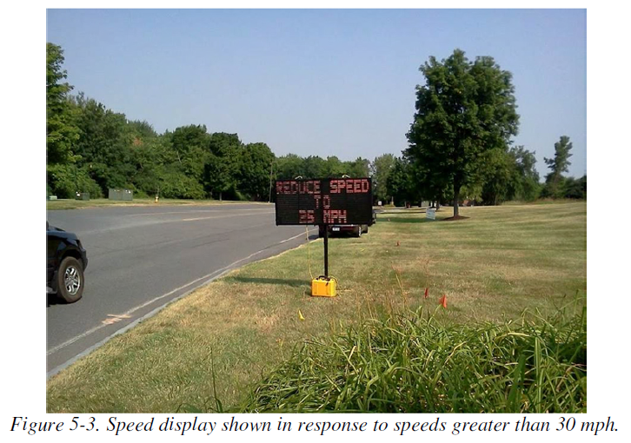

Figure B1. Static, lighted DSFS on CMS which does not display speed and does not flash. (Display activated when speed is greater than 30 mph.) (Bullough, Skinner, Brons, & Rea, 2012)

A mobile, lighted DSFS which displays the driver’s speed is presented below in Figure A2 (Brewer, Pestie, & Schneider, 2006). The DSFS is downstream from a speed limit sign. It is activated at all times and is often referred to as a speed display trailer.
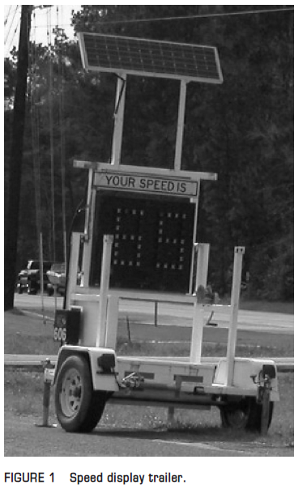

Figure B2. Mobile, lighted DFS which displays speed without flashing. (Speed displayed for all drivers.). (Bullough, Skinner, Brons, & Rea, 2012)

Next, consider a mobile, lighted DSFS which displays the driver’s speed, but does not flash. The speed of the driver may be the last of several messages displayed when a driver is over the speed limit. This is the case for the sequence of messages in Figure A3 below that was used in one of the studies (Brewer, Pestie, & Schneider, 2006). The first message was displayed to all drivers: (a) “Give us a brake”. The second, third and fourth messages were displayed in sequence as a violator approached the DSFS: (b) “Slow Down”, (c) “Your Speed” (d) “(driver’s actual speed)”.
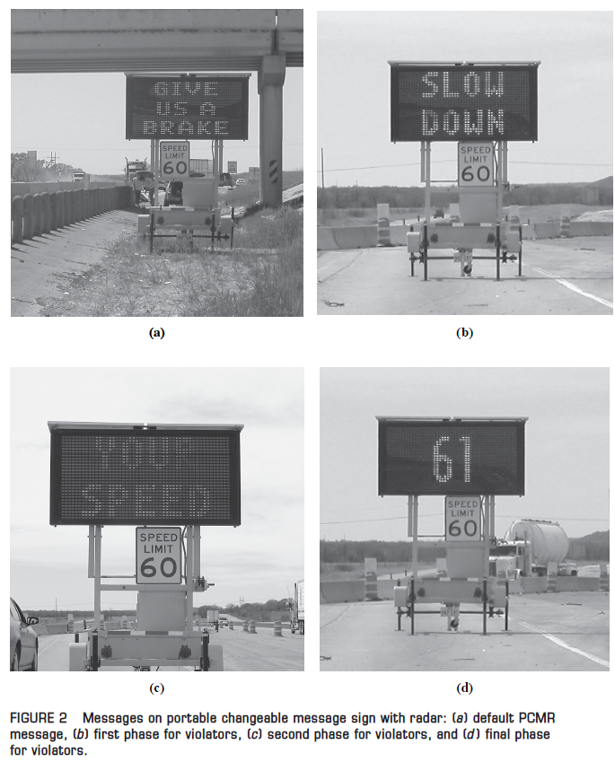

Figure B3. Mobile, lighted, DSFS with multiple messages prior to display of speed – no flashing. [(a) default DSFS message for non-violations; (b) first pass phase for violates; (c) second pass phase for violators; and (d) final phase for violators.] (Brewer, Pestie, & Schneider, 2006)

There also exist examples of dynamic speed feedback signs which do not display the speed, but which do flash when the driver is over the posted speed limit. For example, in one study the top and bottom lights flashed on a message which said “Slow Down” and which had an icon of a sharp right curve (Figure B4) (Robinson, 2012).

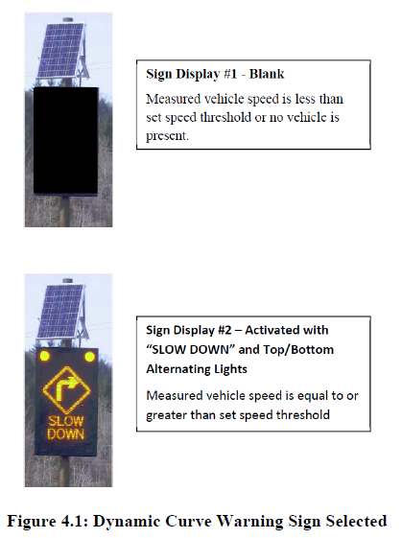

Figure B4. Static, lighted DSFS which does not display speed but which flashes, as a dynamic curve warning sign. (Robinson, 2012)

Finally, there are signs which flash the speed for drivers who travel above the speed limit. A simple example is displayed below in Figure B5 (Santiago-Chaparro, Chitturi, Bill, & Noyce, 2012).

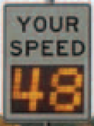

Figure B5. Static, lighted DSFS which displays speed and flashed. (Santiago-Chaparro, Chitturi, Bill, & Noyce, 2012)

Appendix C: Article Review Template
Each of the 43 included articles was reviewed in the Annotated Bibliography is detailed here.
The example article below focused on the use of DSFSs at horizontal curves (Bullough, Skinner, Brons, & Rea, 2012). We begin each article in the review with information on the study identifying information, relevance screening and quality screening. These have been discussed in the Literature Review in Volume 1.

Features
We continue the review with a simple list of information relevant to the study (Table B1). This list includes five different categories:
- What hypotheses were evaluated,
- What dependent variables were used to evaluate the hypotheses,
- What were the results of those evaluations,
- What were the characteristics of the study which the practitioner needs to know in order to implement the DSFS in a particular setting, and
- What are the aspects of the experimental design that the researcher needs to know in order to evaluate the goodness of the study.

Table C1 Features Defining Each Study
Feature | Study data
Experimental Design | O-X-O
Safety Focus | NS
Graphic of DSFS available | Yes
Graphic of Layout available | Yes
Study restricted to free flow level of service | Yes
Classes of vehicles included | NS
Hypothesis 1 level | B
Hypothesis 2 level | B
Hypothesis 3 level | NA
DSFS displays speed | No
DSFS speed lighting | Yes
DSFS flashes (speed or other) | No
Mobile DSFS units | No
Roadway type | Local
Area type (location) | Suburban
Sidewalks present | No
Posted speed | 30 mph
Sensor positions | Adjacent (328 ft. downstream)
Number of sensors | 0,1,1
Sensor types | Radar
Types of treatments | DSFS
Number of sites per treatments | 1
Over how long a period is speed measured: O1(interval) | 5 hours
How long before activation were speed measures taken: T1(interval) | NS
Over how long a period is DSFS activated: X1(interval) | NS
Time of day when speed measured: AM/PM | Multiple
Time of day when speed measured: peak/off peak | Off peak
Times after activation of DSFS when speed is measured X1(measurements) | NS
How long a time period after DSFS was deactivated intervened between deactivation and measurement: T2(interval) | NA
How long after DSFS removal/deactivation were they taken: O2(interval) | NA
H1: Mean speed | Significant reduction recorded
H1: 85 percentile speed | Nothing reported
H1: Percentage of drivers over speed limit | Nothing reported
H1: Distribution of speed | Significant reduction recorded
H2: Mean speed | Significant reduction recorded
H2: 85 percentile speed | Nothing reported
H2: Percentage of drivers over speed limit | Nothing reported
H2: Distribution of speed | Significant reduction recorded
H3: Mean speed | Nothing reported
H3: 85 percentile speed | Nothing reported
H3: Percentage of drivers over speed limit | Nothing reported
H3: Distribution of speed | Nothing reported
Meta-analysis data available | Yes
Caveats | None
Best practices information available | No

More generally, with respect to 1) – 5) above,
- The hypotheses are discussed in detail in Section Error! Reference source not found.,
- The dependent variables are discussed in Section Error! Reference source not found.,
- The results of all of the evaluations are discussed in Section Error! Reference source not found. and then separated out by safety focus in Section Error! Reference source not found.,
- The characteristics of a study which are important to implementation of a DSFS at a location are discussed in Section Error! Reference source not found., and
- Finally, the information necessary to evaluate the scientific validity of a study is described in Section Error! Reference source not found..

Summary of Study
Next, we include a summary of the study. This summary follows verbatim below (Bullough, Skinner, Brons, & Rea, 2012).

This study examined the effectiveness of two safety countermeasures. Relevant to this literature review, it evaluated a sign with conditional messages based on driver speed. Initial tests were conducted in controlled field experiments and then follow-up evaluations studied the effectiveness in real-world conditions. The real-world test location for the sign was located along Jordan Road, a small local road within the Rensselaer Technology Park in the town of North Greenbush, New York. The sign was located on the grass adjacent to the road, and no construction work or other activity took place in the road itself during the data collection.
The LED sign was programmed to display several conditional messages based on the speed of the approaching vehicle:

- If a vehicle is going faster than 30 mph: "REDUCE SPEED TO 25 MPH"
- If a vehicle is going between 25-30 mph: "25 MPH SPEED ZONE"
- If a vehicle is going between 20-25 mph: (No Message)
- If a vehicle is going less than 20 mph: "25 MPH SPEED ZONE"
- When no vehicles are approaching the sign it rests in a blank display.

Although the original speed limit along this road segment was 30 mph, the speed display sign was set up to encourage driving speeds of 25 mph. Approximately 328 ft. downstream from the display a member of the project team hid behind several trees and an electrical junction box and measured speeds with a radar gun. Further downstream a sign alerted drivers that the speed limit reverted to 30 mph. All measurements were taken in clear weather in the middle of the day to avoid peak rush hour. If vehicles were closely spaced, only the speed of the lead vehicle was measured to ensure independent speed measurements.

Data were collected before and during sign implementation, but the publication did not specify how much time elapsed between the measurements:

- Before: Between 10 a.m. and 3 p.m., a total of 663 vehicle speeds were measured.
- During: Between approximately 9:45 a.m. and 11:00 a.m., speeds for 108 vehicles were measured.

The measures of effectiveness were mean speed and the standard deviation of speed. The hypotheses investigated were H1B and H2B.

Data reported. Mean speeds and standard deviation, as well as histograms of speed observations.

Results. There was a statistically significant (p<0.001) reduction in the mean measured speeds during the installation test compared to the baseline conditions. The speed display messaging appeared to have the intended effect of reducing speeds closer to 25 mph (from a mean of 30 mph and a median of 33 mph), and also reduced the standard deviation of the measured speeds from 7.88 to 4.66 mph.

Statistical Analysis. The publication did not describe the statistical analysis, but it did report that results were statistically significant, implying that the researchers conducted statistical analysis. The authors of this publication indicated that significant speed reductions were achieved at the location of the DSFS and downstream of the DSFS, in line with hypotheses H1 and H2.

Study Schematic
When information is available on the details of the implementation of the study, such as a schematic, we include that for reference as well in the review of the study. For example, below in Figure C2 is an aerial view and map of the general area where the DSFS was installed (Bullough, Skinner, Brons, & Rea, 2012).

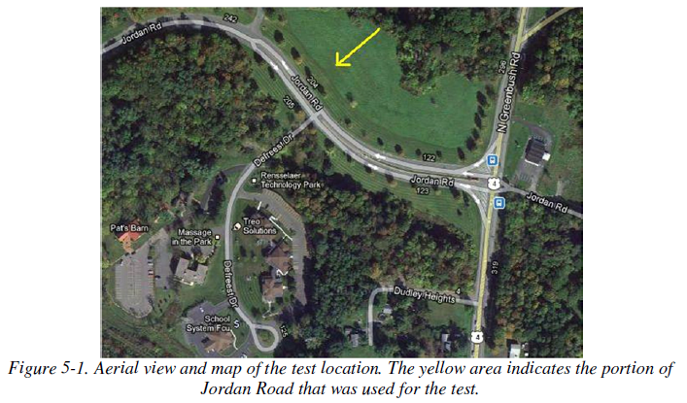
Additionally, where more detail is available, information is provided on the location of the DSFS in relation to any upstream and downstream traffic control devices (Figure C1).
Figure C2. Plan view of geographic location of study. (Bullough, Skinner, Brons, & Rea, 2012)

Figure C1. Location of DSFS relative to other traffic control devices. (Bullough, Skinner, Brons, & Rea, 2012)
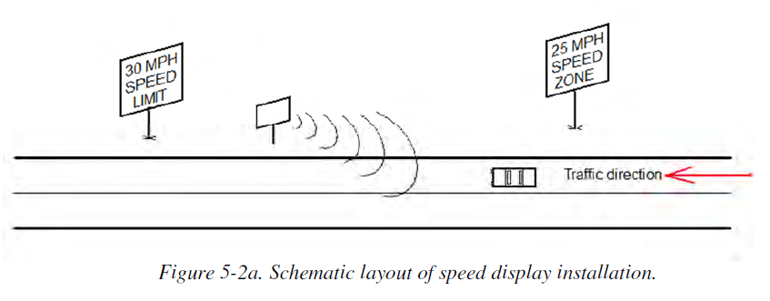

Annotated Bibliography for Review of Dynamic Speed Feedback Signs
This Annotated Bibliography provides detailed descriptions of the publications reviewed in the Literature Review. Readers are asked to refer to the Literature Review for discussion of the study goals, hypotheses, and conclusions. This document provides comprehensive detail on individual studies which may be of interest for matching study characteristics and methods with a DSFS site under consideration.

Candidate publications were identified by a search of the following databases: Transport Research International Documentation (TRID), National Transportation Library (NTL), WorldShare, Academic Search Complete, PsycINFO, Web of Science, and Science Direct. The searches were carried out between 3/9/2016 and 3/16/2016 by research librarians. A full list of the search terms is provided in Table 1 of the Literature Review. The search resulted in 108 candidate references. After filtering for domestic sources which report unique data collection efforts, and had data available for analysis, 43 publications were reviewed.
Publications are listed alphabetically by first author. See the References section for bibliographic details on each publication.

Explanation of Annotated Bibliography Fields and Entries
Each of the entries in this annotated bibliography follow the same format. This initial section displays the format along with explanatory notes to clarify the meaning and purpose of each field. Some of the text in the entries that follow is directly pasted from the publication abstracts.

Study Characteristics
Item | Explanation
Authors | The official authors of the publication
Title | Title as recorded in the publication
Publication year | Initial publication year as recorded in the publication

Relevance Screening
Inclusion Criteria | Explanation
Is this study an empirical investigation of the effects of effectiveness of dynamic speed feedback signs? | The criteria in this table were used to screen each publication. Each publication had to meet both criteria in order to be included. Thus, this table is omitted from the final bibliography entries because it would look the same for each entry.
Is the outcome measure crashes, fatal crashes, and/or traffic speeds? | See above.

Quality Screening
Quality Criteria | Explanation
Were the study population and the context of the study well described? | In order to qualify, the publication must describe the following:  - Study population (e.g., passenger vehicles, trucks, both)  - Context  - Posted speed  - Roadway design  - Placement of sensors and Dynamic Speed Feedback Sign (DSFS)  - Time during day and number of days measurements are taken
Were the exposure variables valid implementations of the conditions that they were meant to represent? | In order to qualify, the following must be true:  - Did the DSFS provide dynamic speed information during the entirety of the treatment conditions?  - Was the DSFS off during the control conditions?
Was the outcome variable both a reliable and valid measure of the outcome of interest? | a. Mean speed, 85th percentile speed, and percentage of drivers exceeding the speed limit were all considered reliable and valid  b. Other variables were only included if reliable and valid

Study Features
Feature | Explanation
Experimental Design | Example entry: O-X-O  Describes the temporal sequence of experimental steps. “O” indicates an observation period, and “X” indicates an experimental intervention (DSFS and/or other treatments). In the example, the first “O” indicates an observation period before activating the DSFS. The second “O” indicates an observation period during activation of the DSFS.
Safety Focus | Identifies the context of concern explicitly identified by the authors (e.g. work zone, school zone, transition zone, horizontal curve).
Graphic of DSFS available | Indicates whether the publication includes an image of the sign.
Graphic of Layout available | Indicates whether the publication includes a map or diagram showing the location of the sign(s) in relation to other traffic elements.
Study restricted to free flow level of service | Notes whether the study only measured vehicles in “free-flow” conditions, meaning that vehicles had enough space around them at a given speed so as to be uninfluenced by the speeds of other vehicles. The exact definition of “free-flow” differs slightly across publications.
Classes of vehicles included | Indicates whether the publication had an explicit focus on one or more vehicle classes (e.g. passenger cars and trucks).
Hypothesis 1 (H1) level | Indicates the type of hypothesis used to test effectiveness at a location adjacent to the DSFS during activation (“activation hypothesis”). See other documentation for more detailed explanation of hypothesis types and codes.
Hypothesis 2 (H2) level | Indicates the type of hypothesis used to test effectiveness at a location downstream of the DSFS during activation (“downstream activation hypothesis”). See other documentation for more detailed explanation of hypothesis types and codes.
Hypothesis 3 (H3) level | Indicates the type of hypothesis used to test effectiveness at a location adjacent to the DSFS after it has been deactivated (“deactivation hypothesis”). See other documentation for more detailed explanation of hypothesis types and codes.
H1: Mean speed | For each combination of hypothesis type and dependent variable, the following entries summarize significant results reported in the publication. Here, for example, if a study reported a significant change in the mean speed during activation as compared to before activation at a location adjacent to the DSFS, this field would indicate that there was a significant difference.
H1: 85th percentile speed | See above.
H1: Percentage of drivers over speed limit | See above.
H1: Distribution of speed | See above.
H2: Mean speed | See above.
H2: 85th percentile speed | See above.
H2: Percentage of drivers over speed limit | See above.
H2: Distribution of speed | See above.
H3: Mean speed | See above.
H3: 85th percentile speed | See above.
H3: Percentage of drivers over speed limit | See above.
H3: Distribution of speed | See above.
DSFS displays speed | Indicates whether the sign displays numerals to show each driver the measured vehicle speed. This is in contrast to a sign that provides feedback to the driver (e.g., displaying “slow down” in response to speeds above a certain threshold) but does not display the exact speed.
DSFS speed lighting | Indicates whether the sign had any lights (e.g., numbers on the sign arranged as a matrix of lights or retroreflective).
DSFS flashes (speed or other) | Indicates whether the sign has any flashing lights (numbers or other lights).
Mobile DSFS units | Indicates whether the sign is portable (e.g. a speed display trailer)
Roadway type | Categorizes the road into one of several major types (e.g. freeway, arterial, collector, and local).
Area type (location) | Categorizes the location as either urban, suburban, or rural.
Sidewalks present | Indicates whether there are pedestrian sidewalks.
Posted speed | Denotes the regulatory speed for the roadway at the location of the DSFS (adjacent).
Sensor positions | Example entry: Adjacent (328 ft. downstream)  Indicates the location of any sensors used to measure speeds in any of three categories: upstream of the DSFS, adjacent to the DSFS, or downstream of the DSFS. The categorization here is consistent with the way that the authors categorized their sensors. This means that in some cases an “adjacent” sensor may actually be located slightly downstream of the DSFS, if the authors argued that it was effectively adjacent (due to delayed driver reaction time, etc.) Not every study had a sensor in all three categories. Missing categories were omitted, such as in the below example, which did not have any upstream or downstream sensors.
Number of sensors | Example entry: 0,1,0  Lists the number of sensors in each category (upstream, adjacent, downstream)
Sensor types | Indicates the type(s) of sensors the researchers used to gather speed data (e.g., radar).
Types of treatments | This may include DSFS, but may also include other treatments implemented in addition to and simultaneously with the DSFS (e.g., police enforcement).
Number of relevant sites | Indicates the number of unique sites where relevant tests were conducted.
Number of cases | Indicates the total number of unique circumstances for which data were reported (e.g., the number of sites multiplied by the number of relevant, unique treatments multiplied by the number of vehicle types separately analyzed)
Duration of measurements before activation (“before” measurements) | Indicates the length of time over which speed measurements were gathered in the baseline observation period (before DSFS activation).
Time interval between “before” measurements and activation | Indicates the amount of time that passed after the last baseline measurement and before DSFS activation.
Duration of activation | Indicates the length of time that the DSFS was activated
Time of day when speed is measured (AM/PM) | Indicates the time of day that speed measurements were taken.
Time of day when speed is measured (peak/off peak) | Indicates whether speed measurements were taken during a peak or off-peak time.
Time intervals at which measurements were taken during activation (“during” measurements) | Indicates the times that speed measurements were taken during activation of the DSFS. For example, an entry of “1, 3, and 6 months,” means that measurements were taken after the DSFS had already been continuously operating for one month, and subsequent separate measurements were taken after 3 and 6 months of operation, respectively.
Amount of time that elapsed after deactivation and prior to subsequent measurements (“after” measurements) | Indicates the amount of time that passed after the DSFS was activated and before the subsequent measurement period.
Duration of “after” measurements | Indicates the length of time over which speed measurements were gathered in the observation period following DSFS deactivation.
Meta-analysis data available | Indicates whether data was available for use in the meta-analysis.
Caveats | Indicates whether there were any unique circumstances affecting the usability of the data for the meta-analysis.
Best practices information available | Indicates whether the publication included any practical implementation advice that may be of interest to a transportation agency that is considering using a DSFS.

Summary of Study
This section of each review describes the basic context of the study in narrative form. It also highlights any aspects that were particularly unique.
Data reported. Describes the data that were actually available in the study. Often this did not include all of the stated measures of effectiveness for which the study collected data.
Results. Describes the major findings of the study and any statements of statistical significance, if available.
Statistical Analysis. Summarizes the statistical analyses and tests that the publication authors conducted, as described by the authors.

Study Schematic
Maps and/or diagrams showing the location(s) of the sign(s) in relation to other traffic elements, if available.

DSFS Graphic
Image(s) of the sign(s), if available.

- Addison County Regional Planning Commission, 2013

  - Study Characteristics
Item | Response
Authors | Addison County Regional Planning Commission
Title | Effectiveness of Radar Speed Feedback Signs and Other Traffic Calming Techniques
Publication year | 2013

  - Quality Screening
Quality Criteria | Response (Yes or No)
Were the study population and the context of the study well described? | Yes
Were the exposure variables valid implementations of the conditions that they were meant to represent? | Yes
Was the outcome variable both a reliable and valid measure of the outcome of interest? | Yes

  - Study Features
Feature | Study Information
Experimental Design | O-X-O
Safety Focus | Pedestrian area
Graphic of DSFS available | Yes
Graphic of Layout available | Yes
Study restricted to free flow level of service | NS
Classes of vehicles included | NS
Hypothesis 1 (H1) level | B
Hypothesis 2 (H2) level | NA
Hypothesis 3 (H3) level | NA
H1: Mean speed | Nothing reported
H1: 85th percentile speed | Nothing reported
H1: Percentage of drivers over speed limit | Nothing reported
H1: Distribution of speed | Nothing reported
H2: Mean speed | Nothing reported
H2: 85th percentile speed | Nothing reported
H2: Percentage of drivers over speed limit | Nothing reported
H2: Distribution of speed | Nothing reported
H3: Mean speed | Nothing reported
H3: 85th percentile speed | Nothing reported
H3: Percentage of drivers over speed limit | Nothing reported
H3: Distribution of speed | Nothing reported
DSFS displays speed | Yes
DSFS speed lighting | Yes
DSFS flashes (speed or other) | NS
Mobile DSFS units | No
Roadway type | Local
Area type (location) | Rural
Sidewalks present | Yes
Posted speed | 25 mph
Sensor positions | NS
Number of sensors | 2
Sensor types | NS
Types of treatments | DSFS
Number of relevant sites | 3
Number of cases | 3
Duration of measurements before activation (“before” measurements) | NS
Time interval between “before” measurements and activation | 2 years
Duration of activation | NS
Time of day when speed is measured (AM/PM) | NS
Time of day when speed is measured (peak/off peak) | NS
Time intervals at which measurements were taken during activation (“during” measurements) | NS
Amount of time that elapsed after deactivation and prior to subsequent measurements (“after” measurements) | NA
Duration of “after” measurements | NA
Meta-analysis data available | Yes
Caveats | None
Best practices information available | No

  - Summary of Study
The Addison Country Regional Planning Commission evaluated the effectiveness of a DSFS within a rural Vermont context, on local roads with pedestrian activity. The Commission measured changes in speed due to two DSFS signs at three locations along Harbor Road in Shelburne, Vermont. The posted speed limit was 25 mph for all three locations.
Speeds were measured in 2010, two years before DSFS installation, for an unspecified duration and at unspecified times. Speeds were measured again in 2012, during DSFS installation, for an unspecified duration and at unspecified times. The technology for collecting speed data was not specified. The exact location of the speed data collection in relation to the DSFS was not specified.
The measures of effectiveness were mean speed, 85th percentile speed, and 10 mph pace speed.
Data reported. The study reported mean speeds, 85th percentile speeds, and 10 mph pace speeds for the before and during periods.
Results. The study reported decreases in speeds, but did not report whether or not the results were statistically significant.
Statistical Analysis. No description provided.

  - Study Schematic
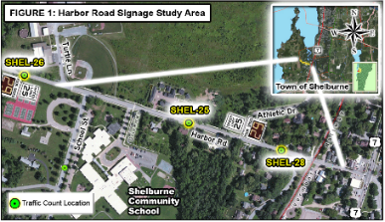

  - DSFS Graphic
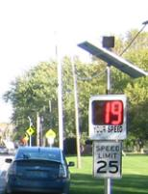
- City of Bellevue Transportation Department, 2009

  - Study Characteristics
Item | Response
- Authors | City of Bellevue Transportation Department
- Title | Stationary Radar Sign Program: 2009 Report
- Publication year | 2009

  - Quality Screening
Quality Criteria | Response (Yes or No)
Were the study population and the context of the study well described? | Yes
Were the exposure variables valid implementations of the conditions that they were meant to represent? | Yes
Was the outcome variable both a reliable and valid measure of the outcome of interest? | Yes

  - Study Features
Feature | Study Information
Experimental Design | O-X-O-O-O
Safety Focus | Multiple
Graphic of DSFS available | Yes
Graphic of Layout available | Yes
Study restricted to free flow level of service | NS
Classes of vehicles included | NS
Hypothesis 1 (H1) level | B
Hypothesis 2 (H2) level | NA
Hypothesis 3 (H3) level | NA
H1: Mean speed | Nothing reported
H1: 85th percentile speed | Nothing reported
H1: Percentage of drivers over speed limit | NA
H1: Distribution of speed | Nothing reported
H2: Mean speed | NA
H2: 85th percentile speed | NA
H2: Percentage of drivers over speed limit | NA
H2: Distribution of speed | NA
H3: Mean speed | NA
H3: 85th percentile speed | NA
H3: Percentage of drivers over speed limit | NA
H3: Distribution of speed | NA
DSFS displays speed | Yes
DSFS speed lighting | Yes
DSFS flashes (speed or other) | Yes
Mobile DSFS units | No
Roadway type | Multiple
Area type (location) | Urban
Sidewalks present | Multiple
Posted speed | 25-35 mph
Sensor positions | Adjacent (NS)
Number of sensors | NS
Sensor types | NS
Types of treatments | DSFS
Number of relevant sites | 31
Number of cases | 31
Duration of measurements before activation (“before” measurements) | NS
Time interval between “before” measurements and activation | 1-30 months
Duration of activation | Multiple
Time of day when speed is measured (AM/PM) | NS
Time of day when speed is measured (peak/off peak) | NS
Time intervals at which measurements were taken during activation (“during” measurements) | 1 month to 8 years
Amount of time that elapsed after deactivation and prior to subsequent measurements (“after” measurements) | NA
Duration of “after” measurements | NA
Meta-analysis data available | Yes
Caveats | None
Best practices information available | No

  - Summary of Study
Dynamic speed feedback signs (DSFS) were installed at 31 site(s) in Washington. The DSFS were from four different companies: 3M, MPH, Vcalm, and SpeedCheck. All display the motorist speed; some flash the speed if it is high enough over the speed limit; some also flash a strobe light. The context was unspecified, but mostly suburban based on the roadway pictures. The roadway type was as follows: clear line of sight to DSFS was required, roads may be straight or curved, collector or arterial, and have only one lane of traffic facing the sign. Most roads were 2-way roads; all appeared to be paved. The posted speeds were between 25 and 35 mph. Measures were taken of the mean speed, the 85th percentile speed, and total traffic volume; however, only 85th percentile speed was provided in the paper. The location and type of sensors was unspecified. The measures were gathered before and during the time that the DSFS was activated. All measurements were taken at various times from 2000 to 2009, but there was no consistent duration between before measurements, installation, and during measurements. Data were not averaged across the sites, but were analyzed in aggregate. Independent variables were as follows: treatment, DSFS type, time since installation, location, number of lanes, and posted speed limit. Dependent variables were as follows: mean speed, 85th percentile speed, traffic volume, and crashes. The major hypothesis was H1B. The measure of effectiveness discussed was 85th percentile speed, specifically the percent reduction in speed, with site results available individually and bucketed into four groups: 1) speed increase 2) 0 to 4 % reduction 3) 5 to 9% reduction and 4) 10+ % reduction. The publication indicates that mean speed was also recorded, but those results are not discussed in this paper.
Data Reported. The only data specifically reported were 85th percentile speeds, for all observation sets.
Results. For H1B, the 85th percentile speed decreased at most sites (97%) in the 1-3 years following installation, and at all sites in the 2-8 years following installation. Effectiveness generally improved over time, with the highest percent of sites finding a 10+% reduction in speed 6 to 8 years after installation. However, the number of sites with data available decreases as time since installation increases. On top of the fact that no statistical analysis is discussed, it is difficult to say whether these results are statistically significant.
Statistical Analysis. There was no statistical analysis discussed
  - Study Schematic

  - DSFS Graphic
There is a picture available of the specific DSFS installed at each of the 31 sites. There are many small variations in style. A few examples:
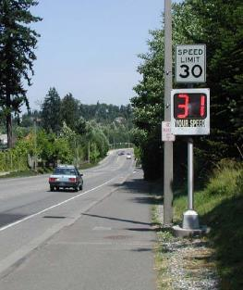

Facing West for Eastbound Motorists
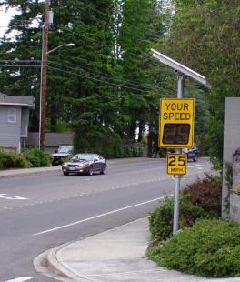

Facing West for Eastbound Motorists

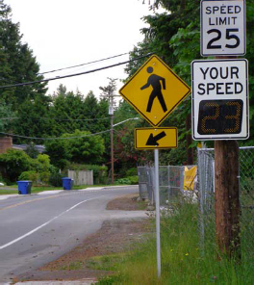

Facing North for Southbound Motorists
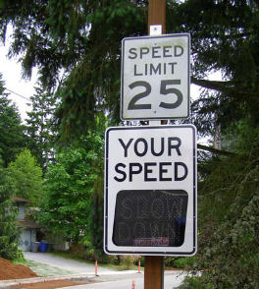

Facing North for Southbound Motorists

- Bertini, Monsere, Nolan, Bosa, and Abou El-Seoud, 2006

  - Study Characteristics
Item | Response
- Authors | Bertini, Monsere, Nolan, Bosa, and Abou El-Seoud
- Title | Field Evaluation of the Myrtle Creek Advance Curve Warning System
- Publication year | 2006

  - Quality Screening
Quality Criteria | Response (Yes or No)
Were the study population and the context of the study well described? | Yes
Were the exposure variables valid implementations of the conditions that they were meant to represent? | Yes
Was the outcome variable both a reliable and valid measure of the outcome of interest? | Yes

  - Study Features
Feature | Study Information
Experimental Design | O-X
Safety Focus | Horizontal curve
Graphic of DSFS available | Yes
Graphic of Layout available | Yes
Study restricted to free flow level of service | NS
Classes of vehicles included | Passenger cars and trucks
Hypothesis 1 (H1) level | Southbound: A,B  Northbound: B
Hypothesis 2 (H2) level | Southbound: A,B  Northbound: B
Hypothesis 3 (H3) level | NA
H1: Mean speed | Significant reduction recorded
H1: 85th percentile speed | NA
H1: Percentage of drivers over speed limit | NA
H1: Distribution of speed | Significant reduction recorded
H2: Mean speed | Significant reduction recorded
H2: 85th percentile speed | NA
H2: Percentage of drivers over speed limit | NA
H2: Distribution of speed | Significant reduction recorded
H3: Mean speed | NA
H3: 85th percentile speed | NA
H3: Percentage of drivers over speed limit | NA
H3: Distribution of speed | Nothing reported
DSFS displays speed | Yes
DSFS speed lighting | LED
DSFS flashes (speed or other) | NS
Mobile DSFS units | No
Roadway type | Arterial
Area type (location) | Rural
Sidewalks present | No
Posted speed | 50 mph
Sensor positions | NS, but observations were binned in 200 ft increments, from -1100 ft upstream to 1100 ft downstream
Number of sensors | 1
Sensor types | Lidar
Types of treatments | DSFS
Number of relevant sites | 2
Number of cases | 2
Duration of measurements before activation (“before” measurements) | 11 hours total, collected in three installments spanning three months
Time interval between “before” measurements and activation | 6 months
Duration of activation | 6 months
Time of day when speed is measured (AM/PM) | Multiple
Time of day when speed is measured (peak/off peak) | Off peak
Time intervals at which measurements were taken during activation (“during” measurements) | 6 months
Amount of time that elapsed after deactivation and prior to subsequent measurements (“after” measurements) | NA
Duration of “after” measurements | NA
Meta-analysis data available | Yes
Caveats | None
Best practices information available | No, but refers to a companion report with best practice information

  - Summary of Study
Dynamic speed feedback signs (DSFS) were installed at two sites in Oregon. The style of DSFS was an overhead LED sign installed on existing sign bridges. The context was rural. The roadway type was as follows: curved interstate (two travel lanes in each direction) tightly constrained by an embankment on one side and a river on the other. The posted speeds were as follows: 50 mph (regulatory) and 45 mph (advised) in the vicinity of the curve. Measures were taken of the mean speed and the speed distribution. For southbound traffic, data were collected from a vehicle parked in the ramp gore area. This location was less than ideal because it was clearly visible to approaching traffic and has been used by Oregon State Police for enforcement purposes. For northbound traffic, data were collected from behind the concrete barrier approximately 420 feet downstream from the sign. Some data were also collected at a location 114 feet upstream of the sign. For each speed observation, the distance was also recorded. This distance was subsequently adjusted to reflect the actual distance of the vehicle upstream or downstream of the dynamic sign system. The speed observations were then binned in 200 ft increments, beginning as far as 1100 ft upstream and extending as far as 1100 ft downstream.. The measures were gathered before and during the time that the DSFS was activated. The "before" set of measurements were taken on four separate occasions between October and December; the "during" measurements were taken on three separate occasions the following May and July. Data were not averaged across the sites. Independent variables were as follows: Treatment, distance from DSFS, vehicle type (passenger or commercial). The measures of effectiveness (dependent variables) were mean speed and speed distribution. The authors also conducted a qualitative survey to obtain driver opinions.
Data Reported. Sample size, mean speed, standard deviation, statistical significance of observed differences, speed distributions, and qualitative survey results.
Results. The system was effective in reducing the mean speeds of passenger cars and trucks by approximately 3 mph for the southbound direction and 2 mph for the northbound direction. SOUTHBOUND CURVE: For the farthest upstream zones, the before and during mean speeds are not statistically significantly different, as indicated by t-tests in zone −1100 ft, −900 ft, and −700 ft in Table 6.1 for passenger cars. As drivers approached the sign, however, there was a statistically significant reduction in the mean speeds that appears to be associated with the presence of the system (because the before speeds are similar when the sign is not visible). For commercial vehicles, the same speed trend is evident; however, the results are not as conclusive statistically. Only in the −1100 and −300 zone are the differences in speeds not significant. After the sign, starting in zone −100, all of the differences are statistically different. The maximum mean speed reduction occurred in the zone immediately following the sign location and is 3.3 mph for passenger cars and 3.0 mph for commercial vehicles. Just before the curve, passenger vehicles were traveling 56.1 mph before the DSFS was activated and 53.7 mph when the DSFS was activated. Commercial vehicles were traveling 49.7 mph before the DSFS was activated and 48.9 mph when the DSFS was activated. NORTHBOUND CURVE: The plots in Figure 6.2 for the northbound curve also display reductions in the mean speeds during implementation, but the clear driver reaction to the sign observed in the southbound direction is not evident. The during speeds are statistically significantly lower in all zones except two (−700 commercial vehicles, and 700 commercial vehicles) making it difficult to conclude that speed reductions are attributable only to the dynamic system. Part of the difficulty is related to the availability of data. Unlike the southbound direction, the data collection point was downstream of the system, and as a result, data points in advance of the sign were not as easy to collect. For example, in the −700 zone, only 21 before and 10 during samples were collected. However, the data in Figure 6.2 show speed reductions during the deployment. There were maximum speed reductions of 2.6 mph for passenger cars and 1.9 mph for commercial vehicles. This is consistent with the southbound direction. Just before the curve, passenger vehicles were traveling 54.9 mph before the DSFS was activated and 51.6 mph when the DSFS was activated. Commercial vehicles were traveling 49.4 mph before the DSFS was activated and 46.4 mph when the DSFS was activated. Southbound and Northbound. After the system was installed, the distribution of vehicle speeds was statistically different with a lower number of vehicles in the higher speed bins for southbound and northbound passenger and commercial vehicles.
Statistical Analysis. The equality of means for the speeds of each vehicle class for each zone was tested using the t-test for significance. Results of the test are displayed in Table 6.1. The chi-square test indicated that all of the speed distribution shifts were statistically significant at a 95th percent confidence level.
  - Study Schematic

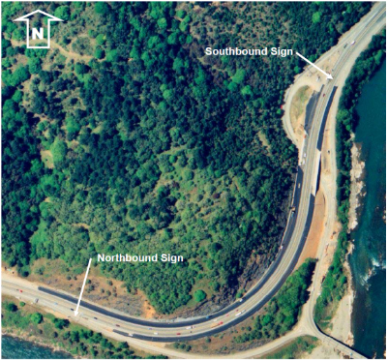
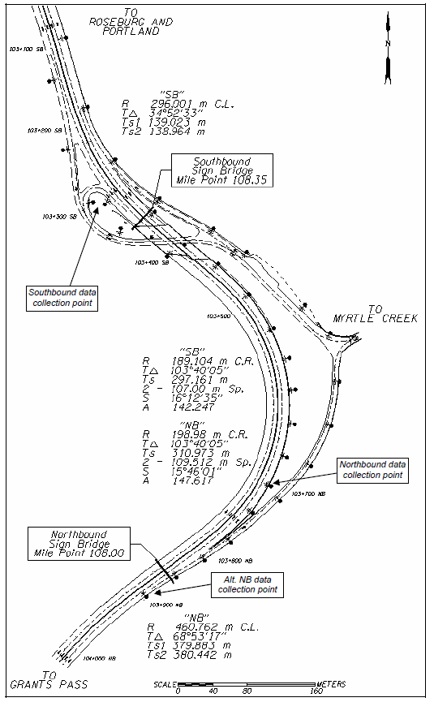

  - DSFS Graphic

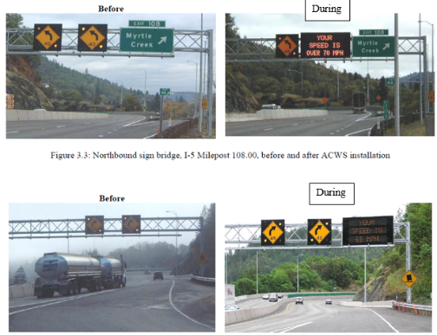
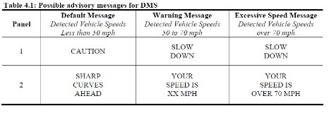

- Bloch and Automobile Club of Southern California, 2007

  - Study Characteristics
Item | Response
- Authors | Bloch and Automobile Club of Southern California
- Title | Comparative Study of Speed Reduction Effects of Photo-Radar and Speed Display Boards
- Publication year | 2007

  - Quality Screening
Quality Criteria | Response (Yes or No)
Were the study population and the context of the study well described? | Yes
Were the exposure variables valid implementations of the conditions that they were meant to represent? | Yes
Was the outcome variable both a reliable and valid measure of the outcome of interest? | Yes

  - Study Features
Feature | Study Information
Experimental Design | O-X-O-O
Safety Focus | Straight section
Graphic of DSFS available | No
Graphic of Layout available | No
Study restricted to free flow level of service | Yes
Classes of vehicles included | NS
Hypothesis 1 (H1) level | B
Hypothesis 2 (H2) level | B
Hypothesis 3 (H3) level | NA
H1: Mean speed | Significant reduction recorded
H1: 85th percentile speed | NA
H1: Percentage of drivers over speed limit | Significant reduction recorded
H1: Distribution of speed | Nothing reported
H2: Mean speed | Significant reduction recorded
H2: 85th percentile speed | NA
H2: Percentage of drivers over speed limit | Significant reduction recorded
H2: Distribution of speed | Nothing reported
H3: Mean speed | No change
H3: 85th percentile speed | na
H3: Percentage of drivers over speed limit | No change
H3: Distribution of speed | Nothing reported
DSFS displays speed | Yes
DSFS speed lighting | NS
DSFS flashes (speed or other) | NS
Mobile DSFS units | Yes
Roadway type | Collector
Area type (location) | Urban
Sidewalks present | NS
Posted speed | 25 mph
Sensor positions | Adjacent (0 ft); downstream (1050 ft)
Number of sensors | 0,1,1
Sensor types | Radar
Types of treatments | DSFS + police
Number of relevant sites | 2
Number of cases | 2
Duration of measurements before activation (“before” measurements) | 2 weeks
Time interval between “before” measurements and activation | NS
Duration of activation | 1 week
Time of day when speed is measured (AM/PM) | Multiple
Time of day when speed is measured (peak/off peak) | Multiple
Time intervals at which measurements were taken during activation (“during” measurements) | 1 week
Amount of time that elapsed after deactivation and prior to subsequent measurements (“after” measurements) | 3 hours and 1 week after
Duration of “after” measurements | NS
Meta-analysis data available | No
Caveats | None
Best practices information available | Yes

  - Summary of Study
DSFS were installed at two sites in Riverside, California. The DSFS were speed display boards (SPECTER Trailers equipped with a traffic radar unit, a solar power cell, and a large (0.3 meter) numerical display). The context was urban. The sites were residential collector roads, 11 to 12 meters wide, with one lane in either direction, with no stop signs or traffic signals, with a traffic volume of 800 to 2,400 vehicles per day per lane. The posted speeds were 25 mph. There were two relevant treatment conditions: one site had a speed display board (unenforced) and the other site had a speed display board accompanied by intermittent police enforcement. These measures were taken adjacent to the speed display board and 320 meters downstream. The measures were gathered before installing and activating the speed display boards, and during their activation. Data were not averaged across sites. Independent variables were as follows: Measurement location, treatment condition. The measures of effectiveness (dependent variables) were mean speed and percent of vehicles 10 mph above the speed limit.
Data Reported. Mean speed and percent of vehicles 10 mph above the speed limit.
Results. Speed display boards reduced mean speeds by 9.3 kph (5.78 mph) at the display board location. They reduced mean speeds by 4.7 kph (2.93 mph) at a location 320 meters downstream. Speed display boards become statistically significantly more effective when supplemented with police enforcement, but only downstream; the site with supplemental police enforcement showed a reduction of 9.8 kph (6.08 mph) at the speed display board and a reduction of 9.5 kph (5.90 mph) 320 meters downstream. Reductions in “excessive speeds” (traveling 16 kph (10 mph) or more over the legal limit) were greater than mean speed reductions, both at the speed display board and downstream. The observed deactivation effects were different for the enforced versus unenforced speed display boards. The former (enforced) showed significant lingering short term effects (3 hours) but no significant long-term effects (1 week) as compared to the before condition, at the DSFS as well as downstream. The latter (unenforced) did not have any available data on short term effects (3 hours), as the study did not collect this data, but data did show a significant lingering effect (1 week) at the DSFS (not downstream).
Statistical Analysis. Statistical analysis not described. However, the paper indicates whether observed differences were statistically significant, so the implication is that the authors conducted statistical testing.
  - Study Schematic
None provided.
  - DSFS Graphic
None provided.

- Bowie, 2003

  - Study Characteristics
Item | Response
- Authors | Bowie
- Title | Efficacy of Speed Monitoring Displays in Increasing Speed Limit Compliance in Highway Work zones
- Publication year | 2003

  - Quality Screening
Quality Criteria | Response (Yes or No)
Were the study population and the context of the study well described? | Yes
Were the exposure variables valid implementations of the conditions that they were meant to represent? | Yes
Was the outcome variable both a reliable and valid measure of the outcome of interest? | Yes

  - Study Features
Feature | Study Information
Experimental Design | O-X-O-X-O
Safety Focus | Work zone
Graphic of DSFS available | Yes
Graphic of Layout available | Yes
Study restricted to free flow level of service | NS
Classes of vehicles included | Passenger cars and trucks
Hypothesis 1 (H1) level | B
Hypothesis 2 (H2) level | B
Hypothesis 3 (H3) level | NA
H1: Mean speed | Significant reduction recorded
H1: 85th percentile speed | Nothing reported
H1: Percentage of drivers over speed limit | Nothing reported
H1: Distribution of speed | Nothing reported
H2: Mean speed | Significant reduction recorded
H2: 85th percentile speed | Nothing reported
H2: Percentage of drivers over speed limit | Nothing reported
H2: Distribution of speed | Nothing reported
H3: Mean speed | Nothing reported
H3: 85th percentile speed | Nothing reported
H3: Percentage of drivers over speed limit | Nothing reported
H3: Distribution of speed | Nothing reported
DSFS displays speed | Yes
DSFS speed lighting | Yes
DSFS flashes (speed or other) | NS
Mobile DSFS units | Yes
Roadway type | Freeway
Area type (location) | Rural
Sidewalks present | No
Posted speed | Multiple
Sensor positions | Upstream (varied at each site), adjacent (NS), downstream (varied at each site)
Number of sensors | 1,1,1
Sensor types | Pneumatic
Types of treatments | DSFS and DSFS + police
Number of relevant sites | 2
Number of cases | 2
Duration of measurements before activation (“before” measurements) | Multiple
Time interval between “before” measurements and activation | Multiple
Duration of activation | Multiple
Time of day when speed is measured (AM/PM) | Multiple
Time of day when speed is measured (peak/off peak) | Multiple
Time intervals at which measurements were taken during activation (“during” measurements) | Multiple
Amount of time that elapsed after deactivation and prior to subsequent measurements (“after” measurements) | NA
Duration of “after” measurements | NA
Meta-analysis data available | Yes
Caveats | None
Best practices information available | No

  - Summary of Study
This study evaluated the effectiveness of two strategies for reducing speeds in highway work zones. The first strategy was a DSFS and the second treatment was the presence of a police vehicle. Specifically, the treatment conditions applied were: one or more DSFS, a stationary police vehicle with radar on, a stationary police vehicle without radar on, a cruising police vehicle, and a combination of the DSFS and each of the police treatments. These were tested at seven highway work zone locations in Utah during the summer and fall of 2002. Speeds and vehicle types were recorded using pneumatic tubes and data recorders.
Although a variety of sites were tested, only two were statistically analyzed (I-80 West and I-15 South). The other sites had various issues that compromised the quality and/or quantity of the data.
- I-80 West: Only one lane was open to traffic at this site. Due to the wide shoulder the speed limit was not lowered in the work zone from the normal 65 mph. Data collection began around 1 AM on a Tuesday in September. At 2:30 AM, the state trooper arrived and turned on his radar and roof lamp. The DSFS was turned on at the same time. Starting at 3:30 AM the trooper turned off the radar, but kept the roof lamp on. The DSFS remained on the entire time. Data collection ended at about 4:15 AM. It was noted that drivers voluntarily significantly slowed down near the workers because the workers were very close to the open lane.
- I-15 South: Researchers noted that this site was ideal for data collection because vehicles were forced to travel in one lane for a long distance with no on- or off-ramps, data could be collected over several weeks and with several different conditions, and drivers were primarily non-commuters. Data were collected over a 3-week period. At various times throughout that 3-week period, the site had no treatment, DSFS, police, or a combination of both. Data were collected and categorized accordingly. The normal speed limit in the study area is 75 mph, but it was decreased to 55 mph in the work zone. The change occurred entirely upstream of the study site.
For each study site, a minimum of three data collectors were used. In each case, the first data collector was set up within the work zone but before the treatment could be detected by the driver. The second data collector was set up near where the treatment was applied (except in the case of a cruising police vehicle, where this was impossible). The final data collector was located in the work zone, usually near the end of the work zone. Where the work zone was long enough, as many as seven data collectors were set up to collect data throughout the entire study area. The measure of effectiveness was mean speed. The DSFS was orange, with a character board display 22.75 inches wide and 16.5 inches high. The hypotheses investigated were H1B and H2B.
Data reported. Sample size, mean speed, standard deviation.
Results. Statistically significant at a 95% confidence level, the study found that: in the no-treatment case, mean speed was reduced about 3 mph as vehicles entered the work area of the work zone. With the DSFS, mean vehicle speed was reduced an additional 4 mph. With the police vehicle, mean vehicle speed was reduced about 6 mph more than in the no-treatment case.
Statistical Analysis. “The statistical analysis was performed using the data from only three data collectors at each site: the initial data collector (where the treatment had not yet been applied), the data collector directly following any treatment that was applied, and one of the final data collectors. Compiled data were analyzed using general linear models to determine if there were statistically significant differences between the treatments.”
  - Study Schematic
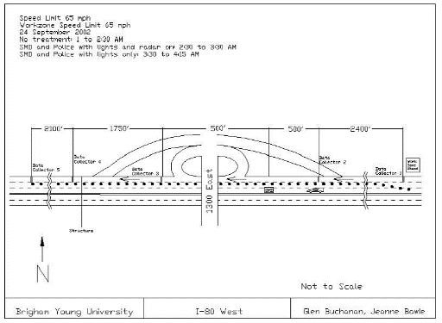
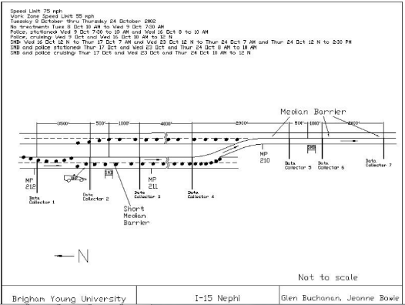

  - DSFS Graphic
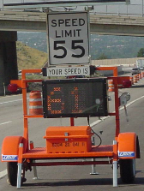

- Brewer, Pesti, and Schneider, 2006

  - Study Characteristics
Item | Response
- Authors | Brewer, Pesti, and Schneider
- Title | Improving Compliance with Work zone Speed Limits
- Publication year | 2006

  - Quality Screening
Quality Criteria | Response (Yes or No)
Were the study population and the context of the study well described? | Yes
Were the exposure variables valid implementations of the conditions that they were meant to represent? | Yes
Was the outcome variable both a reliable and valid measure of the outcome of interest? | Yes

  - Study Features
Feature | Study Information
Experimental Design | O–X–O–X–O
Safety Focus | Work zone
Graphic of DSFS available | Yes
Graphic of Layout available | No
Study restricted to free flow level of service | NS
Classes of vehicles included | Passenger cars and trucks
Hypothesis 1 (H1) level | B
Hypothesis 2 (H2) level | B
Hypothesis 3 (H3) level | B
H1: Mean speed | Nothing reported
H1: 85th percentile speed | Reduction recorded
H1: Percentage of drivers over speed limit | Significant reduction recorded
H1: Distribution of speed | Nothing reported
H2: Mean speed | Nothing reported
H2: 85th percentile speed | Reduction recorded
H2: Percentage of drivers over speed limit | Significant reduction recorded
H2: Distribution of speed | Nothing reported
H3: Mean speed | Nothing reported
H3: 85th percentile speed | No change
H3: Percentage of drivers over speed limit | No change
H3: Distribution of speed | Nothing reported
DSFS displays speed | Yes
DSFS speed lighting | LED
DSFS flashes (speed or other) | NS
Mobile DSFS units | Yes
Roadway type | Arterial
Area type (location) | Rural
Sidewalks present | No
Posted speed | Multiple
Sensor positions | Upstream (-1 mile); at DSFS(0 ft); downstream (unclear)
Number of sensors | 1,1,3
Sensor types | Pneumatic
Types of treatments | DSFS (portable changeable message sign with speed feedback and speed display trailer)
Number of relevant sites | 1
Number of cases | 1
Duration of measurements before activation (“before” measurements) | 3 days
Time interval between “before” measurements and activation | 3 days
Duration of activation | 1 week
Time of day when speed is measured (AM/PM) | Multiple
Time of day when speed is measured (peak/off peak) | Multiple
Time intervals at which measurements were taken during activation (“during” measurements) | 1 week
Amount of time that elapsed after deactivation and prior to subsequent measurements (“after” measurements) | NS
Duration of “after” measurements | NS
Meta-analysis data available | Yes
Caveats | Only graphical. No sample size or standard deviation.
Best practices information available | Yes

  - Summary of Study
Dynamic speed feedback signs (DSFS) were installed at two sites in Texas. The context was rural. This involved portable changeable message signs with radar (PCMRs), speed display trailers (SDTs), and orange border speed limit signs (OBSLS) installed in varying combinations over time. The roadway type was as follows. Site 1: Interstate highway, where two-way traffic was carried on the two reconstructed westbound lanes while the two existing eastbound lanes were removed and rebuilt. Site 2: Four-lane divided highway, where all lanes remained open to traffic during construction. The posted speeds were as follows. Site 1: 70 mph at the first measurement, then 60 mph. Site 2: 70 mph at the first measurement, then 55 mph. Measures were taken of the 85th percentile speed, standard deviation of speed, and the percentage of vehicles complying with the speed limit. These measures were taken 1 mile upstream of the DSFS, at a second location at an unspecified distance upstream of the DSFS, at the DSFS, and at two other locations at an unspecified distance downstream of the DSFS. At Site 1, measures were gathered three days before activation at all six sensors (Before PCMR condition). One PCMR (PCMR1) was installed for a ten days at the merge taper downstream of the first advance warning sign (sensor location 2) and measures were gathered for the last three days at all six sensors (PCMR1 condition). PCMR1 was removed for three days and data were collected (After PCMR1 condition). PCMR1 was reinstalled at the merge taper (downstream of sensor location 2) along with another PMCR (PMCR2) that was installed further downstream near the midpoint of the work zone (downstream of sensor location 3). The installation was again for ten days and measures were gathered during the last three days at all six sensors (PCMR1+PCMR2 condition). Finally, both PMCRs were removed and OBSLSs were installed for ten days, one upstream of the merge taper and one near the midpoint of the work zone (OBSLS condition). Measures were gathered at all six sensors for last three days of the 10 day installation. At Site 2, the procedure was very similar. Data were measured before activation (Before SDT condition). The SDT was installed at the beginning of the work zone (downstream of Location 2) for ten days and measures were taken during the last three days (SDT condition). The SDT was removed for three days and data were collected (After SDT condition). Finally, the OBSLSs were installed at the beginning of the work zone and data were collected (OBSLS condition). Each site had a different treatment, so data were not averaged across the sites. Independent variables were as follows: Vehicle type (truck/car), measurement location (six locations at Site 1; five at Site 2), and treatment condition (four for Site 1; three for Site 2). Dependent variables were as follows: 85th percentile speed, standard deviation of speed, and the percentage of vehicles complying with the speed limit at each of the six different sensor locations. The major hypotheses were H1, H2A, H3A, and H3B. The measures of effectiveness used in the evaluation of the speed control devices included 85th percentile speed, standard deviation of speed, and percentage of vehicles complying with the speed limit.
Data Reported. The 85th percentile speeds and percentage of drivers exceeding the speed limit are reported at all sensor locations for Sites 1 and 2 across all conditions for each site. Pairwise comparisions were reported for the dependent variables at selected sensor locations between selected conditions. The type of statistical test used to evaluate the pairwise comparisons was not reported.
Results. H1: Activation Effect at DSFS. At Site 1 in condition PCMR1, there were statistically significant reductions in the 85th percentile speed of vehicles at Location 3 (2 mph, immediately downstream of PCMR1) and of trucks at Location 3 (1 mph). Additionally, the percentage of vehicles and trucks exceeding the speed limit at Location 3 (immediately downstream of PCMR1) increased during activation to 32% from 21% before activation (significant). At Site 2 in condition SDT, there were stastically significant reductions in the 85th percential speed of vehicles at Location 2 (4 mph, immediately downstream of the SDT) and of trucks at Location 2 (4 mph). Additionally, the percentage of vehicles and trucks exceedinng the speed limit at Location 2 (immediately downstream of PCMR1) increased during activation to 54% from 31% before activation (significant). H2: Activation Effect on Downstream Sensor. At Site 1 the PCMR reduced 85th percentile speeds for both passenger cars (1 mph) and trucks (1 mph) at Location 4, the measurement location that is the next one downstream of the measured location nearest the PCMR (both reductions were significant). The percentage of vehicles complying with the speed limit was higher at Location 4 when the PCMR was activated (44%) then before it was activated (34%) (signficiant). At Site 2, the SDT reduced the 85th percentile speeds for both passenger cars (2 mph) and trucks (2 mph) at Location 3, the measurement location that is the next one downstream of the measured location nearest the SDT (the significance was not reported). The percentage of vehicles complying with the speed limit was higher at Location 3 when the SDT was activated (45%) then before it was activated (41%) (significant). H3A: Deactivation Effect at DSFS. At Site 1 the PCMR at Location 3 did not have a significant residual effect on 85th percentile speeds. At Site 2 the SDT at Location 2 actually increased the 85 percentile speeds after the device was removed. At both sites, the percent of drivers in compliance with the speed limit declined after the DSFS was removed, to a percentage below the "before" value, significant at the 95% confidence level. A multifactor analysis of variance determined that vehicle type, speed measurement location, and treatment all had statistically significant effects on vehicle speeds at both sites at the 95% confidence level. The study did not report any results for mean speeds, even though that was one of stated measures.
Statistical Analysis. "A multifactor analysis of variance was performed to determine which factors have a statistically significant effect on vehicle speed. Factors considered included vehicle type, speed measurement location, and treatment. All significance tests were conducted at the 95% confidence level. The statistical significance of the differences in the mean speeds was determined with t-tests. The differences in 85th percentile speeds were tested for statistical significance through a post hoc quantile test using a nonparametric bootstrapping procedure. Binomial proportion tests were used to evaluate the statistical significance of differences in percentages of vehicles complying with the speed limit. Also, F-tests were used to check for statistically significant differences in the standard deviations of speeds."
  - Study Schematic
Not provided.

DSFS Graphic
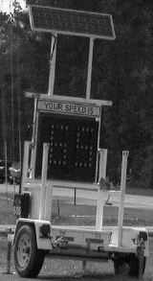
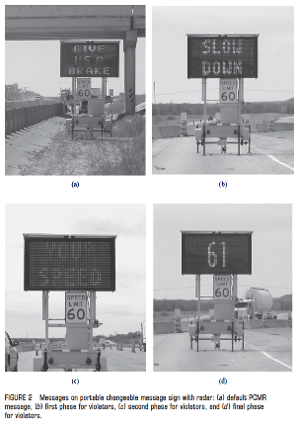

- Bullough, Skinner, Brons, and Rea, 2012

  - Study Characteristics
Item | Response
- Authors | Bullough, Skinner, Brons, and Rea
- Title | Using Lighting and Visual Information to Alter Driver Behavior
- Publication year | 2012

  - Quality Screening
Quality Criteria | Response (Yes or No)
Were the study population and the context of the study well described? | Yes
Were the exposure variables valid implementations of the conditions that they were meant to represent? | Yes
Was the outcome variable both a reliable and valid measure of the outcome of interest? | Yes

  - Study Features
Feature | Study Information
Experimental Design | O-X-O
Safety Focus | Horizontal curve
Graphic of DSFS available | Yes
Graphic of Layout available | Yes
Study restricted to free flow level of service | Yes
Classes of vehicles included | NS
Hypothesis 1 (H1) level | B
Hypothesis 2 (H2) level | B
Hypothesis 3 (H3) level | NA
H1: Mean speed | Significant reduction recorded
H1: 85th percentile speed | Nothing reported
H1: Percentage of drivers over speed limit | Nothing reported
H1: Distribution of speed | Significant reduction recorded
H2: Mean speed | Significant reduction recorded
H2: 85th percentile speed | Nothing reported
H2: Percentage of drivers over speed limit | Nothing reported
H2: Distribution of speed | Significant reduction recorded
H3: Mean speed | Nothing reported
H3: 85th percentile speed | Nothing reported
H3: Percentage of drivers over speed limit | Nothing reported
H3: Distribution of speed | Nothing reported
DSFS displays speed | No
DSFS speed lighting | Yes
DSFS flashes (speed or other) | No
Mobile DSFS units | No
Roadway type | Local
Area type (location) | Suburban
Sidewalks present | No
Posted speed | 30 mph
Sensor positions | Adjacent (328 ft)
Number of sensors | 0,1,0
Sensor types | Radar
Types of treatments | DSFS
Number of relevant sites | 1
Number of cases | 1
Duration of measurements before activation (“before” measurements) | 5 hours
Time interval between “before” measurements and activation | NS
Duration of activation | NS
Time of day when speed is measured (AM/PM) | Multiple
Time of day when speed is measured (peak/off peak) | Off peak
Time intervals at which measurements were taken during activation (“during” measurements) | NS
Amount of time that elapsed after deactivation and prior to subsequent measurements (“after” measurements) | NA
Duration of “after” measurements | NA
Meta-analysis data available | Yes
Caveats | None
Best practices information available | No

  - Summary of Study
This study examined the effectiveness of two safety countermeasures. Relevant to this literature review, it evaluated a sign with conditional messages based on driver speed. Initial tests were conducted in controlled field experiments and then follow-up evaluations studied the effectiveness in real-world conditions. The real-world test location for the sign was located along Jordan Road, a small local road within the Rensselaer Technology Park in the town of North Greenbush, New York. The sign was located on the grass adjacent to the road, and no construction work or other activity took place in the road itself during the data collection.
The light-emitting diode (LED) sign was programmed to display several conditional messages based on the speed of the approaching vehicle:
- If a vehicle is going faster than 30 mph: "REDUCE SPEED TO 25 MPH"
- If a vehicle is going between 25-30 mph: "25 MPH SPEED ZONE"
- If a vehicle is going between 20-25 mph: (No Message)
- If a vehicle is going less than 20 mph: "25 MPH SPEED ZONE"
- When no vehicles are approaching the sign it rests in a blank display.
Although the original speed limit along this road segment was 30 mph, the speed display sign was set up to encourage driving speeds of 25 mph. Approximately 328 ft. downstream from the display a member of the project team hid among several trees and an electrical junction box and measured speeds with a radar gun. Further downstream a sign alerted drivers that the speed limit reverted back to 30 mph. All measurements were taken in clear weather in the middle of the day to avoid peak rush hour. If vehicles were closely spaced, only the speed of the lead vehicle was measured to ensure independent speed measurements.
Data were collected before and during sign implementation, but the publication did not specify how much time elapsed between the measurements:
- Before: Between 10 a.m. and 3 p.m., a total of 663 vehicle speeds were measured.
- During: Between approximately 9:45 a.m. and 11:00 a.m., speeds for 108 vehicles were measured.
The measures of effectiveness were mean speed and the standard deviation of speed. The hypotheses investigated were H1B and H2B.
Data reported. Mean speeds and standard deviation, as well as histograms of speed observations.
Results. There was a statistically significant (p<0.001) reduction in the mean measured speeds during the installation test compared to the baseline conditions. The speed display messaging appeared to have the intended effect of reducing speeds closer to 25 mph (from a mean of 30 mph and a median of 33 mph), and also reduced the standard deviation of the measured speeds from 7.88 to 4.66 mph.
Statistical Analysis. The publication did not describe the statistical analysis, but it did report that results were statistically significant, implying that the researchers conducted statistical analysis.
  - Study Schematic
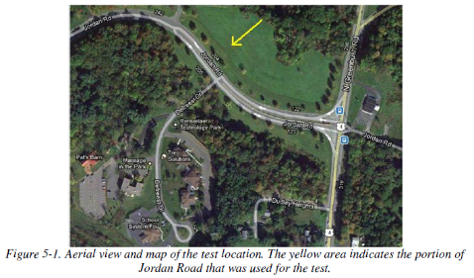
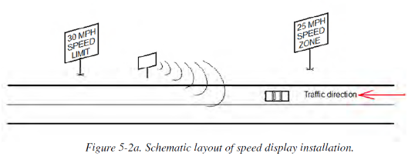

  - DSFS Graphic
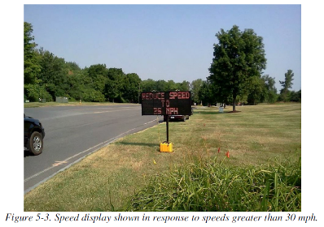

- Chang, Nolan, and Nihan, 2004

  - Study Characteristics
Item | Response
- Authors | Chang, Nolan, and Nihan
- Title | Radar Speed Signs on Neighborhood Streets: An Effective Traffic Calming Device?
- Publication year | 2004

  - Quality Screening
Quality Criteria | Response (Yes or No)
Were the study population and the context of the study well described? | Yes
Were the exposure variables valid implementations of the conditions that they were meant to represent? | Yes
Was the outcome variable both a reliable and valid measure of the outcome of interest? | Yes

  - Study Features
Feature | Study Information
Experimental Design | O-O-O-X-O-O-O
Safety Focus | Straight section
Graphic of DSFS available | No
Graphic of Layout available | No
Study restricted to free flow level of service | NS
Classes of vehicles included | NS
Hypothesis 1 (H1) level | B
Hypothesis 2 (H2) level | NA
Hypothesis 3 (H3) level | NA
H1: Mean speed | Significant reduction recorded
H1: 85th percentile speed | Reduction recorded
H1: Percentage of drivers over speed limit | NA
H1: Distribution of speed | Nothing reported
H2: Mean speed | Nothing reported
H2: 85th percentile speed | Nothing reported
H2: Percentage of drivers over speed limit | Nothing reported
H2: Distribution of speed | Nothing reported
H3: Mean speed | NA
H3: 85th percentile speed | NA
H3: Percentage of drivers over speed limit | NA
H3: Distribution of speed | NA
DSFS displays speed | NS
DSFS speed lighting | Yes
DSFS flashes (speed or other) | Yes
Mobile DSFS units | No
Roadway type | Collector
Area type (location) | Urban
Sidewalks present | NS
Posted speed | 25 mph
Sensor positions | Adjacent (0 ft)
Number of sensors | 0,1,0
Sensor types | Pneumatic
Types of treatments | DSFS
Number of relevant sites | 4
Number of cases | 4
Duration of measurements before activation (“before” measurements) | NS
Time interval between “before” measurements and activation | 15 months, 4 months, and 1 week
Duration of activation | 22 months
Time of day when speed is measured (AM/PM) | NS
Time of day when speed is measured (peak/off peak) | NS
Time intervals at which measurements were taken during activation (“during” measurements) | 1, 7, and 22 months
Amount of time that elapsed after deactivation and prior to subsequent measurements (“after” measurements) | NA
Duration of “after” measurements | NA
Meta-analysis data available | Yes
Caveats | No
Best practices information available | No

  - Summary of Study
Dynamic speed feedback signs (DSFS) were installed on both sides of a straight 2-lane minor (collector) arterial with long sight lines and "some vertical sight distance concerns" in the state of Washington. The site, 108th Avenue NE, was urban. There are 10+ local streets intersecting the roadway, which sees average daily traffic volumes of 2,700 on the north end and 4,900 on the south end. The roadway is ~1400 yards (.8 miles) long, terminating at intersecting roads on both ends. The entire roadway has a posted speed limit of 25 mph. Defining Location 1 as that of the first sensor and setting it at 0 feet, Locations 2, 3 and 4 for the second, third and fourth sensors heading northbound were at 900 feet, 2,500 feet and 3,300 feet. The independent variables were the side of the roadway (northbound or southbound) and the time of measurement -- three times before activation (April 2001, Feburary and early June 2002) and four times after activation (late June and August 2002, January 2003, April 2004). Measures were taken of the mean speed and 85th percentile speed at two locations north bound and two locations southbound. Two DSFSs were installed on the northbound side and two on the southbound side. On the northbound side, the first DSFF was located at approximately 400 feet and the second DSFS was located at approximately 2,600 feet. On the southbound side, the first DSFS encountered was located at approximately 3,200 feet and the second DSFS was located at approximately 1,300 feet. The measures were gathered before (~1 week, 4 months, 15 months) and during (~1 week, 2 months, 7 months, 22 months) the time that the DSFS was activated. There were no measurements after the DSFS was removed. For the northbound side, the measures were taken at Location 1 (400 upstream of the first northbound DSFS) and Location 3 (2,100 feet downstream of the first DSFS and 100 feet before the second northbound DSFS). For the southbound side, the measures were taken at Location 4 (200 feet upstream of the first southbound DSFS) and Location 2 (1,600 feet downstream of the first southbound DSFS and 400 feet downstream of the second DSFS). The major hypothesis was H1B.
Data Reported. Data were reported for each of the two locations on the northbound and southbound sides at each point in time before and during the activation for both dependent variables. Additionally, the traffic volume and standard deviation were reported for the before and during periods. Finally, the mean speed at all four locations along with the sample size and standard deviation were reported.
Results. The mean speed was averaged over the three before periods and the four during periods and compared using a z test. At three of the four locations (one northbound and two southbound), the change was statistically significant. These sites showed a decrease in mean speed of 1.19 to 2.21 mph. The fourth site showed a statistically significant increase in mean speed, of .51 mph. There was a statistically significant (p<.05) decrease in volume at one site. The authors did not report a similar analysis of the 85th percentile speeds, but one can easily obtain descriptive statistics. At the near and far downstream northbound sensor locations, the reductions in 85th percentile speed were respectively -1.90 and -1.30 mph. In the near and far downstream southbound sensor locations, the reductions in speed were respectively -1.60 and -1.00 mph.
Statistical Analysis. The researchers determined whether observed differences were statistically significant at the 0.05 level of significance.
  - Study Schematic
Not provided.
  - DSFS Graphic
Not provided.

- Cruzado and Donnell, 2009

  - Study Characteristics
Item | Response
- Authors | Cruzado
- Title | Evaluating Effectiveness of Dynamic Speed Display Signs in Transition Zones of Two-Lane, Rural Highways in Pennsylvania
- Publication year | 2009

  - Quality Screening
Quality Criteria | Response (Yes or No)
Were the study population and the context of the study well described? | Yes
Were the exposure variables valid implementations of the conditions that they were meant to represent? | Yes
Was the outcome variable both a reliable and valid measure of the outcome of interest? | Yes

  - Study Features
Feature | Study Information
Experimental Design | O-X-O
Safety Focus | Transition zone
Graphic of DSFS available | Yes
Graphic of Layout available | Yes
Study restricted to free flow level of service | Yes
Classes of vehicles included | Passenger cars
Hypothesis 1 (H1) level | A
Hypothesis 2 (H2) level | C'
Hypothesis 3 (H3) level | A'
H1: Mean speed | Significant reduction recorded after 1 week. Nothing reported for the 2 sites at 2 weeks.
H1: 85th percentile speed | Nothing reported
H1: Percentage of drivers over speed limit | Nothing reported
H1: Distribution of speed | Nothing reported
H2: Mean speed | Nothing reported
H2: 85th percentile speed | Nothing reported
H2: Percentage of drivers over speed limit | Nothing reported
H2: Distribution of speed | Nothing reported
H3: Mean speed | Significant increase recorded. Nothing reported for the 2 sites at 2 weeks.
H3: 85th percentile speed | Nothing reported
H3: Percentage of drivers over speed limit | Nothing reported
H3: Distribution of speed | Nothing reported
DSFS displays speed | Yes
DSFS speed lighting | LED
DSFS flashes (speed or other) | NS
Mobile DSFS units | Yes
Roadway type | Arterial
Area type (location) | Rural
Sidewalks present | NS
Posted speed | 45-55 mph before transition; 25-35 mph after transition; reductions could be as much as 20 mph and as little as 15 mph
Sensor positions | Upstream (-0.5 mile); adjacent (0 ft); downstream (500 ft)
Number of sensors | 1,1,1
Sensor types | Other
Types of treatments | DSFS
Number of relevant sites | 12
Number of cases | 12
Duration of measurements before activation (“before” measurements) | NS
Time interval between “before” measurements and activation | NS
Duration of activation | 1 week for 10 of the sites and 2 weeks for 2 of the sites
Time of day when speed is measured (AM/PM) | Weekdays
Time of day when speed is measured (peak/off peak) | Off peak
Time intervals at which measurements were taken during activation (“during” measurements) | 1 week
Amount of time that elapsed after deactivation and prior to subsequent measurements (“after” measurements) | 0
Duration of “after” measurements | 1 week
Meta-analysis data available | Yes
Caveats | No
Best practices information available | No

  - Summary of Study
Dynamic feedback speed signs (DSFS) were installed at 12 sites in rural Pennsylvania. The sites included both curved and straight sections of roadway where a transition was being made from a two lane highway to a rural community. The traffic was freely flowing. The posted speed limits of the highway upstream of the transition zone were between 45 mph and 55 mph. The posted speed limits in the transition zone were between 25 mph and 35 mph. Measures were taken of the mean speed, the 85th percentile speed, and the percentage of vehicles exceeding the speed limit for 0.5 mile upstream of the DSFS, at the DSFS, and 500 feet downstream of the DSFS (12 sites total). The measures were gathered before (1 week), during (1 and 2 weeks for 2 of the 12 sites) and after (1 and 2 weeks for 2 of the 12 sites) the DSFS was activated. The independent variables included the site (1 of 12) and the time of measurement (before, during, and after activation of the DSFS). The dependent variables included the mean speed, 85th percentile speed, and percentage of vehicles exceeding speed limit. Three major hypotheses were evaluated: H1A, H2C’, and H3A’. The mean speeds before, during, and after are reported at each of the 12 sites for the sensors upstream, adjacent, and downstream (and for 2 of the 12 sensors, 2 weeks of during and 2 weeks of after data are reported). Overall information was also reported on the 85th percentile speeds and the percentage of drivers exceeding the speed limit.
Results. H1A: There was a statistically significant decrease in the mean speeds at 11 of the 12 sites. The average decrease across all sites was -6.23 mph. H2C’: At six of the 12 sites, the mean speeds downstream of the DSFS were 1 mph or less (no significance tests reported). No statistical tests were reported. H3A’: There was a statistically significant increase in the mean speed after deactivation of the DSFS compared to the period when the DSFS was activated. The average increase across all 12 sites was 6.58 mph. Additional Results. At both the DSFS and the downstream locations, the 85th percentile speeds were lower when the DSFS was activated, but increased to the before period after deactivation. The same pattern was observed for the percentage of vehicles exceeding the speed limit. At six of the 12 sites the mean speeds at the downstream sensor differed by less than one mph from the sensor at the DSFS when the DSFS was activated. At the remaining six sites the mean speeds were greater than one mph at the two sensors.
Statistical Analysis. Two sample t-tests were used to determine whether differences were significant. As best we can tell, for the analysis of the activation effect at the DSFS the authors took the difference for each vehicle between the speed at the upstream sensor and the DSFS sensor and so had one observation for each vehicle before activation and one observation per vehicle during activation. They then evaluated whether the two differences were statistically significantly different from each other using a between-subjects t-test (H1A). They did the same thing for the deactivation effect (H3A’).

  - Study Schematic
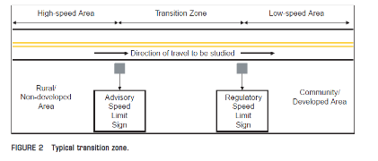

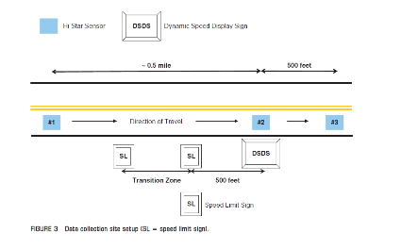

DSFS Graphic
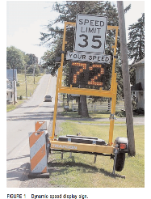

- Drakopoulos, Uprety, and Vergou, 2003

  - Study Characteristics
Item | Response
Authors | Drakopoulos, Uprety, and Vergou
Title | I-43 Speed Warning Sign Evaluation
Publication year | 2003

  - Quality Screening
Quality Criteria | Response (Yes or No)
Were the study population and the context of the study well described? | Yes
Were the exposure variables valid implementations of the conditions that they were meant to represent? | Yes
Was the outcome variable both a reliable and valid measure of the outcome of interest? | Yes

  - Study Features
Feature | Study Information
Experimental Design | O-X-O
Safety Focus | Horizontal curve
Graphic of DSFS available | Yes
Graphic of Layout available | Yes
Study restricted to free flow level of service | Yes
Classes of vehicles included | Passenger cars and trucks
Hypothesis 1 (H1) level | NA
Hypothesis 2 (H2) level | A,B
Hypothesis 3 (H3) level | NA
H1: Mean speed | Nothing reported
H1: 85th percentile speed | Nothing reported
H1: Percentage of drivers over speed limit | Nothing reported
H1: Distribution of speed | Nothing reported
H2: Mean speed | Significant reduction only for semi-trucks that activated the sign
H2: 85th percentile speed | Nothing reported
H2: Percentage of drivers over speed limit | Nothing reported
H2: Distribution of speed | Nothing reported
H3: Mean speed | Nothing reported
H3: 85th percentile speed | Nothing reported
H3: Percentage of drivers over speed limit | Nothing reported
H3: Distribution of speed | Nothing reported
DSFS displays speed | No
DSFS speed lighting | Yes
DSFS flashes (speed or other) | Yes
Mobile DSFS units | No
Roadway type | Freeway
Area type (location) | Urban
Sidewalks present | No
Posted speed | 50 mph
Sensor positions | Upstream (-515 ft) and downstream (345 ft)
Number of sensors | 1,0,1
Sensor types | Multiple (laser and inductive loop)
Types of treatments | DSFS
Number of relevant sites | 1
Number of cases | 1
Duration of measurements before activation (“before” measurements) | 1 week
Time interval between “before” measurements and activation | 1 week
Duration of activation | 1 week
Time of day when speed is measured (AM/PM) | AM
Time of day when speed is measured (peak/off peak) | Multiple
Time intervals at which measurements were taken during activation (“during” measurements) | Entire duration
Amount of time that elapsed after deactivation and prior to subsequent measurements (“after” measurements) | NA
Duration of “after” measurements | NA
Meta-analysis data available | Yes
Caveats | None
Best practices information available | No

  - Summary of Study
The study evaluated the effectiveness of a DSFS installed on a sign bridge over I-43 in urban Milwaukee County, Wisconsin, 345 feet upstream of a curve (point of curvature). The DSFS relied on system detectors another 515 feet upstream of the DSFS sign. These detectors recorded each vehicle’s weight, speed, and vehicle class. If the vehicle exceeded a predetermined threshold for its class (based on weight and speed), the sign would show the message “TOO FAST FOR CURVE” and flash. The speed limit was 50 mph.
Researchers used laser guns to collect speed data at the point of curvature for the curve. Mean speed was the only speed-related measure of effectiveness evaluated in the study. “Before” data were collected over a period of one week. The sign was installed, and then “during” data were collected over a period of one week. Data were collected in the morning during daylight hours, and speeds were recorded 515 feet upstream of the DSFS and 345 feet downstream of the DSFS (at the point of curvature of the curve).
The study evaluated four hypotheses (collectively classified as H2A and H2B, but differentiating between target and non-target populations):
- The speeds of vehicles that activated the sign would decrease downstream of the DSFS.
- The speeds of vehicles that activated the sign would remain the same upstream of the DSFS.
- The speeds of vehicles that did not activate the sign would remain unchanged downstream of the DSFS.
- The speeds of vehicles that did not activate the sign would remain unchanged upstream of the DSFS.
Data reported. Mean speeds, sample sizes, and standard deviations were reported separately for various vehicle types, and for vehicles that activated the sign versus those that did not.
Results. The overall traffic speeds did not show any perceptible change from the “before” to the “during” condition. However, speeds at the point of curvature were lower by 3.2 mph for semi-trucks that activated the sign (statistically significant at the 0.05 level of significance). Speed reductions were also documented for other vehicle types that activated the sign, but these findings were tentative due to small sample sizes.
Statistical Analysis. The researchers determined whether observed differences were statistically significant at the 0.05 level of significance.

  - Study Schematic
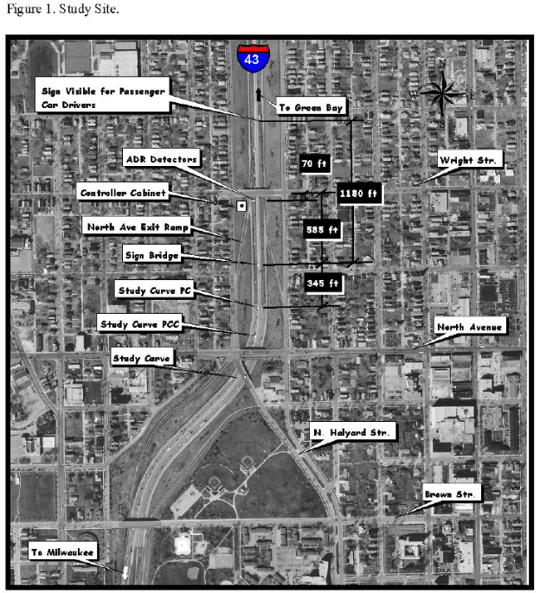

DSFS Graphic
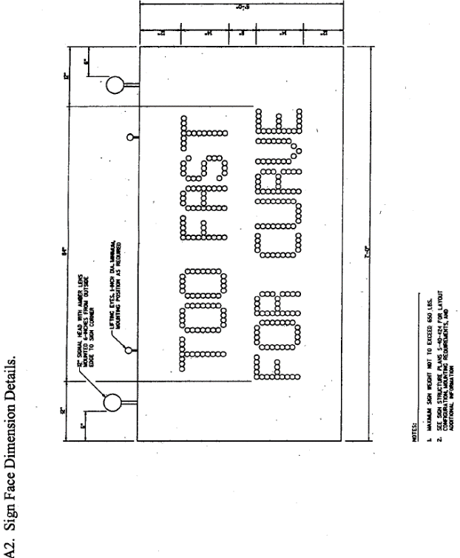
- City of Englewood, Colorado, 2014

  - Study Characteristics
Item | Response
- Authors | City of Englewood, Colorado
- Title | City of Englewood, CO: Recent Accomplishments
- Publication year | 2014

  - Quality Screening
Quality Criteria | Response (Yes or No)
Were the study population and the context of the study well described? | Yes
Were the exposure variables valid implementations of the conditions that they were meant to represent? | Yes
Was the outcome variable both a reliable and valid measure of the outcome of interest? | Yes

  - Study Features
Feature | Study Information
Experimental Design | O-X-O
Safety Focus | Straight section
Graphic of DSFS available | Yes
Graphic of Layout available | No
Study restricted to free flow level of service | NS
Classes of vehicles included | NS
Hypothesis 1 (H1) level | B
Hypothesis 2 (H2) level | NA
Hypothesis 3 (H3) level | NA
H1: Mean speed | Nothing reported
H1: 85th percentile speed | Reduction recorded
H1: Percentage of drivers over speed limit | Nothing reported
H1: Distribution of speed | Nothing reported
H2: Mean speed | NA
H2: 85th percentile speed | NA
H2: Percentage of drivers over speed limit | NA
H2: Distribution of speed | NA
H3: Mean speed | NA
H3: 85th percentile speed | NA
H3: Percentage of drivers over speed limit | NA
H3: Distribution of speed | NA
DSFS displays speed | Yes
DSFS speed lighting | Yes
DSFS flashes (speed or other) | Yes
Mobile DSFS units | No
Roadway type | Local
Area type (location) | Rural
Sidewalks present | Yes
Posted speed | 30 mph
Sensor positions | NS
Number of sensors | 1
Sensor types | NS
Types of treatments | DSFS
Number of relevant sites | 6
Number of cases | 6
Duration of measurements before activation (“before” measurements) | NS
Time interval between “before” measurements and activation | NS
Duration of activation | NS
Time of day when speed is measured (AM/PM) | NS
Time of day when speed is measured (peak/off peak) | NS
Time intervals at which measurements were taken during activation (“during” measurements) | 2 months, 3 years
Amount of time that elapsed after deactivation and prior to subsequent measurements (“after” measurements) | NA
Duration of “after” measurements | NA
Meta-analysis data available | Yes
Caveats | No sample sizes
Best practices information available | No

  - Summary of Study
This report summarized the effectiveness of implemented safety measures; one part of this involved DSFS installed at several residential locations. No sample sizes or significance levels were reported. Stationary DSFS were installed at two locations in 2003 (Quincy Ave. and Logan St) and two locations in 2005 (E. Dartmouth Ave. and Oxford Ave.) All locations had speed limits of 30 mph. The Dartmouth and Oxford locations received signs for both eastbound and westbound traffic, comprising four data sets. Follow up speed studies were conducted in 2006 and found that 85th percentile speeds decreased at all sites. Additionally, mean and 85th percentile speed data is reported for Dartmouth two months after installation and compared to speed data before installation. A DSFS was installed at one additional site, Inca St, but no results are reported for this location.
Data Reported. The article reported 85th percentile speeds for 6 sites and mean speed for 2 sites (one location, eastbound and westbound). For one site, Inca Street, no data was reported.
Results. The 85th percentile speed results show decreases at all six sites when comparing before and after. No significance is reported. The results from Dartmouth two months after installation were inconsistent: the westbound sign found decreases in both mean (33 to 27 mph) and 85th percentile speed (36 to 30mph); the eastbound sign found increases in both (30 to 32 and 34 to 35).
Statistical Analysis. No statistical analysis was discussed.
  - Study Schematic
Not provided
  - DSFS Graphic

- Fontaine, 2001

  - Study Characteristics
Item | Response
- Authors | Fontaine
- Title | Evaluation Of Speed Displays And Rumble Strips At Rural-Maintenance Work Zones
- Publication year | 2001

  - Quality Screening
Quality Criteria | Response (Yes or No)
Were the study population and the context of the study well described? | Yes
Were the exposure variables valid implementations of the conditions that they were meant to represent? | Yes
Was the outcome variable both a reliable and valid measure of the outcome of interest? | Yes

  - Study Features
Feature | Study Information
Experimental Design | O-X-O
Safety Focus | Work zone
Graphic of DSFS available | Yes
Graphic of Layout available | Yes
Study restricted to free flow level of service | Yes
Classes of vehicles included | Passenger cars and trucks
Hypothesis 1 (H1) level | B
Hypothesis 2 (H2) level | B
Hypothesis 3 (H3) level | NA
H1: Mean speed | Significant reduction for trucks at 1/2 sites, insignificant reduction for trucks at 1/2 sites, insignificant reduction for cars at 2/2 sites
H1: 85th percentile speed | Nothing reported
H1: Percentage of drivers over speed limit | Significant reduction for trucks and cars at 1/2 sites, insignificant reduction for cars at 1/2 sites, No change for trucks at 1/2 sites
H1: Distribution of speed | Nothing reported
H2: Mean speed | Significant reduction for trucks at 2/2 sites,significant reduction for cars at 1/2 sites, insignificant reduction for cars at 1/2 site
H2: 85th percentile speed | Nothing reported
H2: Percentage of drivers over speed limit | No change for trucks at 2/2 sites, for cars at 1/2 sites; significant decrease for cars at 1/2 sites.
H2: Distribution of speed | Nothing reported
H3: Mean speed | Nothing reported
H3: 85th percentile speed | Nothing reported
H3: Percentage of drivers over speed limit | Nothing reported
H3: Distribution of speed | Nothing reported
DSFS displays speed | Yes
DSFS speed lighting | LED
DSFS flashes (speed or other) | Yes
Mobile DSFS units | Yes
Roadway type | Freeway
Area type (location) | Rural
Sidewalks present | No
Posted speed | 70 mph
Sensor positions | Upstream(-3077 or -1310 ft); adjacent (-321 or -416 ft); downstream (437 or 578 ft and 1482 or 3112 ft)
Number of sensors | 1, 1, 2
Sensor types | NS
Types of treatments | DSFS
Number of relevant sites | 2
Number of cases | 2
Duration of measurements before activation (“before” measurements) | Half day
Time interval between “before” measurements and activation | Unclear - 0 hours to half a day
Duration of activation | half day
Time of day when speed is measured (AM/PM) | day
Time of day when speed is measured (peak/off peak) | Multiple
Time intervals at which measurements were taken during activation (“during” measurements) | NA
Amount of time that elapsed after deactivation and prior to subsequent measurements (“after” measurements) | NA
Duration of “after” measurements | NA
Meta-analysis data available | No
Caveats | No sample size or standard deviation, Not possible to calculate effrect size
Best practices information available | No

  - Summary of Study
Dynamic speed feedback signs (DSFS) were installed at four rural highway work zone sites in Texas. However, only two of these sites involved a DSFS treatment (at first no controls were in place, then standard work zone traffic controls, and then the DSFS was installed). The remaining two sites followed the same pattern, but with rumble strips as the last intervention instead of DSFS. The posted speed was 70 mph at all sites. Measures were taken of the mean speed and fraction of drivers exceeding the speed limit. Four sensors collected data at each site: an upstream sensor before the DSFS was visible, a sensor “at” the DSFS (321 or 416 feet upstream, but within sight of the DSFS), a near downstream sensor (578 or 437 feet after the DSFS), and a far downstream sensor (1482 or 3112 feet after the DSFS). The far downstream sensor is closest to the work zone, in both cases, and thus is the sensor we use to evaluate H2. Each site additionally had a fifth sensor placed that malfunctioned; one was upstream, one downstream. The measures were gathered before and during the time that the DSFS was activated. There were no measurements after the DSFS was removed. All measurements were taken over the course of a single day, with the DSFS activated around midday. Data were analyzed for each location. All DSFS displayed the speed via LED as well as having a flashing strobe when speeding 5+mph over the limit. Independent variables were as follows: treatment and vehicle type. Dependent variables were as follows: mean speeds and percentage of the sample exceeding the speed limit. The major hypotheses were H1B and H2B. The article reported mean speeds, percent of drivers exceeding the speed limit, and whether these changes were significant for each sensor location. It did not provide sample size, variance, or standard deviation.
Results. For H1, mean speed dropped significantly for trucks at one site, by 9.4mph. Mean speed dropped insignificantly for trucks at the other site, and dropped insignificantly for cars at both sites. For H2, mean speed dropped significantly for trucks at both sites, by 7.1 and 9.9 mph. Mean speed dropped significantly for cars at one site, by 9.0 mph, and dropped insignificantly for cars at one site.
For H1, the percent of drivers over the speed limit dropped significantly for both cars and trucks at one site, by 18 and 16% respectively; there were no significant changes at the other site. For H2, the percent of drivers over the speed limit dropped significantly for cars at one site, by 20%, but not for trucks. There were no significant changes at the other site.
Statistical Analysis. Authors conducted Chi-square testing and identified the significant results (when comparing the DSFS treatment to “Normal Traffic Control”). Details of the statistical testing were not provided.
  - Study Schematic
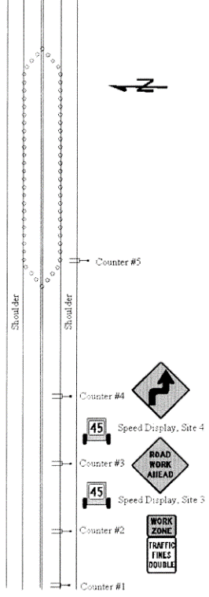
  - DSFS Graphic

- Fontaine, 2008

  - Study Characteristics
Item | Response
Authors | Fontaine
Title | Innovative Traffic Control Devices for Improving Safety at Rural Short-Term Maintenance Work Zones
Publication year | 2008

  - Quality Screening
Quality Criteria | Response (Yes or No)
Were the study population and the context of the study well described? | Yes
Were the exposure variables valid implementations of the conditions that they were meant to represent? | Yes
Was the outcome variable both a reliable and valid measure of the outcome of interest? | Yes

  - Study Features
Feature | Study Information
Experimental Design | O-X-O
Safety Focus | Work zone
Graphic of DSFS available | Yes
Graphic of Layout available | No
Study restricted to free flow level of service | NS
Classes of vehicles included | Passenger cars and trucks
Hypothesis 1 (H1) level | B
Hypothesis 2 (H2) level | B
Hypothesis 3 (H3) level | NA
H1: Mean speed | Reduction recorded, but no information on statistical significance.
H1: 85th percentile speed | Nothing reported
H1: Percentage of drivers over speed limit | Reduction recorded, but no information on statistical significance.
H1: Distribution of speed | Nothing reported
H2: Mean speed | Reduction recorded, but no information on statistical significance.
H2: 85th percentile speed | Nothing reported
H2: Percentage of drivers over speed limit | Reduction recorded, but no information on statistical significance.
H2: Distribution of speed | Nothing reported
H3: Mean speed | Nothing reported
H3: 85th percentile speed | Nothing reported
H3: Percentage of drivers over speed limit | Nothing reported
H3: Distribution of speed | Nothing reported
DSFS displays speed | Yes
DSFS speed lighting | Yes
DSFS flashes (speed or other) | NS
Mobile DSFS units | Yes
Roadway type | Freeway
Area type (location) | Rural
Sidewalks present | No
Posted speed | 70 mph
Sensor positions | NS
Number of sensors | 0,1,1
Sensor types | Lidar
Types of treatments | DSFS
Number of relevant sites | 4
Number of cases | 4
Duration of measurements before activation (“before” measurements) | Half day
Time interval between “before” measurements and activation | Immediately before
Duration of activation | Half day
Time of day when speed is measured (AM/PM) | Multiple
Time of day when speed is measured (peak/off peak) | NS
Time intervals at which measurements were taken during activation (“during” measurements) | Half day
Amount of time that elapsed after deactivation and prior to subsequent measurements (“after” measurements) | NA
Duration of “after” measurements | NA
Meta-analysis data available | No
Caveats | NA
Best practices information available | No

  - Summary of Study
This study evaluated the safety effectiveness of traffic control devices at short-term, rural, highway maintenance work zones in north Texas. The study evaluated speed display trailers, radar drones, and three other strategies. The speed display trailer detected speeds with radar and displayed them to drivers with light-emitting diode (LED) numerals 24-inches in height. It also had a strobe light that flashed when vehicles were detected traveling more than 5 mph over the speed limit. All test sites had 70 mph posted regulatory speed limits and level grades. A mix of four lane and two lane sites were evaluated, and the length of the activity area at these sites was typically between ¼ and ½ mile. In all cases, the work sites were only in place during daylight hours for a single day. Over the first half of the day data were collected before implementing the speed display trailer. Mid-way through the day researchers activated the speed display trailer and began collecting “during” data. The speed display trailer was evaluated at four sites. Researchers used LIDAR guns to measure vehicle speeds.
In addition to measuring speeds, researchers videotaped the area to examine conflicts between vehicles, such as late merges, sudden braking maneuvers, or other actions that caused surrounding vehicles to brake or perform evasive action. They also interviewed workers at the job site to ask about the usability of the devices for short-term operations. Finally, they interviewed some drivers to determine their opinions on the measures being evaluated.
The measures of effectiveness were mean speed and the percent of vehicles exceeding the speed limit. The hypotheses investigated were H1B and H2B.
Data reported. Mean speeds and percent of vehicles exceeding the speed limit.
Results. In general, the speed trailer was effective in reducing vehicle speeds at all four sites. Mean speeds were reduced by an average of 5.2 mph within the advance warning area for both cars and large trucks. Speed reductions were slightly less within the activity area of the work zone.
Statistical Analysis. No information on statistical significance or statistical analysis was provided.
  - Study Schematic
Not provided.
  - DSFS Graphic
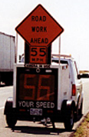
- Gambatese and Zhang, 2014

  - Study Characteristics
Item | Response
- Authors | Gambatese and Zhang
- Title | Safe and Effective Speed Reductions for Freeway Work Zones Phase 2
- Publication year | 2014

  - Quality Screening
Quality Criteria | Response (Yes or No)
Were the study population and the context of the study well described? | Yes
Were the exposure variables valid implementations of the conditions that they were meant to represent? | Yes
Was the outcome variable both a reliable and valid measure of the outcome of interest? | Yes

  - Study Features
Feature | Study Information
Experimental Design | O-X-O-X-O-X-O-X-O-X-O-X-O
Safety Focus | Work zone
Graphic of DSFS available | No
Graphic of Layout available | No
Study restricted to free flow level of service | Yes
Classes of vehicles included | Passenger cars and trucks
Hypothesis 1 (H1) level | B
Hypothesis 2 (H2) level | na
Hypothesis 3 (H3) level | na
H1: Mean speed | No change
H1: 85th percentile speed | Reduction recorded for case study 2 (only when DSFS combined with PCMS). Otherwise, No change for DSFS or PCMS alone.
H1: Percentage of drivers over speed limit | Nothing reported
H1: Distribution of speed | Significant reduction recorded for case study 2 (only when DSFS combined with PCMS). Otherwise, No change for DSFS or PCMS alone.
H2: Mean speed | NA
H2: 85th percentile speed | NA
H2: Percentage of drivers over speed limit | NA
H2: Distribution of speed | NA
H3: Mean speed | NA
H3: 85th percentile speed | NA
H3: Percentage of drivers over speed limit | NA
H3: Distribution of speed | NA
DSFS displays speed | Yes
DSFS speed lighting | NS
DSFS flashes (speed or other) | NS
Mobile DSFS units | Yes
Roadway type | Freeway
Area type (location) | Rural
Sidewalks present | No
Posted speed | 50 mph
Sensor positions | Upstream (-2 miles, -1 mile); within work zone (every 0.5 miles)
Number of sensors | 4,6,0
Sensor types | Multiple (magnetic imaging supplemented with radar and video)
Types of treatments | DSFS + other (portable changeable message sign with no speed feedback)
Number of relevant sites | 2
Number of cases | 2
Duration of measurements before activation (“before” measurements) | 8 hours
Time interval between “before” measurements and activation | 1 day
Duration of activation | 8 hours
Time of day when speed is measured (AM/PM) | PM (night)
Time of day when speed is measured (peak/off peak) | Off peak
Time intervals at which measurements were taken during activation (“during” measurements) | 1,2,3,4,5,6,7,8 hours
Amount of time that elapsed after deactivation and prior to subsequent measurements (“after” measurements) | NA
Duration of “after” measurements | NA
Meta-analysis data available | Yes
Caveats | The study Noted some methodological problems and unanticipated confounding factors.
Best practices information available | Yes

  - Summary of Study
The research study included two case studies on multi-lane freeway paving projects in rural Oregon. For each case study, the researchers implemented combinations of multiple traffic control devices (speed limit signs, portable changeable message signs (PCMS), and (DSFS)) and evaluated their impacts on vehicle speed. For both case studies the posted speed limit was 50 mph within the work zone, and the paving work and associated experiments took place at night. In both cases researchers investigated multiple interventions (speed limit sign, portable changeable message sign, and DSFS) and all possible combinations of those three.
Case study 1 was located in Douglas County Oregon in a mountainous area with sharp curves and steep grades. Researchers noted in retrospect that on some of the test days, the slow speeds recorded may not be the result of the traffic control treatments employed for the research. The slow speeds may be solely due to the grade, roadway curves, and presence of slow trucks. In total, researchers collected data over seven days, but they could not compare or aggregate data across all seven days because the location of the road segment varied. Instead, they did three separate analyses grouping only the days with the same location. The first grouping (days 1, 2, 3) and third grouping (days 6, 7) are most relevant in that they included DSFS as one of the interventions.
Case study 2 was located on I-5 between Grants Pass and Medford. The roadway in this section of I-5 is predominantly straight and almost flat with no grade or horizontal curve impacts on vehicle speed.
The data collection equipment and procedures were similar for both case studies. Measures were taken of the mean speed and 85th percentile speed. The measurement period for each treatment condition was approximately 8 hours, overnight, with one day in between each treatment condition and associated measurement period. Researchers primarily used 10 magnetic imaging sensors at seven locations, but also supplemented this with radar speed guns and video recording. The ten magnetic imaging sensors were placed on the roadway for each work period (night of paving). The first two analyzers were placed approximately 1 mile upstream of the “Road Work Ahead” sign to capture vehicle speeds before the vehicles became aware of the work zone. Two analyzers were placed near the “Road Work Ahead” sign, which is typically approximately one mile upstream of the actual work area. Two analyzers were placed at the beginning of the lane taper at the start of the work zone, and one analyzer was placed at the end of taper. Three analyzers were placed in the traveling lane at different points in the work zone. According to the study, the actual location and spacing of the last three analyzers in the work zone was dependent on the amount and location of work being performed on the given night.
When the portable changeable message signs (PCMS) on trailers and DSFS were used, they were typically initially located after the end of the taper and before the start of the paving area. Later in the work shift, as the paving work progressed downstream, these traffic control measures were not as close to the work activity, so the contractors moved the measures downstream in the middle of the night. However, researchers noted that the timing of when these were moved and the new location relative to the paver were not consistent from one day to the next; this inconsistency may have confounded some of the results.
The DSFS displayed the speed, but the study did not specify the method of illumination or the presence/absence of flashing.
Independent variables were as follows: treatment (traffic control devices), vehicle length, time of day, and distance from paving work. Dependent variables were as follows: mean speed, 85th percentile speed. The major hypothesis evaluated was H1B.
Data Reported. The article reported mean speeds, 85th percentile speeds, sample sizes, standard deviations, and whether or not observed changes in mean speeds and 85th percentile speeds were statistically significant.
Results. The DSFS did not cause a statistically significant reduction in mean speed. In some cases there was actually an increase in mean speeds, but the researchers surmise that this may have related to confounding factors that they did not originally anticipate. On Day 3 of case study 1 (the only day with the DSFS), the contractor paved the roadway shoulder and fully closed the slow lane, moving the passing traffic farther away from the actual work taking place. One may expect that the vehicle speeds would be greater in this case than if the work were directly adjacent the travel lane. That is, when a closed, “buffer” lane is provided, vehicle speeds tend to increase. In case study 2, the DSFS similarly did not cause a statistically significant reduction in mean speed. However, the combination of DSFS with PCMS did result in a statistically significant reduction in the 85th percentile speed, as well as a reduction in the standard deviation.
Statistical Analysis. Two sample t-tests were applied to compare speeds.
  - Study Schematic
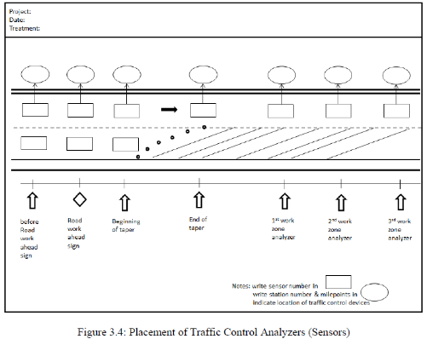

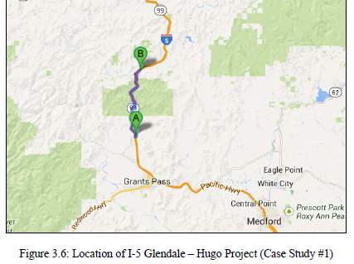

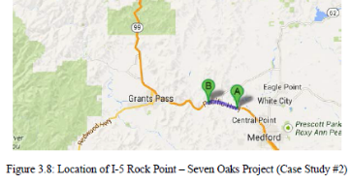

  - DSFS Graphic
Not available

- Gambatese and Jafarnejad, 2015

  - Study Characteristics
Item | Response
Authors | Gambatese and Jafarnejad
Title | Evaluation of Radar Speed Display for Mobile Maintenance Operations
Publication year | 2015

  - Quality Screening
Quality Criteria | Response (Yes or No)
Were the study population and the context of the study well described? | Yes
Were the exposure variables valid implementations of the conditions that they were meant to represent? | Yes
Was the outcome variable both a reliable and valid measure of the outcome of interest? | Yes

  - Study Features
Feature | Study Information
Experimental Design | O-X-O
Safety Focus | Work zone
Graphic of DSFS available | Yes
Graphic of Layout available | No
Study restricted to free flow level of service | No
Classes of vehicles included | Passenger cars and trucks
Hypothesis 1 (H1) level | B
Hypothesis 2 (H2) level | NA
Hypothesis 3 (H3) level | NA
H1: Mean speed | Significant reduction recorded
H1: 85th percentile speed | Nothing reported
H1: Percentage of drivers over speed limit | Significant reduction recorded
H1: Distribution of speed | Nothing reported
H2: Mean speed | Nothing reported
H2: 85th percentile speed | Nothing reported
H2: Percentage of drivers over speed limit | Nothing reported
H2: Distribution of speed | Nothing reported
H3: Mean speed | Nothing reported
H3: 85th percentile speed | Nothing reported
H3: Percentage of drivers over speed limit | Nothing reported
H3: Distribution of speed | Nothing reported
DSFS displays speed | Yes
DSFS speed lighting | LED
DSFS flashes (speed or other) | No
Mobile DSFS units | Yes
Roadway type | Freeway
Area type (location) | Multiple
Sidewalks present | No
Posted speed | 55 mph
Sensor positions | Upstream (NS); within work zone (varied)
Number of sensors | 1,5-6,0
Sensor types | Multiple (magnetic imaging, radar, and video)
Types of treatments | DSFS (intermittent mobile operations with frequent stops) and DSFS (continuous mobile operations)
Number of relevant sites | 4
Number of cases | 8
Duration of measurements before activation (“before” measurements) | Case 1: 3 hours. Case 2: 35 minutes. Case 3: 48 minutes. Case 4: 1 hour
Time interval between “before” measurements and activation | Case 1: 1 day. Case 2: 20 minutes. Case 3: 1 day. Case 4: 40 minutes
Duration of activation | Case 1: 3 hours. Case 2: 23 minutes. Case 3: 77 minutes. Case 4:1 hour
Time of day when speed is measured (AM/PM) | Multiple (night for case studies 1-3,Day-AM for case study 4)
Time of day when speed is measured (peak/off peak) | Multiple
Time intervals at which measurements were taken during activation (“during” measurements) | Entire duration
Amount of time that elapsed after deactivation and prior to subsequent measurements (“after” measurements) | NA
Duration of “after” measurements | NA
Meta-analysis data available | Yes
Caveats | None
Best practices information available | Yes, but dispersed throughout the report

  - Summary of Study
This research study evaluated the impact of truck-mounted DSFS on vehicle speeds in mobile maintenance work zones. Within a mobile maintenance work zone, the truck moves with a low speed (usually 5-10 mph) behind the maintenance equipment conducting the work to provide warning to approaching vehicles about the work zone and to advise a decrease in speed. Thus, this research was unique from most other papers in that the location of the DSFS within the study areas was not fixed; it moved with the truck throughout the work zone over the course of the observation periods.
The research study includes four case studies on multi-lane freeway maintenance projects in Oregon. The first two case studies were located at the same site. The first three studies were in the Portland metropolitan area (urban) and involved night operations and the fourth was in the Klamath Falls area (rural) and involved daytime operations. In all cases the speed limit was 55 mph. The case studies were as follows:
- Site 1 (I-205):
  - Case Study #1: Relamping, i.e. an intermittent mobile operation involving frequent short stops near each light pole with a complete lane closure
  - Case Study #2: Sweeping, i.e. a continuously moving mobile operation without a complete lane closure
- Site 2 (I-84 Banfield Expressway), Case Study #3: Vactoring, i.e., an intermittent mobile operation involving frequent short stops cleaning the drains along the right shoulder of the roadway, without a complete lane closure
- Site 3 (US-97), Case Study #4: Weed spraying, i.e. a continuously moving mobile operation during daylight hours with no lane closure.
For each case study, the researchers conducted two periods of testing – one with the DSFS display turned on and one with the display off, and recorded vehicle speeds. Measures were taken of the mean speed, 85th percentile speed, percentage of vehicles traveling above the speed limit, mean speed difference between adjacent vehicles, and mean distance between adjacent vehicles.
The sites used sensors at one upstream site (unspecified distance, but co-located with a “road work ahead” sign) for each study, and 5-6 sites in the work zone. At each location, a unique sensor was placed in each lane. The measures were gathered before and during the time that the DSFS was activated. There were no measurements after the DSFS was removed. For studies 1 and 3, 1 day intervened in between the before and during observations. For studies 2 and 4, the “during” observations immediately followed the “before” observations on the same day. All DSFS displayed the speed via LED lights but did not flash. Independent variables were as follows: treatment, volume and mix of traffic, roadway location and design, and type of work activity. Dependent variables were as follows: mean speed, 85th percentile speed, percentage of the sample exceeding the speed limit, mean distance between adjacent vehicles and mean speed difference between adjacent vehicles. The major hypothesis evaluated was H1B.
Data Reported. The article reported mean speeds, sample sizes, standard deviations, and whether or not observed changes in mean speeds were statistically significant. The article also reported 85th percentile speeds and the percent of drivers exceeding the speed limit, but did indicate whether these changes were significant.
Results. Overall, the DSFS display proved to be effective in reducing vehicle speeds in the work zone compared to when the DSFS was not used. This impact was observed for both continuously mobile operations (e.g., sweeping and spraying) and intermittent operations (e.g., relamping and vactoring). The magnitude of impact varies from one project to another depending on multiple factors such as the volume and mix of traffic, roadway location and design, and type of work activity. The quantitative analyses of the speed data from the four case study projects included in this research study revealed that the DSFS resulted in the following:
- A larger decrease in vehicle speeds from the upstream (at the “Road Work Ahead” signs) to the active work area. For the case study projects evaluated, 85th percentile speeds decreased approximately 2 to 5 mph (4% - 8%) without the RSS turned on and 3 to 13 mph (5% - 23%) with the RSS turned on.
- A lower percentage of vehicles traveling above the speed limit
- Smaller differences in speeds between adjacent vehicles
- Smaller distances between adjacent vehicles
Based on the findings, the researchers recommend use of truck-mounted radar speed signs during mobile maintenance operations on high-speed roadways.
Statistical Analysis. The authors tested for statistical significance and reported whether differences in means speed were statistically significant. They also conducted statistical tests to explore the effect of vehicle type (passenger vehicle or truck) on mean speed with and without the DSFS display turned on. The results indicated that for site 1 (case studies 1 and 2) trucks had a greater mean speed difference from the “before” to the “during” condition, as compared to passenger vehicles, and this apparent difference by vehicle type was statistically significant. For sites 2 and 3, there was no statistically significant difference between cars and trucks.
  - Study Schematic
Case Study #1
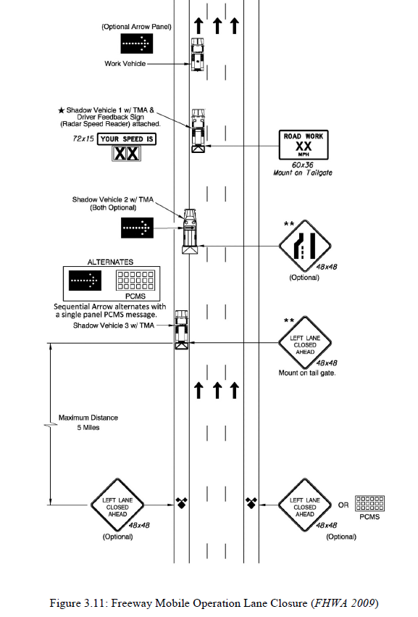
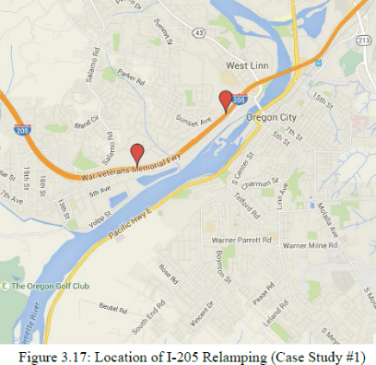

Case Study 2, 3, and 4
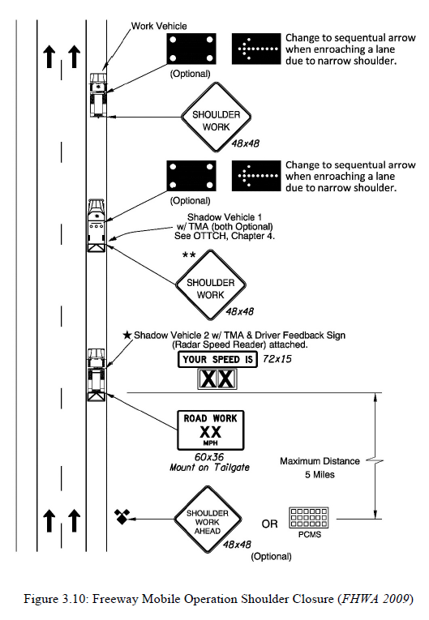

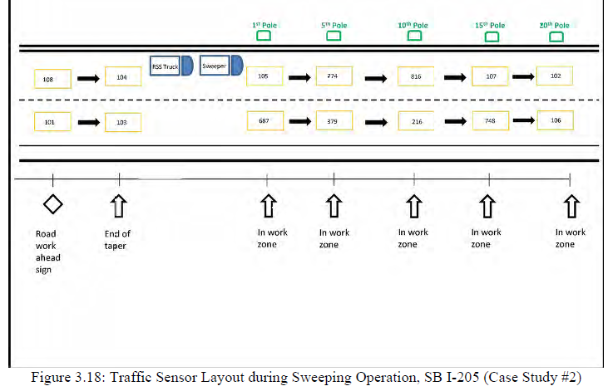

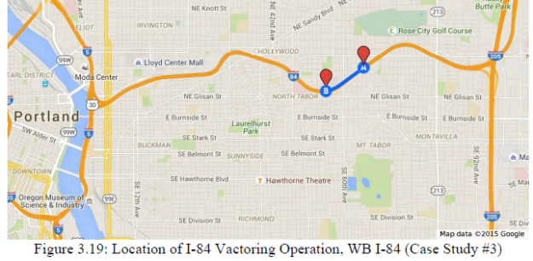

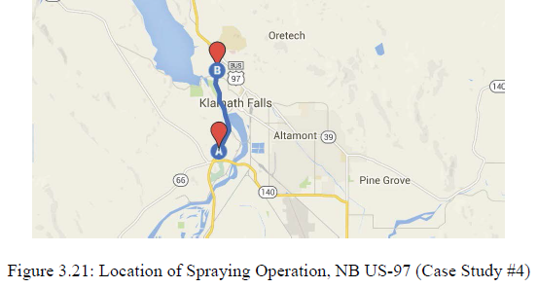

  - DSFS Graphic
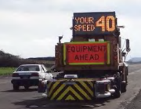

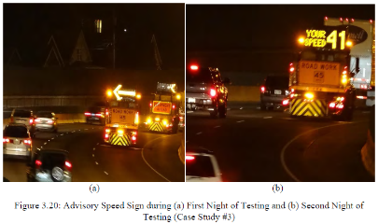

- Hajbabai, Medina, Want, Benekohal, and Chitturi, 2011

  - Study Characteristics
Item | Response
Authors | Hajbabai, Medina, Want, Benekohal, and Chitturi
Title | Sustained and Halo Effects of Various Speed Reduction Treatments in Highway Work Zones
Publication year | 2011

  - Quality Screening
Quality Criteria | Response (Yes or No)
Were the study population and the context of the study well described? | Yes
Were the exposure variables valid implementations of the conditions that they were meant to represent? | Yes
Was the outcome variable both a reliable and valid measure of the outcome of interest? | Yes

  - Study Features
Feature | Study Information
Experimental Design | O-X-O-X-O-X-O
Safety Focus | Work zone
Graphic of DSFS available | No
Graphic of Layout available | Yes
Study restricted to free flow level of service | Yes
Classes of vehicles included | Passenger cars and trucks
Hypothesis 1 (H1) level | B
Hypothesis 2 (H2) level | NA
Hypothesis 3 (H3) level | B
H1: Mean speed | Significant decrease
H1: 85th percentile speed | Nothing reported
H1: Percentage of drivers over speed limit | Nothing reported
H1: Distribution of speed | Nothing reported
H2: Mean speed | Nothing reported
H2: 85th percentile speed | Nothing reported
H2: Percentage of drivers over speed limit | Nothing reported
H2: Distribution of speed | Nothing reported
H3: Mean speed | Nothing reported
H3: 85th percentile speed | Nothing reported
H3: Percentage of drivers over speed limit | Nothing reported
H3: Distribution of speed | Nothing reported
DSFS displays speed | Yes
DSFS speed lighting | NS
DSFS flashes (speed or other) | NS
Mobile DSFS units | Yes
Roadway type | Freeway
Area type (location) | NS
Sidewalks present | No
Posted speed | 55 mph
Sensor positions | Adjacent (200 ft)
Number of sensors | 1
Sensor types | Video
Types of treatments | Speed display trailer, police enforcement with speed display trailer, speed photo enforcement
Number of relevant sites | 2
Number of cases | 6
Duration of measurements before activation (“before” measurements) | NS
Time interval between “before” measurements and activation | NS
Duration of activation | NS
Time of day when speed is measured (AM/PM) | Multiple
Time of day when speed is measured (peak/off peak) | Off peak
Time intervals at which measurements were taken during activation (“during” measurements) | NS
Amount of time that elapsed after deactivation and prior to subsequent measurements (“after” measurements) | Less than 1 hour
Duration of “after” measurements | NS
Meta-analysis data available | Yes
Caveats | No
Best practices information available | No

  - Summary of Study
The safety focus was a work zone on an interstate highway in Illinois. There were two sites, Site 1 and Site 2. At both sites, the roadway was straight, with two lanes of traffic going in one direction. Only free-flowing traffic was included in analysis, with "free-flow" defined as 4 seconds of headway at 55 mph. Four treatments were evaluted: speed display trailer (SDT), police (lights off), speed display trailer and police (lights off), and automated speed photo-radar enforcement (SPE). Both the SDT and SPE displayed the speed to the drivers as they passed the device. At Site 1, data were gathered during the AM off-peak hours (Data Set 1) and PM off-peak hours (Data Set 2) at one location before, during and after treatment. At Site 2, data were gathered during the PM off-peak hours at one location before, during and after treatment. Four independent variables were considered: treatment (baseline, SFT, police, police+SFT, SPE); vehicle class (trucks, cars); lane (right, left lane); free flow (yes, general). Measures were taken of the mean speed, speed distribution, and percentage of speeding drivers (extreme and moderate). The sensor was a video recorder capturing 30 frames per second, with two markers that allowed speed to be determined precisely from the frames. This allowed the data to be sorted by vehicle type, lane traveled, and level of service. The sensor data covered a trapezoidal area from the DSFS to approximately 700 feet downstream. The measures were gathered before (unspecified), during, and after (less than 1 hour) the treatment. Data was analyzed for each location separately. The major hypotheses were H1B and H3B.
Data Reported. The publication reported mean speeds, but did not report mean speed changes for all conditions in data sets 1 and 2 because the drivers in those data stes were already traveling the posted speed.For Data Set 3, mean speed reductions were reported for all combinations of independent variables. The study also reported 85th percentile speeds, the distribution of speeds, and the percentage of excessive and moderate speeders.
Results. “The results indicated that the SPE system and police–trailer treatments reduced the mean speed of both the general traffic stream and free-flowing vehicles by about 5 to 7 mph. The magnitudes of the speed reductions while the treatments were deployed were sustained over time. Police presence alone also reduced the speed significantly but to a lesser degree, and the effects of the trailer treatment alone were limited.”
Statistical Analysis. “The statistical significance of these changes was estimated by the following techniques: (a) t-tests, to evaluate the changes in the mean speeds; (b) least-significant-difference tests, to determine if the speeds changed after the treatments were deployed and removed; and (c) chi-square and Kolmogorov–Smirnov tests, to determine if the speed distributions for two different treatments were the same. In addition, the effects of the treatments on the mean speeds were determined over time to establish whether the effects decreased immediately after the treatments were removed from the work zone or were stable. To determine the effects, a moving average of the general traffic stream (when the treatment was present) was calculated every 5 min and plotted over time.”

  - Study Schematic















Work Activity Area
~500 ft
~200 ft

FIGURE 1 Schematic diagram of data collection setup.
  - DSFS Graphic
Not provided

- Hallmark, Peterson, Fitzsimmons, Hawkins, Resler, and Welch, 2007

  - Study Characteristics
Item | Response
Authors | Hallmark, Peterson, Fitzsimmons, Hawkins, Resler, and Welch
Title | Evaluation of Gateway and Low-Cost Traffic-Calming Treatments for Major Routes in Small Rural Communities
Publication year | 2007

  - Quality Screening
Quality Criteria | Response (Yes or No)
Were the study population and the context of the study well described? | Yes
Were the exposure variables valid implementations of the conditions that they were meant to represent? | Yes
Was the outcome variable both a reliable and valid measure of the outcome of interest? | Yes

  - Study Features
Feature | Study Information
Experimental Design | O-X-O-O
Safety Focus | Transition zone
Graphic of DSFS available | Yes
Graphic of Layout available | Yes
Study restricted to free flow level of service | NS
Classes of vehicles included | Passenger cars and trucks
Hypothesis 1 (H1) level | B
Hypothesis 2 (H2) level | B
Hypothesis 3 (H3) level | NA
H1: Mean speed | Significant reduction recorded
H1: 85th percentile speed | Reduction recorded
H1: Percentage of drivers over speed limit | Significant reduction recorded
H1: Distribution of speed | Nothing reported
H2: Mean speed | Significant reduction recorded
H2: 85th percentile speed | Reduction recorded
H2: Percentage of drivers over speed limit | Significant reduction recorded
H2: Distribution of speed | Nothing reported
H3: Mean speed | Nothing reported
H3: 85th percentile speed | Nothing reported
H3: Percentage of drivers over speed limit | Nothing reported
H3: Distribution of speed | Nothing reported
DSFS displays speed | Yes
DSFS speed lighting | Yes
DSFS flashes (speed or other) | Yes
Mobile DSFS units | No
Roadway type | Local
Area type (location) | Rural
Sidewalks present | NS
Posted speed | 25 mph
Sensor positions | Upstream (-2640 ft), adjacent (just downstream), and downstream (NS)
Number of sensors | 1,1,1
Sensor types | Pneumatic
Types of treatments | DSFS alone and DSFS with peripheral transverse pavement markings and median widening
Number of relevant sites | 0
Number of cases | 0
Duration of measurements before activation (“before” measurements) | 48 to 72 hours
Time interval between “before” measurements and activation | NS
Duration of activation | 3 months
Time of day when speed is measured (AM/PM) | Multiple
Time of day when speed is measured (peak/off peak) | Multiple
Time intervals at which measurements were taken during activation (“during” measurements) | 0 and 3 months
Amount of time that elapsed after deactivation and prior to subsequent measurements (“after” measurements) | NA
Duration of “after” measurements | NA
Meta-analysis data available | Yes
Caveats | None
Best practices information available | No

  - Summary of Study
The study evaluated traffic-calming treatments on major roads going through small Iowa communities. Seven different low-cost traffic treatments were implemented and evaluated in five rural Iowa communities. Union and Slater were the two communities that included DSFS as one of the evaluated treatments. In Slater the DSFS was evaluated as a single measure in a single location, whereas in Union the DSFS was evaluated in three separate locations as part of an overall “gateway” treatment that also included (1) peripheral transverse pavement markings, and (2) median widening. Each site had an existing speeding problem, as documented by the researchers through preliminary speed testing.
Researchers used pneumatic tubes to collect speed and volume data for each site before the implementation of measures and during implementation at 1, 6, 9, and 12 months. At each instance, data were collected for either a 48- or 72-hour period. However, in Union, the DSFS were not installed until just before the 9-month data collection. In Slater, the DSFS was not installed until just before the 3-month data collection, and data were only collected for one “during” period.
In Union, data were collected 0.5 miles upstream, immediately downstream of the devices, and at one other location some additional unspecified distance downstream. In Slater, data were only collected immediately downstream of the device.
In Union, the DSFS would not activate unless the approaching vehicle speed were to exceed 25 mph. It would then begin displaying speeds, with flashing above 45 mph. The DSFS was programmed to not display the speed above a certain threshold (50 mph in one instance and 55 mph in another). In Slater, the DSFS would not activate unless the approaching vehicle speed were to exceed 25 mph. It would then begin displaying speeds up to 40 mph. At speeds above 40 mph it flashed “Slow Down 25), and then stopped displaying anything for vehicles traveling over 75 mph.
The measures of effectiveness were: mean speed; standard deviation; 85th percentile speed; minimum speed; maximum speed; and percent of vehicles traveling at or above 5, 10, 15, 20, and 25 mph over the posted speed limit. The study evaluated hypotheses H1B and H2B.
Data reported. Mean speed; standard deviation; 85th percentile speed; minimum speed; maximum speed; and percent of vehicles traveling at or above 5, 10, 15, 20, and 25 mph over the posted speed limit.
Results. In Union, the other two speed calming measures showed only slight effectiveness. Once the DSFS were installed significant speed reductions were recorded. Speed data for Union were also evaluated by time of day (AM vs. PM, peak vs. off-peak), but no distinguishing pattern emerged. In Slater there was a statistically significant decrease in mean speed during DSFS activation.
Statistical Analysis. “Mean speeds were compared at either the 90 or 95 percent confidence level using a t-test (assuming unequal variances). All datasets were evaluated to ensure that they were normally distributed before the t-test was applied. The percent of vehicles traveling at 5, 10, 15, 20, and 25 mph above the posted speed limit were compared from the before to after periods at the 90 or 95 percent confidence level using a statistical test to infer differences between two population proportions (Ott and Longnecker, 2001).”
  - Study Schematic
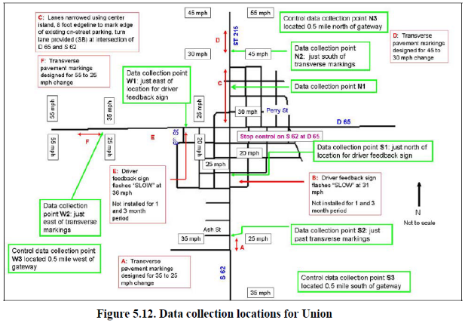
  - DSFS Graphic
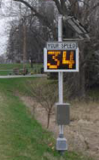

- Hallmark, Hawkins, and Knickerbocker, 2015

  - Study Characteristics
Item | Response
Authors | Hallmark
Title | Use of DSFS as a Speed Transition Zone Countermeasure in Small, Rural Communities
Publication year | 2015

  - Quality Screening
Quality Criteria | Response (Yes or No)
Were the study population and the context of the study well described? | Yes
Were the exposure variables valid implementations of the conditions that they were meant to represent? | Yes
Was the outcome variable both a reliable and valid measure of the outcome of interest? | Yes

  - Study Features
Feature | Study Information
Experimental Design | O-X-O-O
Safety Focus | Transition zone
Graphic of DSFS available | Yes
Graphic of Layout available | No
Study restricted to free flow level of service | NS
Classes of vehicles included | NS
Hypothesis 1 (H1) level | B
Hypothesis 2 (H2) level | NA
Hypothesis 3 (H3) level | NA
H1: Mean speed | Significant reduction recorded
H1: 85th percentile speed | Nothing reported
H1: Percentage of drivers over speed limit | Significant reduction recorded
H1: Distribution of speed | Nothing reported
H2: Mean speed | NA
H2: 85th percentile speed | NA
H2: Percentage of drivers over speed limit | NA
H2: Distribution of speed | NA
H3: Mean speed | NA
H3: 85th percentile speed | NA
H3: Percentage of drivers over speed limit | NA
H3: Distribution of speed | NA
DSFS displays speed | Multiple
DSFS speed lighting | Yes
DSFS flashes (speed or other) | Multiple
Mobile DSFS units | No
Roadway type | Local
Area type (location) | Rural
Sidewalks present | NS
Posted speed | 25 mph
Sensor positions | Adjacent (NS)
Number of sensors | 0,1,0
Sensor types | Pneumatic
Types of treatments | DSFS (3 types)
Number of relevant sites | 6
Number of cases | 6
Duration of measurements before activation (“before” measurements) | 24-48 hours
Time interval between “before” measurements and activation | NS
Duration of activation | 12 months
Time of day when speed is measured (AM/PM) | Multiple
Time of day when speed is measured (peak/off peak) | Multiple
Time intervals at which measurements were taken during activation (“during” measurements) | 1 month, 12 months
Amount of time that elapsed after deactivation and prior to subsequent measurements (“after” measurements) | NA
Duration of “after” measurements | NA
Meta-analysis data available | Yes
Caveats | None
Best practices information available | No

  - Summary of Study
Dynamic speed feedback signs (DSFS) were installed at 6 site(s) in Iowa. The context was rural, specifically highways with speed limits of at least 50 mph entering rural communities with speed limits less than 40 mph. The roadways were paved higways with "no unusual geometry.” The posted speeds were as follows: 25 mph at 5 sites, 30mph at one site. Measures were taken of the mean speed, 85th percentile speed, and fraction of drivers exceeding the speed limit by 5, 10, and 15 mph at 6 sites. Sensors were placed at or slightly downstream of the DSFS; exact locations were not specified. The measures were gathered before and during (1 month, 12 months) the time that the DSFS was activated. There were no measurements after the DSFS was removed. Each set of measurements was taken over one 24 or 48 hour period, on a non-holiday weekday. Data was analyzed for each location. Three different styles of DSFS were applied, but all involved a dynamic visible response to speeding. Independent variables were as follows: treatment and duration of treatment. Dependent variables were as follows: mean speeds, 85th percentile speeds, and percentage of the sample exceeding the speed limit. The major hypothesis evaluated was H1B. The measures of effectiveness were mean speed, 85th percentile speed, and fraction of vehicles exceeding the speed limit (grouped by severity of speeding).
Data Reported. The article reported mean speeds, 85th percentile speeds, sample sizes, and fraction of drivers exceeding the speed limit by 5+, 10+, and 15+ mph. It did not provide variance, standard deviation, or significance data.
Results. For H1B, mean speed dropped at all sites. It is not clear whether the changes were statistically significant. At 5 of the 6 sites, mean speed decreased between 4.6 and 7.9 mph; at one site the mean speed dropped by 0.4mph. When comparing the data from a 1 month installation with a 12 month installation: mean speed increased by 1.7 mph and by 0.5 mph at two sites, and decreased by 0.2 mph at the third site. Malfunctions or other factors prevented 12 month measurements at the other sites. Again, it is not clear whether these changes are statistically significant. All sites showed a decrease in the percent of vehicles traveling 5+ and 10+ mph over the posted limit; 5 of the 6 sites showed a decrease in the percent of vehicles traveling 15+ mph over the posted limit, while one site showed an increase in this number. It is noted that the increase, from 4% to 5%, is not statistically significant at the 95% level. The changes in the percentage of vehicles driving at least 10mph over the speed limit are as follows at the six sites: from 64% to 17%; from 19% to 5%; from 86% to 65%; from 29% to 3%; from 18% to 16%; from 67% to 40%.
Statistical Analysis. The details of the statistical analysis conducted are not specified, but some results are called out as not significant at the 95% level; we therefore assume that other described results are significant.
  - Study Schematic
Not provided.

  - DSFS Graphic
Figure 1: Sign showing driver speed at rural community entrance
Figure 4: LED Lights with speed limit sign

- Hallmark, Hawkins, and Smadi, 2015

  - Study Characteristics
Item | Response
Authors | Hallmark, Hawkins, and Smadi
Title | Evaluation of Dynamic Speed Feedback Signs on Curves: A National Demonstration Project
Publication year | 2015

  - Quality Screening
Quality Criteria | Response (Yes or No)
Were the study population and the context of the study well described? | Yes
Were the exposure variables valid implementations of the conditions that they were meant to represent? | Yes
Was the outcome variable both a reliable and valid measure of the outcome of interest? | Yes

  - Study Features
Feature | Study Information
Experimental Design | O-X-O-O-O
Safety Focus | Horizontal curve
Graphic of DSFS available | Yes
Graphic of Layout available | No
Study restricted to free flow level of service | Yes
Classes of vehicles included | Passenger cars and trucks
Hypothesis 1 (H1) level | A,B
Hypothesis 2 (H2) level | A,B
Hypothesis 3 (H3) level | NA
H1: Mean speed | Significant decrease
H1: 85th percentile speed | Reduction recorded
H1: Percentage of drivers over speed limit | Significant decrease
H1: Distribution of speed | Nothing reported
H2: Mean speed | Significant reduction recorded
H2: 85th percentile speed | Reduction recorded
H2: Percentage of drivers over speed limit | Significant reduction recorded
H2: Distribution of speed | Nothing reported
H3: Mean speed | Nothing reported
H3: 85th percentile speed | Nothing reported
H3: Percentage of drivers over speed limit | Nothing reported
H3: Distribution of speed | Nothing reported
DSFS displays speed | Multiple
DSFS speed lighting | Yes
DSFS flashes (speed or other) | NS
Mobile DSFS units | No
Roadway type | Multiple
Area type (location) | Rural
Sidewalks present | No
Posted speed | At least 50 mph in preceding tangent section
Sensor positions | Upstream (-2640 ft), adjacent (point of curvature), and downstream (distance varied;at center of curve)
Number of sensors | 1,1,1
Sensor types | Pneumatic
Types of treatments | DSFS speed display and DSFS curve warning
Number of relevant sites | 22
Number of cases | 22
Duration of measurements before activation (“before” measurements) | 2 days
Time interval between “before” measurements and activation | NS
Duration of activation | 24 months
Time of day when speed is measured (AM/PM) | Multiple
Time of day when speed is measured (peak/off peak) | Multiple
Time intervals at which measurements were taken during activation (“during” measurements) | 1 month, 12 months, 24 months
Amount of time that elapsed after deactivation and prior to subsequent measurements (“after” measurements) | NA
Duration of “after” measurements | NA
Meta-analysis data available | Yes
Caveats | None
Best practices information available | No

  - Summary of Study
This national demonstration project evaluated the effectiveness of two different DSFS types in reducing speed and crashes on curves at 22 sites on rural two-lane roadways in seven States. The seven States included: Arizona, Florida, Iowa, Ohio, Oregon, Texas, and Washington.
Each site had to meet the following criteria:
- High historical crash totals;
- Existing speeding problem;
- No rehabilitation or reconstruction activities that change the geometry of the roadway scheduled during the 2-year project;
- No geometric or cross-section changes made for 3 years prior to the study;
- Posted speed limit on preceding tangent section 50 mph or greater; and
- Far from any major development, railroad, or major access points, including intersections other than low-volume intersections.
Out of 51 identified viable sites across the States, the researchers randomly selected 22 treatment sites, and the remaining 29 sites served as control sites for the crash analysis. Speed data were only collected at the treatment sites. Table 24 in the publication shows the final list of selected sites and their characteristics.
The two different DSFS types evaluated were as follows:
- Speed display. Displays the vehicle’s actual speed, up to a certain threshold, and then the speed indication is replaced by the actual posted speed limit.
- Curve warning. Displays a warning to slow down due to the curve ahead.
Regardless of the type, they both activated when drivers exceeded the 50th percentile speed.
In most cases, researchers collected 48 consecutive hours of data for each instance. Data were collected before (exact timing unspecified) and at 1, 12, and 24 months during implementation of the DSFS. Data were collected at three locations for each site: 0.5 miles upstream from the curve, at the point of curvature (PC) where the sign was installed, and at the center of curve (CC). Speed and volume data were collected using pneumatic road tubes and counters. The study evaluated hypotheses H1A, H1B, H2A, and H2B.
Data reported. Average daily traffic, sample size, mean speed, standard deviation, 85th percentile speed, and percent of vehicles exceeding the advisory speed limit by 5, 10, 15, and 20 mph (if no advisory speed limit, this was calculated for the regulatory speed limit).
Results. Across all sites, speeds decreased on average by 1.8 mph at 1 month, 2.6 mph at 12 months, and 2.0 mph at 24 months. The 85th percentile speed decreased by 2.2 mph at 1 month, 2.9 at 12 months, and 2.2 mph at 24 months. The fraction of vehicles traveling 10 mph or more over the posted or advisory speed decreased by an average of 30 percent at 1-month, 34 percent at 12 months, and 30 percent at 24 months. Larger decreases were noted for the speed signs than for the curve signs, although differences were not statistically significant. Speed reductions were generally larger at the center of the curve than at the point of curvature. In addition, nighttime versus daytime speeds were compared for several sites, and passenger vehicle versus heavy truck speeds were compared for several sites. No major differences in speed reductions were noted for either of these comparisons. Crashes in both directions decreased by 0.08 crashes per quarter for the control sites, while crashes per quarter at the treatment sites decreased by 0.22 (a 17-percent versus 40-percent reduction).
Statistical Analysis. “The changes in mean speeds from the before to the after periods were evaluated using a t-test, and the changes in the fraction of vehicles traveling over the posted or advisory speed by a certain threshold were compared using a test of proportions. Unless indicated otherwise, differences in means and percent over the posted or advisory speeds were statistically significant at the 95-percent level of significance… A simple descriptive statistical analysis compared reductions in crashes from the before to after period for treatment versus control sites… A before-and-after analysis was also conducted using a Full Bayes Model to develop crash modification factors (CMF).”
  - Study Schematic
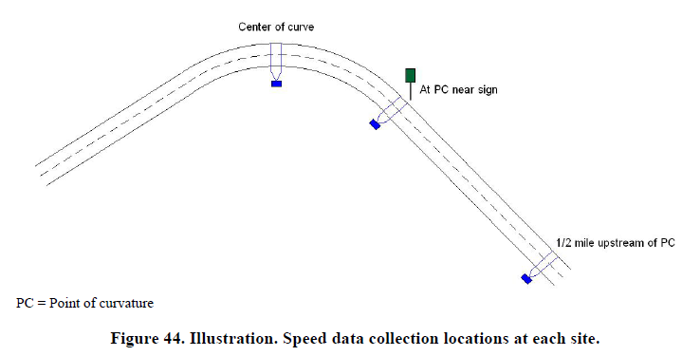
  - DSFS Graphic
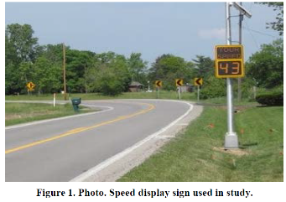
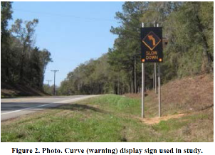

- Hallmark, Knickerbocker, and Hawkins, 2013

  - Study Characteristics
Item | Response
- Authors | Hallmark, Knickerbocker, and Hawkins
- Title | Evaluation of Low Cost Traffic Calming for Rural Communities – Phase II
- Publication year | 2013

  - Quality Screening
Quality Criteria | Response (Yes or No)
Were the study population and the context of the study well described? | Yes
Were the exposure variables valid implementations of the conditions that they were meant to represent? | Yes
Was the outcome variable both a reliable and valid measure of the outcome of interest? | Yes

  - Study Features
Feature | Study Information
Experimental Design | O-X-O-O
Safety Focus | Transition zone
Graphic of DSFS available | Yes
Graphic of Layout available | No
Study restricted to free flow level of service | NS
Classes of vehicles included | NS
Hypothesis 1 (H1) level | B
Hypothesis 2 (H2) level | NA
Hypothesis 3 (H3) level | NA
H1: Mean speed | Significant reduction recorded
H1: 85th percentile speed | Reduction recorded
H1: Percentage of drivers over speed limit | Significant reduction recorded
H1: Distribution of speed | Nothing reported
H2: Mean speed | Nothing reported
H2: 85th percentile speed | Nothing reported
H2: Percentage of drivers over speed limit | Nothing reported
H2: Distribution of speed | Nothing reported
H3: Mean speed | Nothing reported
H3: 85th percentile speed | Nothing reported
H3: Percentage of drivers over speed limit | Nothing reported
H3: Distribution of speed | Nothing reported
DSFS displays speed | Multiple
DSFS speed lighting | Yes
DSFS flashes (speed or other) | Multiple
Mobile DSFS units | No
Roadway type | Local
Area type (location) | Rural
Sidewalks present | NS
Posted speed | 25 mph
Sensor positions | Upstream (NS) and adjacent
Number of sensors | 1,1,0
Sensor types | Pneumatic
Types of treatments | DSFS, radar-activated speed limit sign ringed with LEDs
Number of relevant sites | 3
Number of cases | 3
Duration of measurements before activation (“before” measurements) | 48 hours
Time interval between “before” measurements and activation | NS
Duration of activation | 12 months
Time of day when speed is measured (AM/PM) | Multiple
Time of day when speed is measured (peak/off peak) | Multiple
Time intervals at which measurements were taken during activation (“during” measurements) | 1 month, 12 months
Amount of time that elapsed after deactivation and prior to subsequent measurements (“after” measurements) | NA
Duration of “after” measurements | NA
Meta-analysis data available | Yes
Caveats | None
Best practices information available | No

  - Summary of Study
This study evaluated various countermeasures that agencies can use to reduce speeds in transition zones as drivers enter rural communities located on high-speed roadways. Tests were conducted at multiple sites, but only two of the sites had treatments that were relevant:
- St. Charles, Iowa: A radar-activated LED-fringed speed limit sign was placed at the east entrance to the town, where the speed limit was 25 mph. The sign did not display motorist speed, but speeds above a certain threshold did cause the LED lights to turn on.
- Rowley, Iowa: A DSFS that showed the speed of approaching vehicles was installed at the east entrance to the town, where the speed limit changed from 55 mph to 25 mph. A radar-activated LED-fringed speed limit sign was installed at the west entrance to Rowley, also at a speed limit transition from 55 to 25 mph.
Pneumatic road tubes were used to collect speed and volume data before and during implementation (at 1 month and 12 months), typically adjacent to or just downstream of the treatment. Data were also collected at an upstream location, at an unspecified distance, where drivers were not yet influenced by the treatment. Data were typically collected for 48 hours on a Monday through Friday under mostly dry weather conditions. In a few cases, due to issues with the traffic counters, data were available for only a 24 hour period. The measures of effectiveness were mean speed, 85th percentile speed, standard deviation, and percentage of drivers exceeding the speed limit. The hypothesis investigated was H1B.
Data reported. Sample size, mean speed, 85th percentile speed, standard deviation, and percentage of drivers exceeding the speed limit by 5, 10, and 15 mph. The study also reported upstream mean speeds.
Results. Table 5-10 shows the results for the radar-activated LED-fringed speed limit sign. Minor changes occurred 1 month after installation of the sign with minor reductions in mean speed and with the fraction of vehicles traveling 5 or 10 mph over the speed limit. The fraction of vehicles traveling 15 or more mph over the limit increased from 4 to 5 percent (a 25 percent increase). No changes were noted in the upstream comparison site. Results for the 12 month after period were similar to the 1 month after period, except that the fraction of vehicles traveling 10 or more mph over the limit decreased 22 percent and those traveling 15 or more mph over the limit decreased 25 percent.
Table 5-11 shows results for the DSFS at the east entrance to Rowley. Mean speed decreased by almost 8 mph one month after installation of the DSFS and the 85th percentile speed decreased by 9 mph. There was also a large decrease in the fraction of vehicles traveling over the posted speed limit. The 12 month results were similar but slightly less pronounced.
Table 5-12 shows results for the radar-activated LED-fringed speed limit sign at the west entrance to Rowley. A decrease of almost 6 mph in mean speed and 7 mph in 85th percentile speed occurred 1 month after installation of the sign. The percent of vehicle exceeding the speed limit also decreased significantly. The 12 month results were similar to the 1 month results.
Statistical Analysis. “Change in average speed between analysis periods were compared at the 95 percent confidence level using a t-test (assuming unequal variances). Eighty-fifth percentile speeds were also compared, although there is no simple statistical test to compare whether the differences are statistically significant. For the percent of drivers exceed the speed limit, a z-test was used to detect differences between two population proportions at the 95 percent confidence level. Unless indicated otherwise, differences reported in the publication were statistically significant at the 95 percent level of significance.”
  - Study Schematic
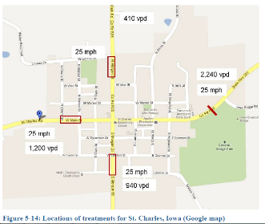
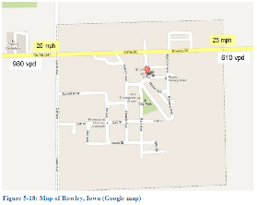

  - DSFS Graphic
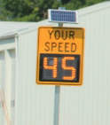

- Jeihani, Ardeshiri, and Naeeni, 2012

  - Study Characteristics
Item | Response
Authors | Jeihani, Ardeshiri, and Naeeni
Title | Evaluating the Effectiveness of Dynamic Speed Display Signs
Publication year | 2012

  - Quality Screening
Quality Criteria | Response (Yes or No)
Were the study population and the context of the study well described? | Yes
Were the exposure variables valid implementations of the conditions that they were meant to represent? | Yes
Was the outcome variable both a reliable and valid measure of the outcome of interest? | Yes

  - Study Features
Feature | Study Information
Experimental Design | O-X-O-O
Safety Focus | Multiple
Graphic of DSFS available | Yes
Graphic of Layout available | Yes
Study restricted to free flow level of service | Yes
Classes of vehicles included | NS
Hypothesis 1 (H1) level | C
Hypothesis 2 (H2) level | C
Hypothesis 3 (H3) level | NA
H1: Mean speed | Significant reduction recorded
H1: 85th percentile speed | Nothing reported
H1: Percentage of drivers over speed limit | NA
H1: Distribution of speed | Nothing reported
H2: Mean speed | No change
H2: 85th percentile speed | NA
H2: Percentage of drivers over speed limit | NA
H2: Distribution of speed | Nothing reported
H3: Mean speed | NA
H3: 85th percentile speed | NA
H3: Percentage of drivers over speed limit | NA
H3: Distribution of speed | Nothing reported
DSFS displays speed | Yes
DSFS speed lighting | LED
DSFS flashes (speed or other) | NS
Mobile DSFS units | NS
Roadway type | Multiple
Area type (location) | Urban
Sidewalks present | NS
Posted speed | Multiple
Sensor positions | Upstream (-200 ft); adjacent (10 ft); downstream (900, 1130, 2390, and 4060 ft)
Number of sensors | 0,1,4
Sensor types | Pneumatic
Types of treatments | DSFS
Number of relevant sites | 3
Number of cases | 3
Duration of measurements before activation (“before” measurements) | 1 week
Time interval between “before” measurements and activation | 3-4 weeks
Duration of activation | Site 1: 3 months  Site 2: 1 week  Site 3: 1 week
Time of day when speed is measured (AM/PM) | Multiple
Time of day when speed is measured (peak/off peak) | Multiple
Time intervals at which measurements were taken during activation (“during” measurements) | Site 1: 2 weeks and 3 months  Site 2: 1 week  Site 3: 1 week
Amount of time that elapsed after deactivation and prior to subsequent measurements (“after” measurements) | NA
Duration of “after” measurements | NA
Meta-analysis data available | No
Caveats | None
Best practices information available | No

  - Summary of Study
Dynamic speed feedback signs (DSFS) were installed at three urban sites in Maryland. Site 1 included the northbound three lanes of a six-lane parkway, with a 45 mph speed limit (initially unposted). It was a 1.4 mile stretch without any entrances or exits. Site 2: One-lane road in a 25 mph school zone (speed limit initially unposted). Site 3: Three lane road, with one lane used for parking after the morning peak period (speed limit 35 mph). Speed limits were as follows: Site 1, 45 mph; Site 2, 25 mph; Site 3: 35 mph. Measures were taken of mean speed and 85 percentile speed. The categorical regression and Bayesian Network analyses also took measures of speed limit compliance. At site 1, these measures were taken upstream, and at five locations downstream. At sites 2 and 3, these measures were taken upstream, at the DSFS, and downstream. The measures were gathered before installing speed limit signs, while signs were installed but before installing DSFS, and during DSFS activation. At Site 1, measures were also gathered again for another "during" measurement once the DSFS had been operating continuously for 3 months. Data were not averaged across the sites. The conventional statistical analysis considered treatment and duration as independent variables and mean speed and 85th percentile speed as dependent variables. In contrast, the categorical regression (CATREG) and Bayesian network (BN) analyses considered day of the week, time of day, speed limit, school zone, lane number, DSFS size, DSFS effective distance, and DSFS effective time as independent variablesa nd considered mean speed and speed compliance as dependent variables. The major hypothesis was H1C. The measures of effectiveness used were mean speed, 85th percentile speed and speed compliance. The article reported mean speeds, 85th percentile speeds, and sample sizes. It also reported variances and f-test results associated with the tests of the hypotheses. The article also reported the results of the CATREG analysis, showing the coefficients for various independent variables and the R-squared value for each regression. Finally, it reported the results of a BN analysis.
Results. Site 1: The mean speed adjacent to the DSFS was significantly less than the mean speed upstream for a short-term period. However, the average speed was higher at downstream sensor 2, which was 900 feet from the DSFS. The authors concluded that the DSFS affects speed reduction only for a very short distance. Also, the mean speed adjacent to the DSFS was not less than the mean speed upstream for a long-term period. The authors concluded that the DSFS is not an effective long-term tool. The mean speed upstream of the DSFS after three months of operation was more than the mean speed immediately after installation. The mean speed adjacent to the DSFS after three months was not less than the mean speed immediately after the DSFS installation. The mean speed adjacent to the DSFS a short term after installation was less than the mean speed pre-DSFS installation. The mean speed downstream of the DSFS was not less than the mean speed upstream of the DSFS. Site 2: The mean speed adjacent to the DSFS was significantly less than the mean speed upstream for a short-term period. Site 3: The mean speed adjacent to the DSFS was significantly less than the mean speed upstream for a short-term period.
Statistical Analysis. The research team performed a conventional statistical analysis of the collected data. Mean speed and variance were calculated for each of the three sites’ peak and off-peak periods. The research team also used Categorical Regression (CATREG), and Bayesian network (BN) to assess a DSFS’s effectiveness with reducing speed. The conventional statistical analysis was a complete aggregate analysis, which analyzed the average speeds as a single value. The latter methods used a hybrid analysis to aggregate the data (aggregation based on an equal number of vehicles (n) passing a section in an appropriate time interval. Different time periods were used in order to have the same number of vehicles.)
  - Study Schematic
Site 1:
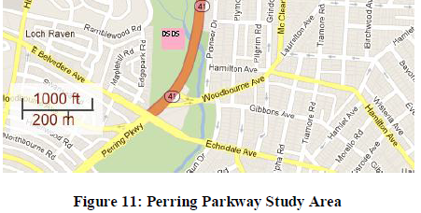
Site 2:
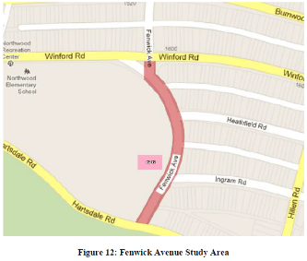
Site 3:
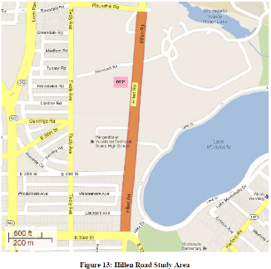
  - DSFS Graphic
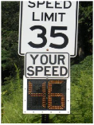

- Kamyab, Andrle, and Kroeger, 2002

  - Study Characteristics
Item | Response
Authors | Kamyab, Andrle, and Kroeger
Title | Methods to Reduce Traffic Speeds at High Pedestrian Areas
Publication year | 2002

  - Quality Screening
Quality Criteria | Response (Yes or No)
Were the study population and the context of the study well described? | Yes
Were the exposure variables valid implementations of the conditions that they were meant to represent? | Yes
Was the outcome variable both a reliable and valid measure of the outcome of interest? | Yes

  - Study Features
Feature | Study Information
Experimental Design | O-X-O-O
Safety Focus | Transition zone
Graphic of DSFS available | Yes
Graphic of Layout available | Yes
Study restricted to free flow level of service | Yes
Classes of vehicles included | Passenger cars and trucks
Hypothesis 1 (H1) level | NA
Hypothesis 2 (H2) level | B
Hypothesis 3 (H3) level | NA
H1: Mean speed | Nothing reported
H1: 85th percentile speed | Nothing reported
H1: Percentage of drivers over speed limit | Nothing reported
H1: Distribution of speed | Nothing reported
H2: Mean speed | No change
H2: 85th percentile speed | No change
H2: Percentage of drivers over speed limit | No change for trucks. Decrease for passenger cars, but only for short-term.
H2: Distribution of speed | Nothing reported
H3: Mean speed | Nothing reported
H3: 85th percentile speed | Nothing reported
H3: Percentage of drivers over speed limit | Nothing reported
H3: Distribution of speed | Nothing reported
DSFS displays speed | No
DSFS speed lighting | Yes
DSFS flashes (speed or other) | No
Mobile DSFS units | No
Roadway type | Local
Area type (location) | Rural
Sidewalks present | No
Posted speed | 35 mph
Sensor positions | Downstream (NS)
Number of sensors | 0,0,1
Sensor types | Video
Types of treatments | DSFS
Number of relevant sites | 1
Number of cases | 1
Duration of measurements before activation (“before” measurements) | 2 days
Time interval between “before” measurements and activation | 1 year
Duration of activation | 2 months
Time of day when speed is measured (AM/PM) | Multiple
Time of day when speed is measured (peak/off peak) | Multiple
Time intervals at which measurements were taken during activation (“during” measurements) | 2.5 weeks and 9.5 weeks
Amount of time that elapsed after deactivation and prior to subsequent measurements (“after” measurements) | NA
Duration of “after” measurements | NA
Meta-analysis data available | Yes
Caveats | None
Best practices information available | Yes

  - Summary of Study
This study evaluated the effectiveness of various speed reduction treatments in rural transition zones where high-speed traffic enters communities with pedestrian traffic. Four sites were evaluated, but only one site, Bemidi Lake, evaluated the effectiveness of a DSFS. The DSFS displayed the word “SLOW” to motorists traveling over the speed limit. Before data were collected July 13-14 in 2000. The sign was installed the week of June 10, 2001 and then “during” data were collected June 28-30, 2001 and then again August 16-18, 2001. Data were collected at an unspecified distance downstream of the DSFS. Data were collected using two traffic data collection trailers, which had poles with video cameras on top. Videos were later reduced into traffic flow performance data through the use of image processing technology. The study only included data from free flowing vehicles, defined as those with headways greater than or equal to five seconds. The speed limit was 35 mph. The measures of effectiveness were: mean speed; standard deviation; 85th percentile speed; 10 mph pace speed; percent of vehicles in pace speed; mean of the highest 15% of vehicles; and percent of vehicles over the posted speed limit. The hypothesis investigated was H2B. Researchers thought that the location of the sign may have been responsible for its limited effectiveness. It was located just after a horizontal curve, such that drivers could not see it until right before they came upon it. They also hypothesized that the single-word message “SLOW” by itself was not informative enough to adequately encourage drivers to slow down.
Data reported. Mean speed; standard deviation; 85th percentile speed; 10 mph pace speed; percent of vehicles in pace speed; mean of the highest 15% of vehicles; and percent of vehicles over the posted speed limit.
Results. The DSFS appeared to increase the speed compliance of passenger cars by about 10 percent in short term. Its impact in improving the speed compliance, however, faded after six weeks into the sign operation. It also did not show any statistically significant impact on the speeding percentage of non-passenger cars. Other measures of effectiveness did not show any significant change from the “before” to the short-term “during” condition: mean speed, 85th percentile and pace interval speeds. For the long-term “during” condition, there were significant increases in mean speeds for “passenger cars” and “all vehicles,” but a significant decrease in mean speed for “non-passenger cars.”
Statistical Analysis. “Statistical comparisons were carried out to ascertain whether the differences of mean speeds and speed compliance rates, obtained in the “before” and “after” conditions, are statistically significant. Tukey’s t-test was utilized to determine significance of differences in the mean speeds at the 95 percent confidence level. As for speed compliance rates, the normal approximation to the binomial distribution was used to determine whether the changes in the rates were statistically significant”
  - Study Schematic
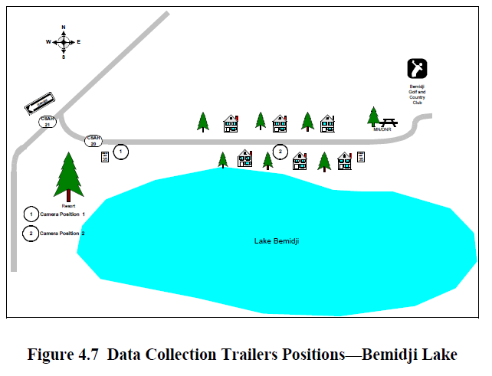

  - DSFS Graphic
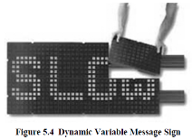

- Knapp and Robinson, 2012

  - Study Characteristics
Item | Response
Authors | Knapp and Robinson
Title | The Vehicle Speed Impacts of a Dynamic Horizontal Curve Warning Sign on Low-Volume Local Roadways
Publication year | 2012

  - Quality Screening
Quality Criteria | Response (Yes or No)
Were the study population and the context of the study well described? | Yes
Were the exposure variables valid implementations of the conditions that they were meant to represent? | Yes
Was the outcome variable both a reliable and valid measure of the outcome of interest? | Yes

  - Study Features
Feature | Study Information
Experimental Design | O-X-O-X-O-X-O-X-O-X-O-X-O
Safety Focus | Horizontal curve
Graphic of DSFS available | Yes
Graphic of Layout available | No
Study restricted to free flow level of service | NS
Classes of vehicles included | Passenger cars and trucks
Hypothesis 1 (H1) level | A,B
Hypothesis 2 (H2) level | A,B
Hypothesis 3 (H3) level | NA
H1: Mean speed | Significant reduction recorded
H1: 85th percentile speed | Reduction recorded
H1: Percentage of drivers over speed limit | Significant reduction recorded
H1: Distribution of speed | Significant reduction recorded
H2: Mean speed | Significant reduction recorded
H2: 85th percentile speed | Reduction recorded
H2: Percentage of drivers over speed limit | Significant reduction recorded
H2: Distribution of speed | Significant reduction recorded
H3: Mean speed | NA
H3: 85th percentile speed | NA
H3: Percentage of drivers over speed limit | NA
H3: Distribution of speed | NA
DSFS displays speed | No
DSFS speed lighting | LED
DSFS flashes (speed or other) | Yes
Mobile DSFS units | No
Roadway type | Local
Area type (location) | Rural
Sidewalks present | No
Posted speed | 55 mph regulatory, 35-40 advisory
Sensor positions | Upstream (-0.5 to -0.25 miles); adjacent (NS); downstream (275 to 500 ft)
Number of sensors | 1,1,1
Sensor types | Pneumatic
Types of treatments | DSFS
Number of relevant sites | 3
Number of cases | 3
Duration of measurements before activation (“before” measurements) | 2-5 days
Time interval between “before” measurements and activation | 1 month
Duration of activation | 18 months
Time of day when speed is measured (AM/PM) | NS
Time of day when speed is measured (peak/off peak) | NS
Time intervals at which measurements were taken during activation (“during” measurements) | 1, 6, 12, and 18 months
Amount of time that elapsed after deactivation and prior to subsequent measurements (“after” measurements) | NA
Duration of “after” measurements | NA
Meta-analysis data available | Yes
Caveats | None
Best practices information available | Yes

  - Summary of Study
This research project evaluated the vehicle speed impacts of a DSFS used as a dynamic curve warning sign at three study sites on low-volume, two-lane, rural highways. Two to five days of vehicle speed data were collected 1 month before and 1 month, 6 months, 1 year, and 18 months after the installation of a DSFS at the visually identified point of curvature (PC). Data were collected at three locations within each study site: upstream (typically ¼ to ½ mile from the visually identified initial point of curvature (PC), at the DSFS (at the PC), and downstream (within the curve). Bidirectional vehicle speed data were collected using a pneumatic tube automatic traffic recorder. Measures were taken of the mean speed, 85th percentile speed, minimum speed, maximum speed, sample size, standard deviation of the speed, and percent of vehicles exceeding the speed limit.
The study sites selected were on CSAH 25 and CSAH 3 in Meeker County and CSAH 7 in McLeod County. In each case the DSFS were installed as supplements to existing traditional (i.e. static) curve warning signs. The regulatory speed limit at all sites was 55 mph. In addition some of the sites had advisory speed limits:
- CSAH 3, advisory speed limit of 40 mph
- CSAH 25, no advisory speed limit
- CSAH 7, advisory speed limit of 35 mph
Independent variables were as follows: treatment and location. Dependent variables were as follows: mean speed, 85th percentile speed, minimum speed, maximum speed, sample size, standard deviation of the speed, and percent of vehicles exceeding the speed limit.
The major hypotheses evaluated were H1A, H1B, H2A, and H2B. However, as it pertains to H1A and H2A, the study only collected data for one “control” location. For one direction of travel, this “control” location was upstream of the DSFS and curve; for the other direction of travel, this “control” site was actually downstream of the DSFS and curve. In this sense, the use of H1A and H2A was slightly different than the standard description enumerated in other reviews.
Data Reported. The article reported mean speeds, 85th percentile speeds, minimum speed, maximum speed, sample sizes, and standard deviations, for both directions of travel at each data collection location.
Results. The overall average of the “before and during” differences (H1B) in mean vehicle speed (for all the data collection time periods) at the visually identified PC location of the CSAH 25 study site was -1.9 mph. This same measure was -7.0 mph at the CSAH 3 study site and -3.0 mph at the CSAH 7 study site. If these overall averages are adjusted for the shifts in upstream speeds, however, (as per hypothesis H1A), they change to -2.5 mph at CSAH 25, -5.2 mph at CSAH 3, and -2.6 mph at CSAH 7. The authors note that the vehicle speed impacts of the DSFS were greatest at the study site with the lowest posted advisory speed limit. The percentage of vehicles traveling at least 5, 10, 15, and 20 mph faster than the posted or advisory speed limit at each study site was also analyzed for each before and during time period comparison. The results showed a reduction in the percentages of vehicles exceeding the speed limit and also suggested that the impact of the DSFS is larger on vehicles traveling at higher speeds.
The authors noted one caveat about the results. When reviewing the data it is also important to take into account an unexpected event at the CSAH 25 study site. After about 9 months of operation the DCWS at the CSAH 25 study site fell during a severe winter event (e.g., high winds and heavy snow) and was not reinstalled for another 3 months. Therefore, the 12-month vehicle speeds collected at CSAH 25, while presented in the report, should not be considered representative of those that might be expected at one year of continuous DSFS operation. The drivers approaching this location likely adjusted their driving to account for the three month absence of the DCWS, and then had to readjust to its reintroduction. The same caveat may apply to the 18-month data from this site to the extent that this interruption may have had a lingering effect.
Statistical Analysis. A simple t-test (assuming a normal distribution of data and unequal variances) was applied to determine whether observed differences were statistically significant (with a 95 percent level of confidence).
  - Study Schematic
Not provided.
  - DSFS Graphic

- Lee, Lee, Choi, and Oh, 2006

  - Study Characteristics
Item | Response
Authors | Lee, Lee, Choi, and Oh
Title | Effectiveness of Speed-Monitoring Displays in Speed Reduction in School Zones
Publication year | 2006

  - Quality Screening
Quality Criteria | Response (Yes or No)
Were the study population and the context of the study well described? | Yes
Were the exposure variables valid implementations of the conditions that they were meant to represent? | Yes
Was the outcome variable both a reliable and valid measure of the outcome of interest? | Yes

  - Study Features
Feature | Study Information
Experimental Design | O-X-O-O
Safety Focus | School zone
Graphic of DSFS available | Yes
Graphic of Layout available | Yes
Study restricted to free flow level of service | Yes
Classes of vehicles included | NS
Hypothesis 1 (H1) level | B
Hypothesis 2 (H2) level | B
Hypothesis 3 (H3) level | NA
H1: Mean speed | Significant reduction recorded
H1: 85th percentile speed | Nothing reported
H1: Percentage of drivers over speed limit | Significant reduction recorded
H1: Distribution of speed | Significant reduction recorded
H2: Mean speed | Significant reduction recorded
H2: 85th percentile speed | Nothing reported
H2: Percentage of drivers over speed limit | Significant reduction recorded
H2: Distribution of speed | Significant reduction recorded
H3: Mean speed | NA
H3: 85th percentile speed | NA
H3: Percentage of drivers over speed limit | NA
H3: Distribution of speed | NA
DSFS displays speed | Yes
DSFS speed lighting | NS
DSFS flashes (speed or other) | NS
Mobile DSFS units | No
Roadway type | Local
Area type (location) | Urban
Sidewalks present | NS
Posted speed | 18.6 mph
Sensor positions | Upstream (-545 ft, -381 ft, -190 ft, -131 ft, -66 ft); downstream (66 ft)
Number of sensors | 5,0,1
Sensor types | Magnetic
Types of treatments | DSFS
Number of relevant sites | 1
Number of cases | 1
Duration of measurements before activation (“before” measurements) | 24 hours
Time interval between “before” measurements and activation | NS
Duration of activation | 12 months
Time of day when speed is measured (AM/PM) | Multiple
Time of day when speed is measured (peak/off peak) | Multiple
Time intervals at which measurements were taken during activation (“during” measurements) | 12 months
Amount of time that elapsed after deactivation and prior to subsequent measurements (“after” measurements) | NA
Duration of “after” measurements | NA
Meta-analysis data available | Yes
Caveats | International, thus not included
Best practices information available | No

  - Summary of Study
Dynamic speed feedback signs (DSFS) were installed at one site in South Korea. The site was urban, and a school zone. The site was a straight section of road following a curved expressway offramp. The roadway was 441m and the study covered approximately the first 186 m. The posted speed was 30 km/h (18.6 mph) throughout, beginning at the first measurement point. Measures were taken of the mean speed, 85th percentile speed, and the distribution of speed data at 7 positions: 166m upstream of the DSFS, 116m upstream, 58m upstream, 40m upstream, 20m upstream, at the DSFS, and 20m downstream of the DSFS. The measures were gathered before and during (2 weeks, 12 months) the time that the DSFS was activated. There were no measurements after the DSFS was removed. Each set of measurements was taken over one 24 hour period, on the same day of the week. There was only one site, so the data were not averaged over multiple locations. The major hypotheses were H1B and H2B. To evaluate hypothesis 1, the investigators performed a large sample Z-test on the 2 week data, and similarly on the 12 month data, for each measurement point individually.
Results. The null hypotheses, that there was no difference in the average speed before and during DSFS operation, was rejected for sites 3-7 for both the long and short term studies (p< .0001). There were statistically significant decreases in mean speed at all locations where the DSFS was noticeable by drivers. When comparing the 2 week and 12 month results, the "level of attention of the drivers to the existence of the [DSFS] was slightly reduced." Drivers began slowing farther downstream than in the 2 week study, and average speed dropped by 3.6 mph at 12 weeks compared to 5.1 mph at 2 weeks. Additionally, the researchers analyzed the distribution of speed data at the DSFS (reference point 6) using the Kolmogorov-Smirnov two-sample test. The analysis of speed distribution showed a significant change in the distribution of speed data at the DSFS site. The percentage of vehicles driving > 31mph dropped from 26.5% to 9.9% (2 weeks) and 5.4% (12 months).
Statistical Analysis. The researchers conducted a large-sample Z-test and reported p-values for their results; most results were significant with p < .0001.
  - Study Schematic
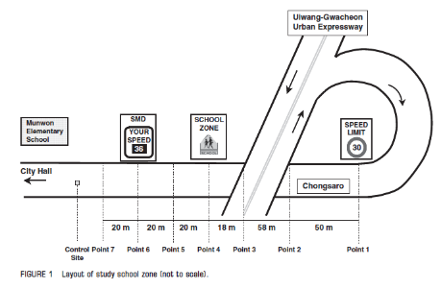

  - DSFS Graphic
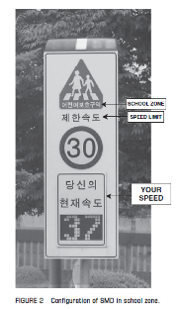

- Mattox, Sarasua, Ogle, Eckenrode, and Dunning, 2007

  - Study Characteristics
Item | Response
Authors | Mattox, Sarasua, Ogle, Eckenrode, and Dunning
Title | Development and Evaluation of a Speed Activated Sign to Reduce Speeds in Work Zones
Publication year | 2007

  - Quality Screening
Quality Criteria | Response (Yes or No)
Were the study population and the context of the study well described? | Yes
Were the exposure variables valid implementations of the conditions that they were meant to represent? | Yes
Was the outcome variable both a reliable and valid measure of the outcome of interest? | Yes

  - Study Features
Feature | Study Information
Experimental Design | O-X
Safety Focus | Work zone
Graphic of DSFS available | Yes
Graphic of Layout available | Yes
Study restricted to free flow level of service | Yes
Classes of vehicles included | NS
Hypothesis 1 (H1) level | B
Hypothesis 2 (H2) level | B
Hypothesis 3 (H3) level | NA
H1: Mean speed | Significant reduction recorded
H1: 85th percentile speed | Reduction recorded
H1: Percentage of drivers over speed limit | Significant reduction recorded
H1: Distribution of speed | Nothing reported
H2: Mean speed | Significant reduction recorded
H2: 85th percentile speed | Reduction recorded
H2: Percentage of drivers over speed limit | Significant reduction recorded
H2: Distribution of speed | Nothing reported
H3: Mean speed | NA
H3: 85th percentile speed | NA
H3: Percentage of drivers over speed limit | NA
H3: Distribution of speed | Nothing reported
DSFS displays speed | No
DSFS speed lighting | No
DSFS flashes (speed or other) | Yes
Mobile DSFS units | No
Roadway type | Multiple
Area type (location) | Rural
Sidewalks present | No
Posted speed | 45 mph
Sensor positions | Upstream ( -500 ft); adjacent (0 ft); downstream (200ft and 800 ft)
Number of sensors | 1,1,2
Sensor types | Multiple
Types of treatments | DSFS
Number of relevant sites | 5
Number of cases | 5
Duration of measurements before activation (“before” measurements) | NS
Time interval between “before” measurements and activation | NS
Duration of activation | NS
Time of day when speed is measured (AM/PM) | NS
Time of day when speed is measured (peak/off peak) | NS
Time intervals at which measurements were taken during activation (“during” measurements) | NS
Amount of time that elapsed after deactivation and prior to subsequent measurements (“after” measurements) | NA
Duration of “after” measurements | NA
Meta-analysis data available | No
Caveats | None
Best practices information available | No

  - Summary of Study
Dynamic speed feedback signs (DSFS) were installed at five sites in South Carolina. The style was a fixed-message, speed-activated sign that triggers a flashing beacon when a predetermined speed threshold is exceeded. The context was rural. Three sites were two-lane primary and secondary highways. An additional phase investigated two additional sites that were multilane, divided highways. The posted speed was 45 mph. Measures were taken of the speed 500 ft upstream of the DSFS, at a second location 150-200 ft downstream of the sign, and at a third location 800 ft downstream of the DSFS. The measures were gathered "before" (after installing signs but before turning them on) and "during" (while the signs were turned on). Three before/during measures were made at one site, four before/during measures at a second site, and two before/during measures made at a third site. No data were collected prior to sign installation. Data were not averaged across the sites. Independent variables included: measurement location, treatment condition (DSFS on or off), and upstream approach speed. Dependent variables included: mean speed, 85th percentile speed, percentage of vehicles exceeding the speed limit (3 mph and 10 mph), and distribution of speeds. The major hypotheses were H1B and H2B. The measures of effectiveness used were mean speed, 85th percentile speed, speed compliance and the distribution of speeds. For the first three sites (two lane highways), the publication reported mean speed changes at the three sensors for each of the three before/during measures at one site, four before/during measures at a second site, and two before/during measures at a third site. It also reported the t-value and the significance level. Speed distributions were also reported combined over the second and third sensors, but in graph rather than tabular form, so exact values are not known. Summary measures were also reported across all data collection sites for reductions in mean speed, 85th percentile speed, and percentage of vehicles exceeding the speed limit (by 3 mph and 10 pmh) (Table 4). For the last two sites (multilane divided highways), average (as well as maximum and minimum) reductions in mean speed, 85th percentile speed, and the percent of drivers exceeding the speed limit were reported. Finally, the distribution of speeds at the two sites at all three stations was reported.
Results. There was a significant reduction in the mean speeds at Station 2 [150 to 200 ft (45.7 to 60.9 m) past the sign] for all of the data sets when the speed-activated sign was on. Results from Station 1 [more than 500 ft (152.4 m) upstream] indicated that there was not a significant reduction in speed from the "control" to the "treatment" condition at the upstream location. The upstream Station 1 was located at such a distance that the speed-activated sign could not be seen. Results from the downstream Station 3 [more than 800 ft (243.8 m) downstream] showed a significant reduction in the means for all the treatment data sets. The speed-activated sign also caused reductions in 85th-percentile speed and the percentage of vehicles exceeding the speed limit. These data were reported for both the first three sites (two lane highways) and the latter two sites (multilane divided highways), but statistical significance was mentioned only for the latter two sites. Table 4 depicts the large variation in the ranges of reductions for the first three sites and Table 5 depicts the same information for the last two sites. The authors attribute this to variation in the number of vehicles traveling over the posted speed limit for each period. They posit that that the speed-activated sign was most effective during periods of excessive speeding.
Statistical Analysis. Data were collected to ensure results at a 95%-confidence level. A minimum sample size of 97 was determined based on an estimated sample standard deviation of 5.0 mph and a permitted error of 1.0 mph for the mean speed. "Data obtained were assumed to be normally distributed; therefore parametric hypothesis testing was conducted to test for equal means and changes in the percentages of vehicles exceeding the speed limit. The two-sample t-test was used to evaluate the difference in mean speeds, while the z-test for comparing proportions taken from two independent samples was used to test for significant differences in the proportion of vehicles exceeding the speed limit by 3 mph (4.8 km/h) and 10 mph (16.1 km/h) at each station. Each test was conducted to ensure a 95%-level of confidence."
  - Study Schematic
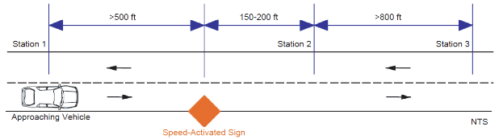
  - DSFS Graphic
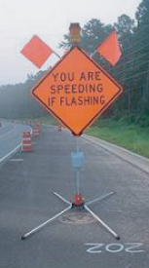

- McCoy and Pesti, 2001

  - Study Characteristics
Item | Response
Authors | McCoy and Pesti
Title | Smart Work Zone Technology Evaluations: Speed Monitoring Displays and Condition-Responsive, Real-Time Travel Information Systems
Publication year | 2001

  - Quality Screening
Quality Criteria | Response (Yes or No)
Were the study population and the context of the study well described? | Yes
Were the exposure variables valid implementations of the conditions that they were meant to represent? | Yes
Was the outcome variable both a reliable and valid measure of the outcome of interest? | Yes

  - Study Features
Feature | Study Information
Experimental Design | O-X-O
Safety Focus | Work zone
Graphic of DSFS available | Yes
Graphic of Layout available | Yes
Study restricted to free flow level of service | Yes
Classes of vehicles included | Passenger cars and trucks
Hypothesis 1 (H1) level | NA
Hypothesis 2 (H2) level | B
Hypothesis 3 (H3) level | NA
H1: Mean speed | NA
H1: 85th percentile speed | NA
H1: Percentage of drivers over speed limit | NA
H1: Distribution of speed | NA
H2: Mean speed | Significant reduction recorded
H2: 85th percentile speed | Reduction recorded
H2: Percentage of drivers over speed limit | Significant reduction recorded
H2: Distribution of speed | Significant reduction recorded (only for passenger vehicles)
H3: Mean speed | NA
H3: 85th percentile speed | NA
H3: Percentage of drivers over speed limit | NA
H3: Distribution of speed | NA
DSFS displays speed | Yes
DSFS speed lighting | LED
DSFS flashes (speed or other) | NS
Mobile DSFS units | Yes
Roadway type | Freeway
Area type (location) | Rural
Sidewalks present | No
Posted speed | 55 mph
Sensor positions | Upstream (-250 ft); downstream (750 ft)
Number of sensors | 1,0,1
Sensor types | Magnetic
Types of treatments | DSFS
Number of relevant sites | 1
Number of cases | 1
Duration of measurements before activation (“before” measurements) | 58 hours
Time interval between “before” measurements and activation | NS
Duration of activation | NS
Time of day when speed is measured (AM/PM) | Multiple
Time of day when speed is measured (peak/off peak) | Multiple
Time intervals at which measurements were taken during activation (“during” measurements) | NA
Amount of time that elapsed after deactivation and prior to subsequent measurements (“after” measurements) | NA
Duration of “after” measurements | NA
Meta-analysis data available | Yes
Caveats | None
Best practices information available | No

  - Summary of Study
The article discusses two studies, which took place in 1999 and 2000, respectively. This review summarizes the 1999 study. The 2000 study is described in a separate review (Pesti and McCoy, 2011), as it is redundant with that article. The 1999 study evaluated three technologies at a work zone on a rural interstate highway in Nebraska. These included DSFS and two types of portable, condition-responsive, real-time traveler information systems. The DSFS was evaluated in a short-term deployment at a single point on an approach to the work zone.
The speed limit was 55 mph at the DSFS, but it was 65 mph immediately upstream and 75 mph even further upstream. About 58 hours of speed data were collected before the DSFS sign was deployed. Only 7 hours of speed data were collected during the deployment, due to an equipment malfunction. The article did not specify the exact timing of these measurements relative to the deployment of the DSFS. Measures were taken of the mean speed, standard deviation, 85th-percentile speed, 10-mph pace, percentage of speeds within the pace, percentage complying with the speed limit, and mean of highest 15 percent of speeds. Data for passenger and non-passenger vehicles were analyzed separately.
The DSFS displayed the speed via LED, and was located at the outside edge of the left shoulder about 250 feet in advance of the “SPEED LIMIT 55” sign, or about 1,250 feet before the merge taper. Three magnetic imaging sensors were installed in the center of each traffic lane at distances of 1,500 and 500 feet in advance of the merge taper. This is equivalent to 250 feet upstream of the DSFS and 750 feet downstream of the DSFS. Four sets of uncongested flow data were analyzed: passenger cars, daytime; non-passenger cars, daytime; passenger cars, nighttime; and non-passenger cars, nighttime. Independent variables included treatment and vehicle type. Dependent variables were as follows: mean speed, standard deviation, 85th-percentile speed, 10-mph pace, percentage of speeds within the pace, percentage complying with the speed limit, and mean of highest 15 percent of speeds. Hypothesis H2B was evaluated. The article reported data for all seven of the stated dependent variables for the two locations (250 feet upstream and 750 feet downstream), before and during deployment. The article also indicated whether differences were statistically significant.
Results. The DSFS was found to be effective in lowering speeds and increasing the uniformity of speeds. At 500 feet in advance of the merge taper, which was 750 feet downstream from the DSFS, the 85th percentile speed, upper limit of the pace, and mean of the highest 15 percent of speeds were reduced significantly (α = 0.05) by about 5 mph, which lowered the values of these parameters to, or below, the speed limit. Its effects on passenger car and truck speeds were similar, increasing speed limit compliance to 90 percent or more. At this location, it was equally effective day and night. However, at 1,500 feet before the taper, which was 250 feet in advance of the DSFS location, its effects were greater at night because of its greater nighttime visibility.
Statistical Analysis. The statistical significance of the differences in these speed parameters before and during the deployment of the DSFS was determined. The t test was used to evaluate the differences between the before and after values of the mean speed, 10-mph pace, and mean of highest 15 percent of speeds. An analysis of covariance was also conducted to account for the effects of traffic volume in the comparison of mean speeds. The binomial proportion test was used to evaluate the statistical significance of differences between the before and after values of the 85th-percentile speed, percentage of speeds within the pace, and percentage complying with the speed limit. The F test was used to check for statistically significant differences between the before and after values of the standard deviation of the speed distribution.
  - Study Schematic
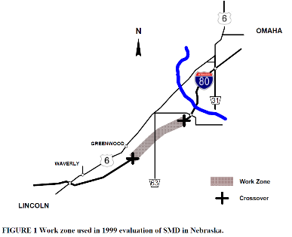
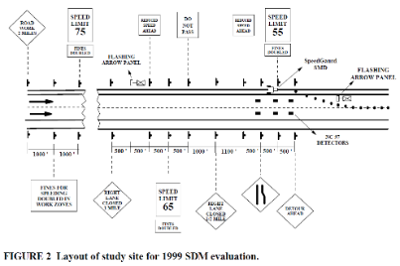
  - DSFS Graphic
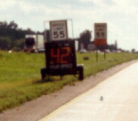

- McCoy, Bonneson, and Kollbaum, 1995

  - Study Characteristics
Item | Response
Authors | McCoy, Bonneson, and Kollbaum
Title | Speed Reduction Effects of Speed Monitoring Displays with Radar in Work Zones on Interstate Highways
Publication year | 1995

  - Quality Screening
Quality Criteria | Response (Yes or No)
Were the study population and the context of the study well described? | Yes
Were the exposure variables valid implementations of the conditions that they were meant to represent? | Yes
Was the outcome variable both a reliable and valid measure of the outcome of interest? | Yes

  - Study Features
Feature | Study Information
Experimental Design | O-X-O
Safety Focus | Work zone
Graphic of DSFS available | Yes
Graphic of Layout available | Yes
Study restricted to free flow level of service | Yes
Classes of vehicles included | Passenger cars and trucks
Hypothesis 1 (H1) level | B
Hypothesis 2 (H2) level | B
Hypothesis 3 (H3) level | NA
H1: Mean speed | Significant reduction recorded
H1: 85th percentile speed | NA
H1: Percentage of drivers over speed limit | Significant reduction recorded
H1: Distribution of speed | No change
H2: Mean speed | Significant reduction recorded
H2: 85th percentile speed | NA
H2: Percentage of drivers over speed limit | Significant reduction recorded
H2: Distribution of speed | Nothing reported
H3: Mean speed | NA
H3: 85th percentile speed | NA
H3: Percentage of drivers over speed limit | NA
H3: Distribution of speed | Nothing reported
DSFS displays speed | Yes
DSFS speed lighting | NS
DSFS flashes (speed or other) | NS
Mobile DSFS units | Yes
Roadway type | Arterial
Area type (location) | Rural
Sidewalks present | No
Posted speed | 55 mph before the lane taper, 45 mph at start of lane taper (312 ft downstream of the DSFS), and 30 mph in the work zone (downstream of the last speed detector).
Sensor positions | Upstream (-3691 ft); adjacent (312 ft); downstream (984 ft)
Number of sensors | 1,1,1
Sensor types | Pneumatic
Types of treatments | DSFS
Number of relevant sites | 1
Number of cases | 1
Duration of measurements before activation (“before” measurements) | 1 day
Time interval between “before” measurements and activation | 1 day
Duration of activation | 1 week
Time of day when speed is measured (AM/PM) | Multiple
Time of day when speed is measured (peak/off peak) | Multiple
Time intervals at which measurements were taken during activation (“during” measurements) | 1 week
Amount of time that elapsed after deactivation and prior to subsequent measurements (“after” measurements) | NA
Duration of “after” measurements | NA
Meta-analysis data available | Yes
Caveats | None
Best practices information available | No

  - Summary of Study
Dynamic speed feedback signs (DSFS) were installed at one site in South Dakota. The site was an urban section of interstate, 4-lane (2 on each side), but with a lane merge down to one lane on the study side. The segment was lightly curved with one off-ramp and one on-ramp, but only free flowing traffic was included in the analysis. The posted speeds were as follows: 55 mph before the lane taper, 45 mph at start of lane taper (95 m downstream of the DSFS), and 30 mph in the work zone (520 m downstream of the DSFS and 220 m after the last speed detector). Measures were taken of the mean speed and the percentage of vehicles exceeding the speed limit. These measures were taken 1125 m upstream, 95 m downstream, and 300 m downstream of the DSFS. The measures were gathered before (1 day), and during (1 day of measurement after DSFS had been operating for 7 days). Observations were also made of the time of day and the number of axles. There was only one site, so the data were not averaged over multiple locations. Independent variables were as follows: measurement location, treatment condition, approach speed upstream, time of day, number of axles Dependent variables were as follows: mean speed and percentage of vehicles exceeding the speed limit The major hypotheses were H1B and H2B. The measures of effectiveness were mean speed and percentage of vehicles exceeding the speed limit. The article reported mean speeds and percentage of drivers exceeding the speed limit
Results. The results are as follows for changes in mean speeds. H1B: There was a significant main effect of the DSFS on the mean speed at the DSFS. The least-square mean speed at the DSFS was 4.7 mph less during its activation than before. H2B: There was a significant main effect of the DSFS on the mean speed downstream of the DSFS. The least-square mean speed downstream of the DSFS was 3.8 mph less during its activation than before. At the DSFS and downstream, there was a statistically significant decrease (at the 0.05 significance level) in the percentage of vehicles exceeding the speed limit during DSFS activation as compared to before. There was also a significant main effect of the number of axles at the DSFS and downstream of the DSFS. At the DSFS and downstream, there was a statistically significant decrease (at the 0.05 significance level) in the percentage of vehicles exceeding the speed limit during DSFS activation as compared to before.
Statistical Analysis. “An analysis of variance was conducted to determine the statistical significance of the differences in the before and after mean speeds at Stations 2 and 3. In the analysis, time of day and number of axles were used as blocking factors because they were expected to have influenced the vehicle speeds. In general, traffic speeds are lower during periods of higher traffic volumes, and because traffic volume varied throughout the day, time of day was used as a blocking factor in the analysis. The differences in mean speeds observed between the vehicle classes shown in Table 2 indicated that the number of axles may affect vehicle speeds and therefore should be used as a blocking factor. Another factor that would be expected to influence a vehicle's speeds at Stations 2 and 3 was its speed at Station 1. The faster a vehicle is traveling at Station 1, the faster it would be expected to be traveling at Stations 2 and 3. However, it was not possible to accurately track vehicles over the 1,220 m ( 4,000 ft) between Stations 1 and 2. Therefore, the average speed at Station 1 during the same hour of the time of day when the vehicle's speeds were recorded at Stations 2 and 3 was used as a covariate to account for the possible effect of speed at Station 1. Thus, the effects of time of day, number of axles, and speed at Station 1 were accounted for in the analysis. In addition, all two factor interactions were considered, and those that were not significant were eliminated. The analysis was performed using the General Linear Analysis Procedure of the Statistical Analysis System.”
  - Study Schematic
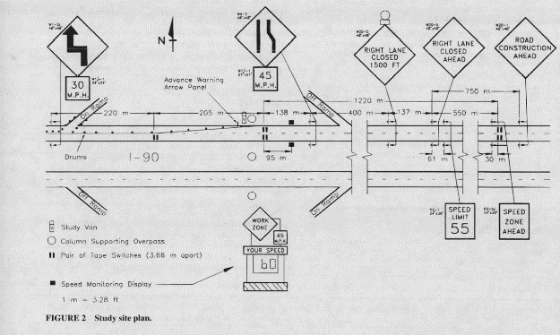

  - DSFS Graphic
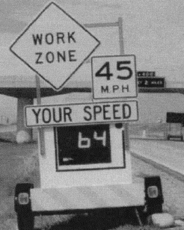

- Medina, Benekohal, Hajbabaie, Wang, and Chitturi, 2009

  - Study Characteristics
Item | Response
Authors | Medina, Benekohal, Hajbabaie, Wang, and Chitturi
Title | Downstream Effects of Speed Photo–Radar Enforcement and Other Speed Reduction Treatments on Work zones
Publication year | 2009

  - Quality Screening
Quality Criteria | Response (Yes or No)
Were the study population and the context of the study well described? | Yes
Were the exposure variables valid implementations of the conditions that they were meant to represent? | Yes
Was the outcome variable both a reliable and valid measure of the outcome of interest? | Yes

  - Study Features
Feature | Study Information
Experimental Design | O-X-O
Safety Focus | Work zone
Graphic of DSFS available | No
Graphic of Layout available | No
Study restricted to free flow level of service | Yes
Classes of vehicles included | Passenger cars and trucks
Hypothesis 1 (H1) level | NA
Hypothesis 2 (H2) level | B
Hypothesis 3 (H3) level | NA
H1: Mean speed | NA
H1: 85th percentile speed | NA
H1: Percentage of drivers over speed limit | NA
H1: Distribution of speed | NA
H2: Mean speed | Mixed
H2: 85th percentile speed | Nothing reported
H2: Percentage of drivers over speed limit | Nothing reported
H2: Distribution of speed | Nothing reported
H3: Mean speed | NA
H3: 85th percentile speed | NA
H3: Percentage of drivers over speed limit | NA
H3: Distribution of speed | NA
DSFS displays speed | NS
DSFS speed lighting | NS
DSFS flashes (speed or other) | NS
Mobile DSFS units | Yes
Roadway type | Freeway
Area type (location) | NS
Sidewalks present | No
Posted speed | 55 mph
Sensor positions | Downstream (1.5 miles)
Number of sensors | 0,0,1
Sensor types | Video
Types of treatments | DSFS, DSFS with police (lights on), DSFS with police (lights off), police( lights on), police (lights off), speed photo-radar enforcement
Number of relevant sites | 3
Number of cases | 24
Duration of measurements before activation (“before” measurements) | 1 hour
Time interval between “before” measurements and activation | Ranged from 10 minutes to 10 days
Duration of activation | 1 hour
Time of day when speed is measured (AM/PM) | Multiple
Time of day when speed is measured (peak/off peak) | Off peak
Time intervals at which measurements were taken during activation (“during” measurements) | 1 hour
Amount of time that elapsed after deactivation and prior to subsequent measurements (“after” measurements) | NA
Duration of “after” measurements | NA
Meta-analysis data available | Yes
Caveats | lacking standard deviation
Best practices information available | No

  - Summary of Study
The effects of automated speed photo–radar enforcement and traditional speed reduction treatments (DSFS, presence of police vehicles with emergency lights on and off, and combinations of the DSFS and police presence) on speed were studied at a location 1.5 miles downstream of the actual treatments.
Three data sets, each including several treatments, were collected in two work zones on Illinois interstate highways. Data Sets 1 and 2 were collected on a 7-mile work zone on I-64 in Illinois near St. Louis, at off-peak morning hours (Data Set 1) and off-peak afternoon hours (Data Set 2). Another data set (Data Set 3) was collected on a 7-mile work zone on I-55 near Joliet, a suburb of Chicago, during off-peak afternoon hours. In both work zones, the posted speed limit was 55 mph, two lanes were open to through traffic, and concrete barriers separated the work area from the traveled lanes.
The downstream effects on the mean speed and degree of speeding of the following six different speed reduction treatments were compared with a base condition without any treatment:
- Mobile DSFS;
- Police vehicle with emergency lights on (“police lights on”);
- Police vehicle with emergency lights off (“police lights off ”);
- DSFS + police lights on;
- DSFS + police lights off; and
- Speed photo-radar enforcement.
For the speed photo-radar enforcement, data were collected a few weeks after its first deployment and after an extensive public campaign by the Illinois Department of Transportation informing motorists of the use of speed photo-radar enforcement in work zones in the state.
Video recorders and two markers about 200 feet apart from each other were used to determine vehicles’ speed. Similar to the treatment location, the downstream data collection site was located within the work zone, along an approximately level and straight stretch of roadway, and away from ramps and pronounced curves. Data were reported for the general traffic stream and also separately reported for vehicles in free-flow traffic conditions. If the headway between a vehicle and the vehicle in front was more than or equal to 4 seconds, the following vehicle was considered free-flowing. The mean speeds and the speeding percentages were analyzed separately for passenger cars and trucks and for vehicles in the median and in the shoulder lane.
Results. At 1.5 miles downstream, field data consistently showed significant effects for speed photo-radar enforcement. The effects of “DSFS + Police Lights Off” were limited to Data Set 2 on cars in the median (2.7 mph reduction) and shoulder lanes (1.5 mph reduction), and on trucks in median lanes (1.7 mph reduction). The “Police Lights Off” and “DSFS + Police Lights On” treatments did not show any significant effects on mean speed at 1.5 miles downstream.
Statistical Analysis. “For comparing the mean speed of different treatments, ‘least significant difference’ tests were performed with a confidence level of 90%. This test classifies the mean speeds into groups where means that are not statistically different are grouped together.”
  - Study Schematic
Not available
  - DSFS Graphic
Not available

- Meyer, 2000

  - Study Characteristics
Item | Response
Authors | Meyer
Title | Evaluation of Two Strategies for Improving Safety in Highway Work Zones
Publication year | 2000

  - Quality Screening
Quality Criteria | Response (Yes or No)
Were the study population and the context of the study well described? | Yes
Were the exposure variables valid implementations of the conditions that they were meant to represent? | Yes
Was the outcome variable both a reliable and valid measure of the outcome of interest? | Yes

  - Study Features
Feature | Study Information
Experimental Design | O-X-O-X-O
Safety Focus | Work zone
Graphic of DSFS available | No
Graphic of Layout available | No
Study restricted to free flow level of service | Yes
Classes of vehicles included | Passenger cars and trucks
Hypothesis 1 (H1) level | B
Hypothesis 2 (H2) level | B
Hypothesis 3 (H3) level | NA
H1: Mean speed | Significant reduction recorded
H1: 85th percentile speed | Reduction recorded
H1: Percentage of drivers over speed limit | Significant reduction recorded
H1: Distribution of speed | Significant reduction recorded
H2: Mean speed | Significant reduction recorded
H2: 85th percentile speed | Reduction recorded
H2: Percentage of drivers over speed limit | Significant reduction recorded
H2: Distribution of speed | Significant reduction recorded
H3: Mean speed | NA
H3: 85th percentile speed | NA
H3: Percentage of drivers over speed limit | NA
H3: Distribution of speed | NA
DSFS displays speed | Yes
DSFS speed lighting | Yes
DSFS flashes (speed or other) | Yes
Mobile DSFS units | Yes
Roadway type | Freeway
Area type (location) | Rural
Sidewalks present | No
Posted speed | 60 mph
Sensor positions | Upstream (-1500 ft,-1000 ft,-500 ft); Adjacent (0 ft); Downstream (2600 ft)
Number of sensors | 3,1,1
Sensor types | Pneumatic
Types of treatments | DSFS
Number of relevant sites | 1
Number of cases | 2
Duration of measurements before activation (“before” measurements) | 1 week
Time interval between “before” measurements and activation | 1 week
Duration of activation | NS
Time of day when speed is measured (AM/PM) | Multiple
Time of day when speed is measured (peak/off peak) | NS
Time intervals at which measurements were taken during activation (“during” measurements) | NS
Amount of time that elapsed after deactivation and prior to subsequent measurements (“after” measurements) | NA
Duration of “after” measurements | NA
Meta-analysis data available | Yes
Caveats | No
Best practices information available | No

  - Summary of Study
Dynamic speed feedback signs (DSFS) were installed at one site in Kansas. The DSFS included “a back-lit dynamic speed display, a standard speed limit sign posted above the display, and a strobe flash, all contained in a trailer mount DSFS.” The context was rural. The roadway was a straight segment of highway with four travel lanes (two in each direction) with work zone restricted to two lanes with two-way traffic (eastbound merges to westbound). The posted speed was 60mph. Measures were taken of the mean speed, the 85th percentile speed, and the percentage of vehicles exceeding the speed limit. Ten sensors were placed around the DSFS (upstream, adjacent, and downstream), but useable data were only obtained from four sites. Data were discussed for two locations – adjacent to the DSFS and a half mile (2600 ft) downstream. The measures were gathered before and during the time that the DSFS was activated. The "before" set of measurements were taken over the course of one week; the timeframe for the measurements while the DSFS was in place was not specified. Independent variables included treatment, measurement location, vehicle type (cars, trucks), and time of day (night, day). Dependent variables included mean speed, 85th percentile speed, percentage of the sample exceeding the speed limit, and standard deviation. The major hypotheses were H1B and H2B.
Data Reported. Mean speed, percentage of drivers exceeding the speed limit, and speed distribution graphs for baseline, radar drone, and DSFS treatments adjacent to the DSFS and 0.5 mile downstream of the DSFS for both passenger vehicles and trucks.
Results. For H1B, mean speed of passenger cars decreased from 62.3 mph to 59.5 mph. For H2B, mean speed of passenger cars decreased to 61.4 mph (baseline not specified). The percentage of passengers cars speeding dropped from 67% to 30% at the DSFS, and dropped to 60% downstream of the DSFS.
Statistical Analysis. The details of the statistical analysis conducted are not specified, but all reported reductions were statistically significant at a 95% confidence level
  - Study Schematic
Not provided.
  - DSFS Graphic
Not provided.

- O’Brien and Simpson, 2012

  - Study Characteristics
Item | Response
Authors | O’Brien and Simpson
Title | Use of "Your Speed" Changeable Message Signs in School Zones: Experience from North Carolina Safe Routes to School Program
Publication year | 2012

  - Quality Screening
Quality Criteria | Response (Yes or No)
Were the study population and the context of the study well described? | Yes
Were the exposure variables valid implementations of the conditions that they were meant to represent? | Yes
Was the outcome variable both a reliable and valid measure of the outcome of interest? | Yes

  - Study Features
Feature | Study Information
Experimental Design | O-X-O-O-O-O-O
Safety Focus | School zone
Graphic of DSFS available | Yes
Graphic of Layout available | Yes
Study restricted to free flow level of service | Yes
Classes of vehicles included | NS
Hypothesis 1 (H1) level | B
Hypothesis 2 (H2) level | NA
Hypothesis 3 (H3) level | NA
H1: Mean speed | Significant reduction recorded
H1: 85th percentile speed | Reduction recorded
H1: Percentage of drivers over speed limit | Significant reduction recorded
H1: Distribution of speed | Significant reduction recorded
H2: Mean speed | NA
H2: 85th percentile speed | NA
H2: Percentage of drivers over speed limit | NA
H2: Distribution of speed | NA
H3: Mean speed | NA
H3: 85th percentile speed | NA
H3: Percentage of drivers over speed limit | NA
H3: Distribution of speed | Nothing reported
DSFS displays speed | Yes
DSFS speed lighting | LED
DSFS flashes (speed or other) | Yes
Mobile DSFS units | No
Roadway type | Collector
Area type (location) | Suburban
Sidewalks present | Yes
Posted speed | 25 mph
Sensor positions | Adjacent (0 ft)
Number of sensors | 0,1,0
Sensor types | Lidar
Types of treatments | DSFS
Number of relevant sites | 2
Number of cases | 2
Duration of measurements before activation (“before” measurements) | 1 day
Time interval between “before” measurements and activation | 1 day
Duration of activation | 1 year
Time of day when speed is measured (AM/PM) | Multiple
Time of day when speed is measured (peak/off peak) | Peak
Time intervals at which measurements were taken during activation (“during” measurements) | 1, 3, 6, 9, and 12 months
Amount of time that elapsed after deactivation and prior to subsequent measurements (“after” measurements) | NA
Duration of “after” measurements | NA
Meta-analysis data available | Yes
Caveats | None
Best practices information available | Yes

  - Summary of Study
Dynamic speed feedback signs (DSFS) were installed at a site in Greenville, North Carolina. The DSFS was a dynamic speed display sign appearing immediately below the regulatory speed limit sign, showing "Your Speed ______" in amber-lit numerals with a yellow–green color for the sign backing. The context was suburban, on a four-lane road divided by a tree-lined median with unmarked bike lanes, on-street parking, and a sidewalk on both sides through the school zone. The posted speeds were 35 mph when the school zone was inactive and 25 mph when the school zone was active. Measures were taken of the mean speed, the 85th percentile speed, the percentage of vehicles exceeding the speed limit, and the pace speed. These measures were taken at a position adjacent to the DSFS. The team installed DSFS devices and collected data simultaneously on both sides of the street, for opposite directions of travel. So, in effect, there are actually data from two "sites" although they are both at the same cross section. The measures were gathered before (1 day), and during (at 1, 3, 6, 9, and 12 months of cumulative operation). For each interval, speed data were collected for the duration (approximately one hour) of each school time (morning and afternoon) on a given day. In addition at least 100 speed samples or 1 hour of data collection were obtained in each direction of travel in the morning and afternoon during non–school time on the same day. The non–school time data were collected beginning (and ending) at least 30 minutes after (and before) the school time speed limit was in effect. Speed data were collected on a Tuesday, Wednesday, or Thursday when school was in session (i.e., teacher workdays and early release days were avoided). All attempts were made to collect data under similar weather conditions and from an inconspicuous spot so as not to influence drivers’ speeds. Data were not averaged across the sites. Independent variables were as follows: treatment, duration of treatment, school zone status (active or inactive). Dependent variables were as follows: mean speed, 85th percentile speed, percentage of vehicles exceeding the speed limit, and 10 mph pace speed. The major hypothesis was H1B. The publication reported sample size, mean speed, standard deviation, 85th percentile speed, percentage of vehicles exceeding the speed limit, and 10 mph pace speed for each site, measurement period, and school zone status (i.e. school zone inactive versus active).
Results. For data collected while the school zone was active, significant findings of this study include a 3.0 mph (p < .0001) to 4.5 mph (p < .0001) reduction in speed sustained over a 12-month period. Also, for data collected while the school zone was active, the difference between the average speed and 85th percentile speed, which can be a rough indicator of speed dispersion, decreased for both directions of travel, with the widest spread (5.3 mph) observed before and the narrowest spread (2.5 mph) observed 6 months after installation of the signs in the southbound direction of travel. Standard deviation results also indicate that speed dispersion was significantly reduced. Data collected while the school zone was not active served as a control group. No significant variation in speed measures were expected when before and during data were compared for this group, primarily because the DSFS signs were not operational when the school zone was inactive. However, the actual results showed that there was some variation. For example, there was a sharp reduction in northbound speeds one month after installation of the DSFS devices observed when the school zone was inactive. This suggests that other factors may be at work. The authors note that other education and outreach activities conducted through the Safe Routes to School project may have augmented the observed effectiveness.
Statistical Analysis. "The speed measurements generally followed a normal distribution; therefore, data were analyzed by using methods that assume normality. Average speeds before and after installation of the “Your Speed” signs were compared by using two-sided unpaired t-tests. Differences in standard deviations before and after installation were assessed by using f-tests. Differences in the 85th percentile speed, pace speeds, and percentages of drivers within the pace speeds were not tested directly because these are determined by the mean and standard deviation. P-values less than .05 were considered statistically significant."
  - Study Schematic
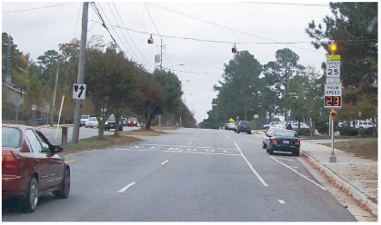

  - DSFS Graphic


- Pesti and McCoy, 2011

  - Study Characteristics
Item | Response
Authors | Pesti and McCoy
Title | Long-Term Effectiveness of Speed Monitoring Displays in Work Zones on Rural Interstate Highways
Publication year | 2011

  - Quality Screening
Quality Criteria | Response (Yes or No)
Were the study population and the context of the study well described? | Yes
Were the exposure variables valid implementations of the conditions that they were meant to represent? | Yes
Was the outcome variable both a reliable and valid measure of the outcome of interest? | Yes

  - Study Features
Feature | Study Information
Experimental Design | O-X-O
Safety Focus | Work zone
Graphic of DSFS available | Yes
Graphic of Layout available | Yes
Study restricted to free flow level of service | Yes
Classes of vehicles included | Passenger cars and trucks
Hypothesis 1 (H1) level | na
Hypothesis 2 (H2) level | B
Hypothesis 3 (H3) level | B
H1: Mean speed | na
H1: 85th percentile speed | na
H1: Percentage of drivers over speed limit | na
H1: Distribution of speed | na
H2: Mean speed | Significant reduction recorded
H2: 85th percentile speed | Reduction recorded
H2: Percentage of drivers over speed limit | Significant reduction recorded
H2: Distribution of speed | Significant reduction recorded
H3: Mean speed | Significant reduction recorded
H3: 85th percentile speed | Reduction recorded
H3: Percentage of drivers over speed limit | Significant reduction recorded
H3: Distribution of speed | No change
DSFS displays speed | Yes
DSFS speed lighting | LED
DSFS flashes (speed or other) | NS
Mobile DSFS units | Yes
Roadway type | Freeway
Area type (location) | Rural
Sidewalks present | No
Posted speed | 55 mph
Sensor positions | Upstream (-1150 ft); downstream (1000 ft from first DSFS, 1000 ft from second DSFS, and adjacent to third DSFS)
Number of sensors | 1,0,3
Sensor types | Lidar
Types of treatments | DSFS
Number of relevant sites | 1
Number of cases | 2
Duration of measurements before activation (“before” measurements) | 4 days
Time interval between “before” measurements and activation | 4 days
Duration of activation | 5 weeks
Time of day when speed is measured (AM/PM) | NS
Time of day when speed is measured (peak/off peak) | NS
Time intervals at which measurements were taken during activation (“during” measurements) | 1,2,3,4, and 5 weeks
Amount of time that elapsed after deactivation and prior to subsequent measurements (“after” measurements) | 1 week
Duration of “after” measurements | NS
Meta-analysis data available | Yes
Caveats | None
Best practices information available | No

  - Summary of Study
Three dynamic speed feedback signs (DSFS) were installed on a 2.7 mile stretch of roadway in between two work zones on I-80, a rural freeway near Lincoln, Nebraska. The effectiveness of the system was studied over a period of 5 weeks. The normal speed limit on I-80 is 75 mph, but the speed limit in the study area was 55 mph, due to the fact that it was a short segment in between two work zones.
Traffic speeds were measured once before DSFS deployment, five times during the 5-week deployment, and once after removal of the DSFS. The before studies were conducted four days before the DSFS were deployed. The DSFS were operated continuously for the next five weeks, during which traffic speeds were measured once each week at one-week intervals. Finally, one week after the removal of the DSFS another set of speed measurements was taken to determine if there were any residual speed-reduction effects of the system.
All measurements took place on the same day of the week, during approximately the same time period of the day, and under very similar traffic and environmental conditions (i.e., comparable traffic volumes, dry weather, and dry pavement). Measures were taken of the mean speed, 85th percentile speed, standard deviation of speeds, the percentage of vehicles complying with the speed limit, percentage complying with the speed limit plus 5 mph, and percentage complying with the speed limit plus 10 mph. Volume and truck percentages were also recorded.
The speed data were collected with LIDAR sensors, capable of measuring the speed of vehicles with an accuracy of ±1 mph. Vehicle speeds were measured at four locations: (1) 350 m (1,150 ft) upstream of the first DSFS where vehicles entered the study area, (2) approximately 305 m (1,000 ft) downstream of the first DSFS, (3) approximately 305 m (1,000 ft) downstream of the second DSFS, and (4) at the beginning of the lane closure taper where vehicles passed the third DSFS. Data were analyzed for each location. All DSFS displayed the speed of approaching vehicles via LED.
Independent variables were as follows: treatment and vehicle type. Dependent variables were as follows: mean speed, 85th percentile speed, standard deviation, the percentage of vehicles complying with the speed limit, percentage complying with the speed limit plus 5 mph, and percentage complying with the speed limit plus 10 mph. Hypotheses included: H1B, H2B, and H3B.
The article reported data for all six of the stated dependent variables for three locations (each just downstream of one of three DSFS), and for seven different times. The times included: before (4 days before deployment), during (at 1,2,3,4, and 5 weeks of deployment) and after (1 week after removal). The article also indicated whether differences were statistically significant.
Results. The results indicate an improvement in all measures of effectiveness at each observation point just downstream of the DSFS devices during their five-week deployment. The improvement was about a 3- to 4-mph reduction in mean speed, 2- to 7-mph reduction in 85th percentile speed, and about a 20- to 40-point increase in the percentage of vehicles complying with the speed limit and the 60-mph speed threshold. As expected, much smaller changes were observed upstream of the first DSFS. Statistically significant improvements in speed parameters and speed-limit compliance were observed at the measurement points downstream of the first two DSFS. The improvement in standard deviation and some compliance percentages were not statistically significant at the third DSFS. Greater speed reductions and compliance increases were observed for passenger cars than for other vehicles. H3: One week after the removal of the DSFS, there were still statistically significant speed reductions and compliance increases, although they were less than during the deployment.
Statistical Analysis. The statistical significance of the differences in the measures of effectiveness corresponding to the periods before, during, and after the use of the DSFS was determined. The t-test was used to evaluate the differences in mean speeds. The binomial proportion test was used to evaluate the statistical significance of differences in the 85th-percentile speeds, and the percentages complying with the speed limit and the speed thresholds of 5 and 10 mph above the speed limit. The F-test was used to check for statistically significant differences in the standard deviations of the speed distribution.
  - Study Schematic
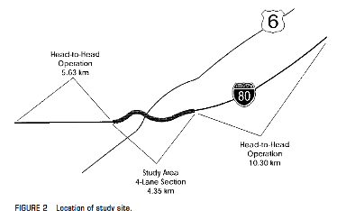
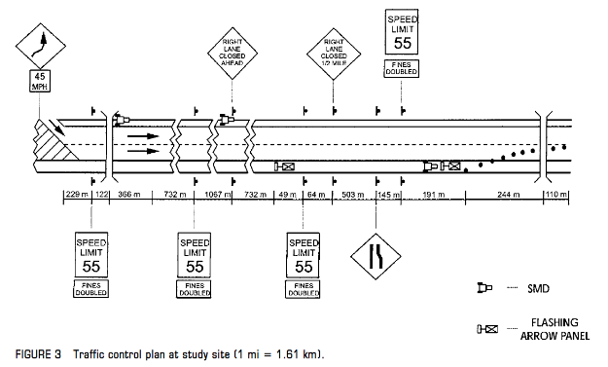
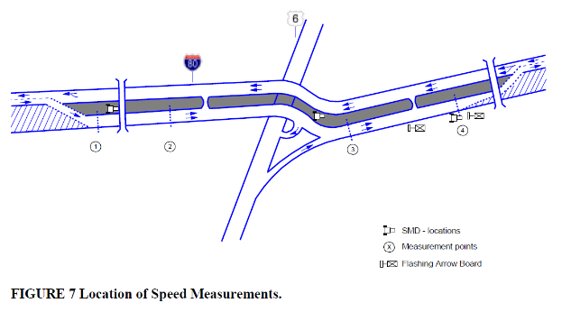

  - DSFS Graphic
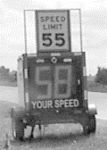

- Reddy, Datta, Savolainen, and Pinapaka, 2008

  - Study Characteristics
Item | Response
Authors | Reddy, Datta, Savolainen, and Pinapaka
Title | Evaluation of Innovative Safety Treatments: A Study of the Effectiveness of Motorist Awareness System in Construction Work Zones
Publication year | 2008

  - Quality Screening
Quality Criteria | Response (Yes or No)
Were the study population and the context of the study well described? | Yes
Were the exposure variables valid implementations of the conditions that they were meant to represent? | Yes
Was the outcome variable both a reliable and valid measure of the outcome of interest? | Yes

  - Study Features
Feature | Study Information
Experimental Design | O-X-O* (see summary)
Safety Focus | Work zone
Graphic of DSFS available | No
Graphic of Layout available | Yes
Study restricted to free flow level of service | NS
Classes of vehicles included | NS
Hypothesis 1 (H1) level | B
Hypothesis 2 (H2) level | B
Hypothesis 3 (H3) level | na
H1: Mean speed | Significant reduction recorded
H1: 85th percentile speed | Reduction recorded
H1: Percentage of drivers over speed limit | Significant reduction recorded
H1: Distribution of speed | Significant reduction recorded
H2: Mean speed | Significant reduction recorded
H2: 85th percentile speed | Reduction recorded
H2: Percentage of drivers over speed limit | Significant reduction recorded
H2: Distribution of speed | Significant reduction recorded
H3: Mean speed | Nothing reported
H3: 85th percentile speed | Nothing reported
H3: Percentage of drivers over speed limit | Nothing reported
H3: Distribution of speed | Nothing reported
DSFS displays speed | Yes
DSFS speed lighting | NS
DSFS flashes (speed or other) | Yes
Mobile DSFS units | Yes
Roadway type | Freeway
Area type (location) | Multiple
Sidewalks present | No
Posted speed | 70 mph
Sensor positions | Upstream (NS); adjacent (NS); downstream (NS)
Number of sensors | 1,1,1
Sensor types | Radar
Types of treatments | DSFS in combination with changeable message sign and flashing speed limit sign; police enforcement
Number of relevant sites | 2
Number of cases | 2
Duration of measurements before activation (“before” measurements) | Multiple
Time interval between “before” measurements and activation | Multiple
Duration of activation | Multiple
Time of day when speed is measured (AM/PM) | Multiple
Time of day when speed is measured (peak/off peak) | Multiple
Time intervals at which measurements were taken during activation (“during” measurements) | Multiple
Amount of time that elapsed after deactivation and prior to subsequent measurements (“after” measurements) | Multiple
Duration of “after” measurements | Multiple
Meta-analysis data available | Yes
Caveats | DSFS Not evaluated in isolation; distances of Sensors from DSFS NS
Best practices information available | No

  - Summary of Study
This study sought to measure the effectiveness of a group of interventions which collectively comprise the Florida Department of Transportation (FDOT) Motorist Awareness System (MAS). The MAS is intended to reduce travel speeds through work zones. The MAS includes DSFS, but it also includes additional portable changeable message signs and regulatory speed limit signs (with flashers) to alert motorists of work zone activities. The study evaluated the effectiveness of the MAS overall, but did not evaluate the effectiveness of the DSFS as an individual component. The study also investigated the additional impact of supplementary police enforcement.
The study investigated construction projects on two segments of Florida interstate highways: a suburban section of I-10 in Baker County, and a rural section of I-95 in Flagler County. Both sites were four lane-divided freeways with 70 mph posted speed limits prior to the work zones, although I-95 has three travel lanes in one direction at some locations. The speed limit within the work zone on I-10 was 60 mph. For the I-95 locations, the speed limit within the work zone was 70 mph for the control studies and either 55 mph or 60 mph for the treatment studies. This appears to be a flaw of the study for that location, if the speed limit for the control condition truly differed from the treatment condition. The authors did not address this in the paper.
Researchers indicated that the study used a “comparative parallel” evaluation methodology. In other words, this study did not involve the common “before” (pre-intervention), “during” (while the treatment is in place), and “after” (following the removal of the treatment) pattern observed in other studies. Instead, the control and treatment conditions occurred in an intermittent and alternating temporal pattern. The I-10 observations all took place over a two month span, whereas the I-95 observations spanned two years. Each individual observation period was one to two hours in duration, and there were 3-11 observation periods for the I-10 conditions and 5-16 observation periods for the I-95 conditions.
The work zone changed positions as work progressed. Thus, researchers were able to collect data at similar locations with and without the treatment condition but not necessarily at the identical locations. The researchers noted that road geometries, traffic, and weather conditions were quite similar along the study sections, making it possible to compare the test and control data collected at these sites. Speed data were collected for the control condition and the test condition at various times of the day and week. The researchers did conduct a suite of statistical tests to understand the variation within and across observations/locations.
Speeds were collected using radar at three relative locations (upstream, within the work zone, and downstream). However, the exact distance of those locations from the DSFS was not specified in the article. Measures were taken of the mean speeds, 85th percentile speeds, percent of speeding motorists, and variability of the speed distribution. Independent variables were as follows: presence or absence of the MAS treatment (including DSFS), location (upstream, within, or downstream of the work zone), and presence or absence of police enforcement. Dependent variables were as follows: mean speeds, 85th percentile speeds, percent of speeding motorists, and variability of the speed distribution. The major hypotheses evaluated were H1B and H2B.
The article reported sample size, mean speeds, 85th percentile speeds, percent of speeding motorists, and variability of the speed distribution for each treatment condition at each location.
Results. Overall, the MAS was effective in reducing vehicular speeds through construction work zones. Targeted supplementary police enforcement resulted in additional speed reductions. The MAS decreased the proportion of motorists traveling over the posted speed limit.
- Travel speeds, both the mean and 85th percentile speeds, were consistently lower at the locations within the work zones where the MAS was utilized in comparison to the control. The implementation of the MAS along I-10 reduced average speeds by an average of 1.5 miles per hour in comparison to the control. Combining MAS with enforcement resulted in additional reduction in mean speeds by 3 to 4 miles per hour in comparison to the control.
- The combination of the MAS with enforcement was also shown to decrease speeds in comparison to the control with enforcement along I-95. In general, speeds within the work zone were reduced by an average of 4 to 5 miles per hour.
- The variability of travel speeds along I-10 within the work zone decreased when MAS was utilized in comparison to the control.
- The proportions of drivers speeding within and near the end of the work zones were also substantially reduced when the MAS was utilized in comparison to the control under all scenarios. Further, combining MAS with enforcement produced more pronounced reductions both within and near the end of the work zone.
Statistical Analysis. “A number of statistical tests were conducted to determine whether the changes observed in the measures of effectiveness are attributable to the use of the motorist awareness system or simply due to chance. Statistical tests that were conducted to test the effectiveness include:
- One-Sample Kolmogorov-Smirnov (K-S) Test – to determine if the speed distributions are normally distributed
- F-Test – to determine if the variances are equal between the test and control groups
- Student’s t-Test and Analysis of Variance (ANOVA) – to determine if differences between mean speed and 85th percentile speed are statistically significant
- Z-Test – to determine if differences between the proportion of vehicles speeding are statistically significant”
  - Study Schematic
Control condition
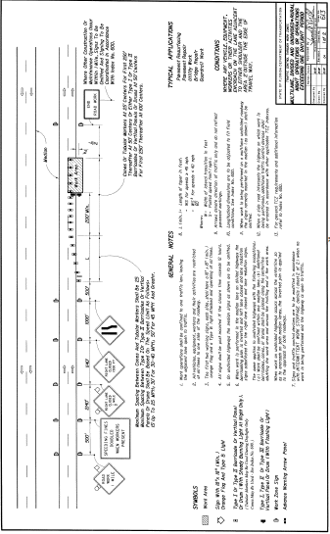

Treatment condition
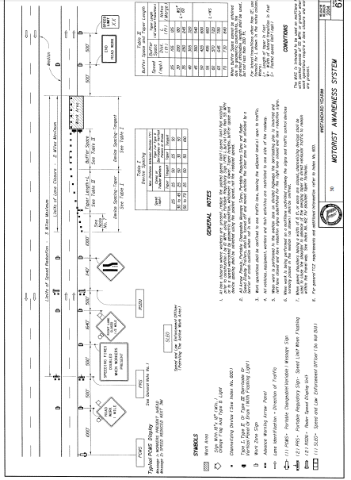
  - DSFS Graphic
Not provided.
- Roberts and Smaglik, 2012

  - Study Characteristics
Item | Response
Authors | Roberts and Smaglik
- Title | Driver Feedback on Monetary Penalty and Its Impact on Work Zone Speed
- Publication year | 2012

  - Quality Screening
Quality Criteria | Response (Yes or No)
- Were the study population and the context of the study well described? | Yes
- Were the exposure variables valid implementations of the conditions that they were meant to represent? | Yes
- Was the outcome variable both a reliable and valid measure of the outcome of interest? | Yes

  - Study Features
Feature | Study Information
Experimental Design | O-X-X-O
Safety Focus | Work zone
Graphic of DSFS available | No
Graphic of Layout available | Yes
Study restricted to free flow level of service | Yes
Classes of vehicles included | Passenger cars and trucks
Hypothesis 1 (H1) level | A
Hypothesis 2 (H2) level | A
Hypothesis 3 (H3) level | A
H1: Mean speed | Significant reduction recorded
H1: 85th percentile speed | Reduction recorded
H1: Percentage of drivers over speed limit | Significant reduction recorded
H1: Distribution of speed | Nothing reported
H2: Mean speed | Significant reduction recorded
H2: 85th percentile speed | Reduction recorded (only for display showing fine in addition to speed)
H2: Percentage of drivers over speed limit | Significant reduction recorded
H2: Distribution of speed | Nothing reported
H3: Mean speed | Significant reduction recorded
H3: 85th percentile speed | Significant reduction recorded (only for display showing fine in addition to speed)
H3: Percentage of drivers over speed limit | Reduction recorded for H3A, but for H3A' there was no change for the speed display only and an increase for the speed+fine display
H3: Distribution of speed | Nothing reported
DSFS displays speed | Yes
DSFS speed lighting | Yes
DSFS flashes (speed or other) | Yes
Mobile DSFS units | Yes
Roadway type | Collector
Area type (location) | Rural
Sidewalks present | No
Posted speed | 35 mph
Sensor positions | Upstream (-2088 ft); adjacent (-178 ft); downstream (792 ft)
Number of sensors | 1,1,1
Sensor types | Pneumatic
Types of treatments | DSFS (displaying speed and fine)
Number of relevant sites | 1
Number of cases | 2
Duration of measurements before activation (“before” measurements) | 1 week
Time interval between “before” measurements and activation | 0 days
Duration of activation | 1-2 weeks
Time of day when speed is measured (AM/PM) | Multiple
Time of day when speed is measured (peak/off peak) | Multiple
Time intervals at which measurements were taken during activation (“during” measurements) | NS
Amount of time that elapsed after deactivation and prior to subsequent measurements (“after” measurements) | 12 hours
Duration of “after” measurements | 4 days
Meta-analysis data available | Yes
Caveats | Flashing DSFS additionally displayed Fine $$ information and was deployed in the same location the week following the standard DSFS.
Best practices information available | No

  - Summary of Study
A Changeable Message Sign (CMSR) was installed at one site in Arizona. The context was a work zone on a rural state highway. Four sets of measurements were taken:
- Before the sign was activated, with only standard work zone signage;
- While the sign was active and displayed the driver’s speed;
- While the sign was active and alternated displaying the driver’s speed with a message showing their possible fine for speeding; and
- After the sign was removed, with only standard work zone signage.
Measurements were taken over 6 weeks, with each data set lasting 4 to 13 days. Data was taken at all times of day, but restricting to free flow traffic with at least 5 seconds headway.
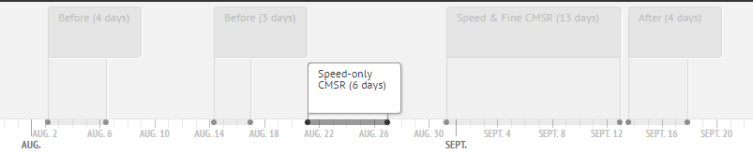
Measurements were taken with pneumatic sensors at three locations: upstream (-2088 ft); adjacent (-178 ft); and downstream (792 ft) at a point in the work zone where speed should be slowed. The posted speed was 50 mph upstream, and 35 mph at the CMSR and downstream (in the work zone). Measures were taken of mean speed, median speed, 85th percentile speed, percentage of drivers above the speed limit (in 5mph brackets), and sample size after data cleaning.
Data Reported. The article reported mean speed, median speed, 85th percentile speed, percentage of drivers above the speed limit (in 5mph brackets), and whether changes were statistically significant for each sensor location, time period, and treatment. Sample size and standard deviation were also provided.
Results. For H1, mean speed, 85th percentile speed, and percentage of drivers speeding in each bracket dropped significantly for both treatments, except the 60+mph speed bracket for the Speed Only treatment (no significant change). For H2, mean speed, 85th percentile speed, and percentage of drivers speeding in each bracket dropped significantly for both treatments relative to upstream, relative to at the CMSR, and relative to before the treatments, with the exception of comparing downstream 85th percentile speed to speed at the CMSR for the Speed Only treatment (no significant change there). For H3, mean speed decreased significantly relative to upstream, relative to at the CMSR (both treatments), and relative to before the treatments. 85th percentile speed decreased significantly relative to upstream, relative to at the CMSR (Speed and Fine treatment, no change relative to Speed Only treatment), and relative to before the treatments. The percentage of drivers over the speed limit, for all brackets, decreased significantly relative to before the treatments, increased significantly relative to during the Speed and Fine treatment, and had no significant change relative to the Speed Only treatment. Compared to upstream, after, the +5mph and +10mph brackets increased significantly and the other three brackets decreased significantly.
Statistical Analysis. Not described.
  - Study Schematic
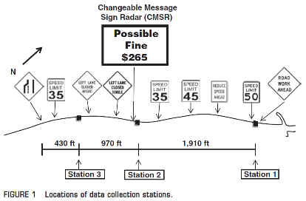
  - DSFS Graphic
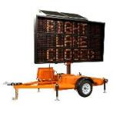
DSFS model cited in paper, image sourced from Ver-Mac company website: www.ver-mac.com/en/products/series/serie/message-signs/product/portable-changeable-message-sign-pcms/1
- Saito and Ash, 2005

  - Study Characteristics
Item | Response
Authors | Saito and Ash
Title | Speed Monitoring Displays: Increasing Speed Limit Compliance in Reduced Speed School Zones
Publication year | 2005

  - Quality Screening
Quality Criteria | Response (Yes or No)
Were the study population and the context of the study well described? | Yes
Were the exposure variables valid implementations of the conditions that they were meant to represent? | Yes
Was the outcome variable both a reliable and valid measure of the outcome of interest? | Yes

  - Study Features
Feature | Study Information
Experimental Design | O-X-O-O
Safety Focus | School zone
Graphic of DSFS available | Yes
Graphic of Layout available | No
Study restricted to free flow level of service | NS
Classes of vehicles included | NS
Hypothesis 1 (H1) level | B
Hypothesis 2 (H2) level | NA
Hypothesis 3 (H3) level | NA
H1: Mean speed | Significant reduction recorded (5 of 8 sites)
H1: 85th percentile speed | Nothing reported
H1: Percentage of drivers over speed limit | Nothing reported
H1: Distribution of speed | Nothing reported
H2: Mean speed | NA
H2: 85th percentile speed | NA
H2: Percentage of drivers over speed limit | NA
H2: Distribution of speed | NA
H3: Mean speed | NA
H3: 85th percentile speed | NA
H3: Percentage of drivers over speed limit | NA
H3: Distribution of speed | NA
DSFS displays speed | Yes
DSFS speed lighting | Yes
DSFS flashes (speed or other) | Yes
Mobile DSFS units | No
Roadway type | Local
Area type (location) | NS
Sidewalks present | NS
Posted speed | 20 mph
Sensor positions | Adjacent (NS)
Number of sensors | 0,2,0
Sensor types | Pneumatic
Types of treatments | DSFS
Number of relevant sites | 8
Number of cases | 8
Duration of measurements before activation (“before” measurements) | NS
Time interval between “before” measurements and activation | NS
Duration of activation | 3-6 months
Time of day when speed is measured (AM/PM) | Multiple
Time of day when speed is measured (peak/off peak) | Multiple
Time intervals at which measurements were taken during activation (“during” measurements) | 3-6 months. Some sites also had measurements after 4 or 8 weeks.
Amount of time that elapsed after deactivation and prior to subsequent measurements (“after” measurements) | NA
Duration of “after” measurements | NA
Meta-analysis data available | Yes
Caveats | No
Best practices information available | No

  - Summary of Study
Dynamic speed feedback signs (DSFS) were installed at eight sites in Utah. The style of DSFS was a Speed Measurement Display (see picture below). It was not clear from the study whether sites were rural or urban. The roadway was a straight segment, paved, with two-way traffic. There were two, four, or six lanes depending on the site. The posted speed was 20 mph. Measures were taken of the mean speed, 85th percentile speed, the percentage of vehicles exceeding the speed limit, the 10mph pace, and the percent of vehicles within the 10mph pace. The measures were gathered adjacent to the DSFS before and during the time that the DSFS was activated. The duration that the DSFS had been in place when measurements were taken ranged from 4 weeks to 6 months, partially deliberately and partially due to equipment malfunctions. There were no measurements after the DSFS was removed. Each set of measurements was taken over a four day weekday period, Monday-Thursday. Measurements were only taken when the school zone was in effect, but at various times between 7:30AM and 4PM. The time of day was tracked. Data were not averaged across the sites. Independent variables included treatment, duration of treatment, time of day, and number of lanes. Dependent variables included mean speed; 85th percentile speed; 10 mph pace; percent of vehicles exceeding the speed limit; and percent of vehicles within the 10mph pace. The major hypothesis was H1B. No statistical analysis was described to evaluate the hypotheses, only the raw data. However, results that were significant "based on a normal approximation test at a 95 percent confidence level" are identified.
Data Reported. Mean speed, 85th percentile speed, the percentage of vehicles exceeding the speed limit, the 10mph pace, the percent of vehicles within the 10mph pace, the sample size, and standard deviation for each site.
Results. Five sites showed a statistically significant decrease in mean speed for at least one set of measurements (out of two or three taken at different times of day). The significant decreases in mean speed ranged from .08 to 3.45, but most were between 1 and 3mph. Three sites showed a statistically significant increase in mean speed ranging from .55 to 2.3mph. There were no statistically signficant changes identified in the other measures, but they generally changed in the same direction as the mean speed with less magnitude.
Statistical Analysis. No statistical analyis was described, but changes to mean speed that are statistically significant "based on a normal approximation test at a 95 percent confidence level" are identified.
  - Study Schematic
Not provided.
  - DSFS Graphic

- Santiago-Chaparro, Chitturi, Bill, and Noyce, 2011

  - Study Characteristics
Item | Response
Authors | Santiago-Chaparro, Chitturi, Bill, and Noyce
Title | Spatial Effectiveness of Speed Feedback Signs
Publication year | 2011

  - Quality Screening
Quality Criteria | Response (Yes or No)
Were the study population and the context of the study well described? | Yes
Were the exposure variables valid implementations of the conditions that they were meant to represent? | Yes
Was the outcome variable both a reliable and valid measure of the outcome of interest? | Yes

  - Study Features
Feature | Study Information
Experimental Design | X-O
Safety Focus | NS
Graphic of DSFS available | Yes
Graphic of Layout available | Yes
Study restricted to free flow level of service | Yes
Classes of vehicles included | NS
Hypothesis 1 (H1) level | C
Hypothesis 2 (H2) level | C
Hypothesis 3 (H3) level | na
H1: Mean speed | Nothing reported
H1: 85th percentile speed | Nothing reported
H1: Percentage of drivers over speed limit | Nothing reported
H1: Distribution of speed | Nothing reported
H2: Mean speed | Nothing reported
H2: 85th percentile speed | Nothing reported
H2: Percentage of drivers over speed limit | Nothing reported
H2: Distribution of speed | Nothing reported
H3: Mean speed | NA
H3: 85th percentile speed | NA
H3: Percentage of drivers over speed limit | NA
H3: Distribution of speed | NA
DSFS displays speed | Yes
DSFS speed lighting | Yes
DSFS flashes (speed or other) | Yes
Mobile DSFS units | NS
Roadway type | Freeway
Area type (location) | Rural
Sidewalks present | No
Posted speed | NS
Sensor positions | Upstream (1,125 ft) through downstream (900 ft)
Number of sensors | 3
Sensor types | Radar
Types of treatments | DSFS
Number of relevant sites | 1
Number of cases | 1
Duration of measurements before activation (“before” measurements) | NA
Time interval between “before” measurements and activation | NA
Duration of activation | 18 months
Time of day when speed is measured (AM/PM) | Multiple
Time of day when speed is measured (peak/off peak) | Off peak
Time intervals at which measurements were taken during activation (“during” measurements) | 12 months
Amount of time that elapsed after deactivation and prior to subsequent measurements (“after” measurements) | NA
Duration of “after” measurements | NA
Meta-analysis data available | No
Caveats | None
Best practices information available | No

  - Summary of Study
Data were collected on State Highway 164, a two-lane rural highway in Washington County, Wisconsin with a posted speed limit of 55 miles per hour. Speeds were monitored upstream and downstream of the DSFS, which was installed for an 18-month period. Incidentally, DSFS were also installed concurrently at three other locations on Highway 164 to complement periodic police enforcement. Researchers attempted to assess the spatial effectiveness of the DSFS by using radar to record the speed trajectories of vehicles from 1,125 feet upstream to 900 feet downstream of the DSFS. In addition, video data were collected. Trajectories upstream of the sign were monitored from 11:00 a.m. to 1:00 p.m., while downstream trajectories were monitored from 2:00 p.m. to 4:00 p.m., therefore avoiding the morning and afternoon peak periods. Both were measured on the same day, one year after the initial DSFS installation.
Trajectories were obtained only for free-flowing vehicles. A free-flowing vehicle was defined as one that maintained at least an eight second gap to the leading vehicle. The change in vehicle speed was determined, as well as the corresponding speed profile when the vehicle approached the DSFS or receded from the DSFS. Change in speed upstream of the DSFS was defined as the difference between the first speed recorded and the speed at the end of the section. Accordingly, change in speed downstream of the DSFS was defined as the difference between the speed at the DSFS and the speed at the end of the section. A binary logistic regression model was developed to predict the probability of speed reduction as a function of initial speed.
The article only reported changes in speeds from the upstream to the adjacent and from the adjacent to the downstream. It did not report the actual speeds. Although the article reported changes in speeds, it did not report whether or not they were statistically significant.
Results. As expected, the model revealed that the greater the speeding, the higher was the probability of a vehicle reducing speed. Even drivers who were not speeding reduced their speed when approaching the DSFS, although with a lesser probability. The speed reductions were most apparent 1,200 to 1,400 feet upstream of the DSFS. Downstream, speeds started to increase again 300 to 500 feet past the DSFS; nonetheless, within 800 feet downstream of the sign, 49% (n=23) of the vehicles had reduced their speeds by at least 1.0 mile per hour.
Statistical Analysis. A binary logistic regression model was developed to predict the probability of speed reduction as a function of initial speed.

  - Study Schematic
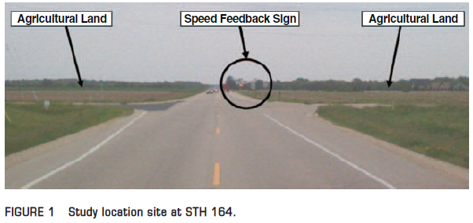
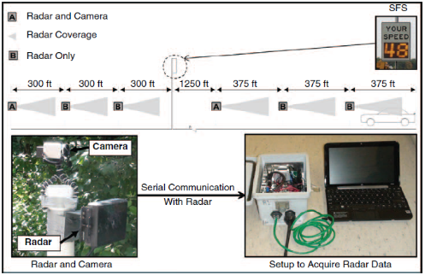
  - DSFS Graphic
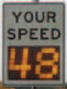

- Sarasua, Ogle, Davis, and Chowdhury, 2006

  - Study Characteristics
Item | Response
Authors | Sarasua, Ogle,Davis, and Chowdhury
Title | Better Management of Speed Control in Work Zones
Publication year | 2006

  - Quality Screening
Quality Criteria | Response (Yes or No)
Were the study population and the context of the study well described? | Yes
Were the exposure variables valid implementations of the conditions that they were meant to represent? | Yes
Was the outcome variable both a reliable and valid measure of the outcome of interest? | Yes

  - Study Features
Feature | Study Information
Experimental Design | O-X-O
Safety Focus | Work zone
Graphic of DSFS available | Yes
Graphic of Layout available | Yes
Study restricted to free flow level of service | Yes
Classes of vehicles included | Passenger cars and trucks
Hypothesis 1 (H1) level | B
Hypothesis 2 (H2) level | B
Hypothesis 3 (H3) level | NA
H1: Mean speed | Significant reduction recorded
H1: 85th percentile speed | Reduction recorded
H1: Percentage of drivers over speed limit | Significant reduction recorded
H1: Distribution of speed | Nothing reported
H2: Mean speed | Significant reduction recorded
H2: 85th percentile speed | Reduction recorded
H2: Percentage of drivers over speed limit | Significant reduction recorded
H2: Distribution of speed | Nothing reported
H3: Mean speed | Nothing reported
H3: 85th percentile speed | Nothing reported
H3: Percentage of drivers over speed limit | Nothing reported
H3: Distribution of speed | Nothing reported
DSFS displays speed | Multiple
DSFS speed lighting | Yes
DSFS flashes (speed or other) | Multiple
Mobile DSFS units | Multiple
Roadway type | Freeway
Area type (location) | NS
Sidewalks present | NS
Posted speed | 35-65 mph
Sensor positions | Upstream (at least -500 ft), adjacent (150-200 ft ) and downstream ( at least 1200 ft)
Number of sensors | 1,1,1
Sensor types | Multiple (laser, radar, and video)
Types of treatments | Changeable message sign with radar, speed monitoring display, police enforcement, speed activated blinker
Number of relevant sites | 17
Number of cases | 17
Duration of measurements before activation (“before” measurements) | 1 hour
Time interval between “before” measurements and activation | NS
Duration of activation | 1 hour
Time of day when speed is measured (AM/PM) | Multiple
Time of day when speed is measured (peak/off peak) | Multiple
Time intervals at which measurements were taken during activation (“during” measurements)
Amount of time that elapsed after deactivation and prior to subsequent measurements (“after” measurements) | NA
Duration of “after” measurements | NA
Meta-analysis data available | Yes
Caveats | Graphical only
Best practices information available | No

  - Summary of Study
This study evaluated the effectiveness of a variety of devices and strategies for reducing vehicle speeds in work zones on highways in South Carolina. The devices selected were as follows, with bold font to emphasize those relevant to this literature review:
- Drone radar
- Portable rumble strips
- Changeable message sign with radar. Message panel measured 126 inches wide by 76 inches high. It displayed a default message unless cars were speeding, in which case it displayed a warning to slow down, as shown in the four-stage sequence in Figure 4.4, pasted below.
- DSFS with changeable message sign. Equipped with a programmable two-line message panel capable of displaying five 12-inch characters per line. Speeds were displayed below the lines of text by two 24-inch digits. For this study, it asked drivers to “stay alert” unless they were speeding, in which case it alternated “watch speed” with either “you are speeding” or “fines ahead,” depending on whether there was law enforcement. It was mounted on the rear of a van.
- Novel speed activated sign designed by the researchers. 4-foot by 4-foot corrugated plastic reflective sign with 6-inch lettering reading “YOU ARE SPEEDING IF FLASHING,” with a flashing light on top.
Some of the devices were also studied in combination with police enforcement:
- Marked enforcement: The marked police vehicle remained stationary throughout the data collection period at a distance of 500 feet from the sign. The police officer was in the vehicle, but did not issue any tickets.
- Unmarked enforcement: The unmarked police vehicle monitored speeds and actively ticketed vehicles. The sign displayed “fines ahead” to speeding vehicles.
The typical data collection was one hour for each condition, both with and without the treatment implemented. Each time researchers made sure to collect the minimum sample size necessary to report results at a 95% level of confidence, which they estimated as 96.
Data were collected at up to three stations in each work zone studied: upstream (using laser), adjacent (using radar or video), and downstream (using radar or video). The exact position of each sensor varied for each work site, but in general, the upstream sensors were at least 500 ft upstream of the treatment, the adjacent sensors were about 150-200 ft downstream of it, and the downstream sensors were at least an additional 800 ft downstream. In most cases, speed data were collected for two conditions—one without any countermeasure and one with a countermeasure. Data collectors with the radar units attempted to hide behind vegetation and roadside structures to avoid being seen so as not to skew or bias the data. Data were only collected for platoon leaders, so speeds could be considered free flow.
Tables 4.1 and 4.2 in the publication summarize all of the data collection sites and the evaluated measures at each. The sites relevant to this analysis include the following.
Construction Sites:
- I-585, speed limit 45 mph, tested drone radar and the changeable message sign with radar
- SC Route 72 in Laurens County, tested drone radar, speed activated sign, and changeable message sign with radar
- SC Route 290 in Spartanburg County, tested speed activated sign and changeable message sign with radar
- SC Route 101 in Spartanburg County, tested changeable message sign with radar, the speed activated sign, and the speed monitoring display with changeable message sign.
- SC Route 219 in Newberry, South Carolina, speed limit 45 mph, tested speed activated sign
- US Route 278 in Hilton Head, South Carolina, speed limit 45 mph, tested dual speed activated signs and the speed monitoring display with changeable message sign
- SC Route 121 in Newberry County, speed limit 45 mph, tested and the speed monitoring display with changeable message sign
- SC Route 295, speed limit 45 mph, tested and the speed monitoring display with changeable message sign in conjunction with police enforcement
- SC Route 292, speed limit 45 mph, tested and the speed monitoring display with changeable message sign in conjunction with police enforcement
Maintenance Work Sites:
- US Highway 72 in Abbeville County, tested speed monitoring display with changeable message sign
- US Highway 123/76 in Pickens County, speed limit 35 mph, tested modified speed-activated sign setup
- US Highway 123 in Pickens County, tested speed monitoring display with changeable message sign
The measures of effectiveness were mean speed, 85th percentile speed, and the percent of drivers exceeding the speed limit. The hypotheses investigated were H1B and H2B.
The publication presented summary data on mean speeds, 85th percentile speeds, and the percent of speeders, but only in graphical format, in the form of histograms of speed observations and other similar graphics.
Results. Researchers noted that the results of the analysis show that all of the speed control devices studied during this project have the capability of lowering speeds.
- Changeable message sign: All of four of the sites showed a significant reduction in mean speeds adjacent to the sign for all of the message sequences with the exception of only one message sequence. It also produced a significant reduction in vehicles exceeding the speed limit by more than 5 mph at all sites and in vehicles exceeding it by more than 10 mph at almost all sites.
- Speed activated sign: Showed a significant reduction in the mean speeds adjacent to the sign for nearly all of the data sets at the six sites when the speed-activated sign was on. Produced a significant reduction in vehicles exceeding the speed limit.
- Speed monitoring display with changeable message sign: Five of five construction sites showed a significant reduction in mean speeds between the upstream and downstream locations and a significant reduction in the percent of vehicles exceeding the speed limit by five mph. However, the two maintenance sites did not show significant reductions. The speed display coupled with enforcement did not produce results much different from the display-only treatment.
Statistical Analysis. “Sufficient data were collected to ensure a confidence level of 95 percent. Researchers assumed that the data followed the normal distribution. Based on this assumption, they used parametric hypothesis testing to test for equal means (two-sample t-test) and the percentage of vehicles exceeding the speed limit (z-statistic). They used non-parametric testing to compare the 85th percentile speeds.”
  - Study Schematic
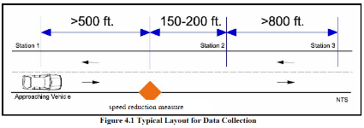
  - DSFS Graphic
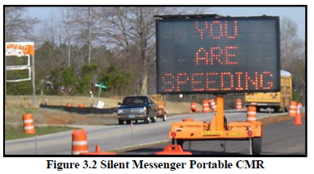
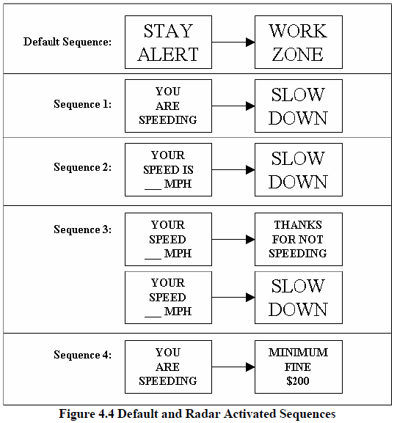

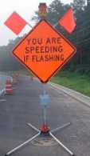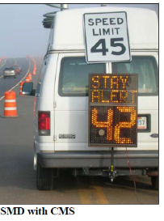

- Schoenecker, Sandberg, Sebastian, and Soler, 2008

  - Study Characteristics
Item | Response
Authors | Schoenecker, Sandberg, Sebastian, and Soler
Title | Long-term Effectiveness of Dynamic Speed Monitoring Displays for Speed Management at Speed Limit Transitions
Publication year | 2008

  - Quality Screening
Quality Criteria | Response (Yes or No)
Were the study population and the context of the study well described? | Yes
Were the exposure variables valid implementations of the conditions that they were meant to represent? | Yes
Was the outcome variable both a reliable and valid measure of the outcome of interest? | Yes

  - Study Features
Feature | Study Information
Experimental Design | O-X-O-O-O
Safety Focus | Transition zone
Graphic of DSFS available | Yes
Graphic of Layout available | No
Study restricted to free flow level of service | NS
Classes of vehicles included | NS
Hypothesis 1 (H1) level | B
Hypothesis 2 (H2) level | NA
Hypothesis 3 (H3) level | NA
H1: Mean speed | Significant reduction recorded
H1: 85th percentile speed | Reduction recorded
H1: Percentage of drivers over speed limit | NA
H1: Distribution of speed | Nothing reported
H2: Mean speed | NA
H2: 85th percentile speed | NA
H2: Percentage of drivers over speed limit | NA
H2: Distribution of speed | Nothing reported
H3: Mean speed | NA
H3: 85th percentile speed | NA
H3: Percentage of drivers over speed limit | NA
H3: Distribution of speed | Nothing reported
DSFS displays speed | Yes
DSFS speed lighting | LED
DSFS flashes (speed or other) | No
Mobile DSFS units | No
Roadway type | Collector
Area type (location) | Rural to urban transition
Sidewalks present | NS
Posted speed | Multiple
Sensor positions | Upstream (-1/3 to -1/2 mile); adjacent (0 ft)
Number of sensors | 1,1,0
Sensor types | Pneumatic
Types of treatments | DSFS
Number of relevant sites | 4
Number of cases | 4
Duration of measurements before activation (“before” measurements) | NS
Time interval between “before” measurements and activation | NS
Duration of activation | 1 year
Time of day when speed is measured (AM/PM) | All measurements were taken mid-week for 48 to 72 consecutive hours simultaneously.
Time of day when speed is measured (peak/off peak) | Multiple
Time intervals at which measurements were taken during activation (“during” measurements) | 1 week, 2 months, 7 months, and 1 year
Amount of time that elapsed after deactivation and prior to subsequent measurements (“after” measurements) | NA
Duration of “after” measurements | NA
Meta-analysis data available | Yes
Caveats | None
Best practices information available | No

  - Summary of Study
Dynamic speed feedback signs (DSFS) were installed at four experimental sites in Washington and Dakota Counties, Minnesota. There was also one control site. The criteria used to identify the sites were the following:
- Located on county controlled two-lane roads within Washington and Dakota Counties, Minnesota.
- Transition from a rural high speed highway to an urbanized area.
- Reduction in posted speed limit of 10 mph or greater at the transition.
- Existing history of speed related safety concerns.
- No other engineering measures planned at the site for at least 12 months.
The posted speeds were as follows:
- Site 1 (Hugo): 50 to 30 mph
- Site 2 (Bailey): 55 to 40 mph
- Site 3 (Hastings 1): 55 to 45 mph
- Site 4 (Hastings 2): 45 to 35 mph
- Site 5 (Stonebridge, control site): 55 to 30 mph
Vehicle speeds were binned in 1 mph increments at 15-minute intervals. All measurements were taken mid-week for 48 to 72 consecutive hours simultaneously at both the upstream and DSFS positions. Measures were taken of mean speed; 50th, 85th, and 95th percentile speeds; and 10 mph pace. These measure were taken 1/3 to 1/2 mile upstream and at the DSFS, which was co-located with the official speed transition. The measures were gathered before and during activation (1 week, 2 months, 7 months, 1 year). Data were not averaged across the sites. Independent variables were as follows: treatment, duration of treatment, time of day, upstream vehicle speed, traffic volume. Dependent variables were as follows: mean speed; 50th (median), 85th, and 95th percentile speeds; 10-mph pace. The major hypothesis was H1B. The publication reported mean speed; 50th, 85th, and 95th percentile speed; 10 mph pace; sample size; standard deviation; and average daily traffic volume
Results. The study reported mean speed results in the tables for each site, but did not report a summary of results across all of the studies. All of the experimental sites showed a statistically and practically significant reduction in mean speed at the DSFS, which persisted throughout the study (one year). The control site did not show a reduction in speed. The results of the study indicated that DSFS signs at transitions zones have a significant long-term (one year or greater) positive effect on driver speed. This study found overall decreases in speed of approximate six to eight mph at the transition point. The data showed the overall results across all the DSFS sign locations were fairly consistent. The study found:
- Speed reductions of approximately 6-8 mph in the 85th percentile speed (averaging 6.9 mph).
- Average speed reductions of 6.3 and 7.0 mph, respectively, for the 50th and 95th percentile speeds.
- Decrease of 10 mph in the 10 mph Pace
- Consistent reductions through all time frames including the 24-hour data, AM peak hour, and PM peak hour.
- Consistent shift across the entire speed distribution to lower speeds.
- At the upstream locations and the control site, the corresponding speeds were either flat or increased slightly over the course of the research.
Statistical Analysis. "Statistical analyses were run on the data comparing changes in vehicle speed distributions as a function of time period and location. Significance testing included an analysis of Variance, Z-test, t-test and Odds Ratio. All statistical measures showed highly significant associations (alpha < 0.01) between the presence of a DSFS and speed reductions within the transition zone."
  - Study Schematic
Not provided.
  - DSFS Graphic
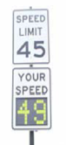

- Teng, Xu, Li, Kwigizile, and Gibby, 2009

  - Study Characteristics
Item | Response
- Authors | Teng, Xu, Li, Kwigizile, and Gibby
- Title | Evaluation of Speed Monitoring Displays for Work Zones in Las Vegas, Nevada
- Publication year | 2009

  - Quality Screening
Quality Criteria | Response (Yes or No)
Were the study population and the context of the study well described? | Yes
Were the exposure variables valid implementations of the conditions that they were meant to represent? | Yes
Was the outcome variable both a reliable and valid measure of the outcome of interest? | Yes

  - Study Features
Feature | Study Information
Experimental Design | O-X-O-X-O-X-O-X-O-X-O
Safety Focus | Work zone
Graphic of DSFS available | Yes
Graphic of Layout available | Yes
Study restricted to free flow level of service | Yes
Classes of vehicles included | Passenger cars and trucks
Hypothesis 1 (H1) level | B
Hypothesis 2 (H2) level | B
Hypothesis 3 (H3) level | na
H1: Mean speed | Significant reduction recorded
H1: 85th percentile speed | Reduction recorded
H1: Percentage of drivers over speed limit | Significant reduction recorded
H1: Distribution of speed | Nothing reported
H2: Mean speed | Significant reduction recorded
H2: 85th percentile speed | Reduction recorded
H2: Percentage of drivers over speed limit | Significant reduction recorded
H2: Distribution of speed | Nothing reported
H3: Mean speed | NA
H3: 85th percentile speed | NA
H3: Percentage of drivers over speed limit | NA
H3: Distribution of speed | NA
DSFS displays speed | Yes
DSFS speed lighting | LED
DSFS flashes (speed or other) | Multiple
Mobile DSFS units | Yes
Roadway type | Multiple
Area type (location) | Rural
Sidewalks present | No
Posted speed | 45 mph
Sensor positions | Downstream (200 ft)
Number of sensors | 0,0,2
Sensor types | Magnetic
Types of treatments | DSFS (large and small, flashing and non-flashing, 1 device or 2 in series)
Number of relevant sites | 1
Number of cases | 1
Duration of measurements before activation (“before” measurements) | 5 days
Time interval between “before” measurements and activation | 6 days
Duration of activation | 5 days
Time of day when speed is measured (AM/PM) | Multiple
Time of day when speed is measured (peak/off peak) | Multiple
Time intervals at which measurements were taken during activation (“during” measurements) | 1 week, 2 months
Amount of time that elapsed after deactivation and prior to subsequent measurements (“after” measurements) | NA
Duration of “after” measurements | NA
Meta-analysis data available | Yes
Caveats | Only graphical data
Best practices information available | Yes

  - Summary of Study
This study evaluated how the characteristics of a DSFS system (e.g., message size, presence of flashing, number of DSFS units) may impact effectiveness in terms of vehicle speed reduction. Researchers collected speed data for different treatments and developed regression models to estimate the speeding likelihood and vehicle speeds for various treatment conditions, based on free-flow speed data. Field tests were conducted at two sites in the vicinity of Las Vegas, Nevada. However, only one of the sites (county arterial CR-215) included a “before” condition in which speeds were collected in the absence of any DSFS. The other site is not relevant for this review because it did not include any means of comparing a DSFS condition to a non-DSFS condition. The remainder of this review focuses on details for the one relevant site.
Researchers collected at least five days of vehicle speed data for each test condition. Testing of the treatment (“during”) conditions began six days after the “before” measurement period. All of the various treatment conditions were tested in sequence over a period of two months. Data were collected using a magnetometer 200 feet downstream of each DSFS. In one treatment condition there was only one DSFS, but in the other treatment conditions there were two DSFS units, spaced 2,000 feet apart, with a horizontal curve between these two locations, making it impossible for motorists to see the DSFS at the second location when they saw the DSFS at the first location.
Treatment condition | Location 1 | Location 2 (2,000 feet downstream)
1 (“before”) | No DSFS | No DSFS
2 | Small DSFS | No DSFS
3 | Big DSFS | Small DSFS
4 | Big DSFS with fast flashing | Small DSFS
5 | Big DSFS with slow flashing | Small DSFS
6 | “Slow Down” message | Small DSFS

Measures were taken of the mean speed, 85th percentile speed, and percent of vehicles exceeding the speed limit. Independent variables were as follows: treatment and location. Dependent variables were as follows: mean speed, 85th percentile speed, and percent of vehicles exceeding the speed limit. The major hypotheses evaluated were H1B and H2B.
The article reported approximate observed mean speed data for each treatment condition in the form of graphs. It also reported the results of two regression analyses on speeding likelihood (one for the left lane, and the other for the right lane). The goal of the regression modeling was to reveal the relative performance of the treatment scenarios for different vehicles.
Results. The average speeds under the tested scenarios with the presence of a speed trailer (“during condition”) were lower than the average speed under the “before condition” for the traffic at the left and right lanes and at both the first and second locations. The scenario with a non-flashing big DSFS had the lowest speeds compared with other scenarios, and the scenario with a non-flashing small DSFS was second, followed by the scenario with a large DSFS with flashing features and a warning message. The presence of a second DSFS sign appeared to result in a further reduction in speeds for vehicles traveling in the right lane.
Statistical Analysis. The authors conducted regression analyses and recorded information on statistical significance for the resulting coefficients. The authors also noted: “The results of the likelihood ratio tests shown in these two tables indicate that these two outcome models were justified statistically. The R-square values of the two linear regression models for speeds are low. Because the purpose of the modeling was to reveal the relative performance of the scenarios for different vehicles, the estimation accuracy as reflected by R-square values became secondary in this study.”
  - Study Schematic
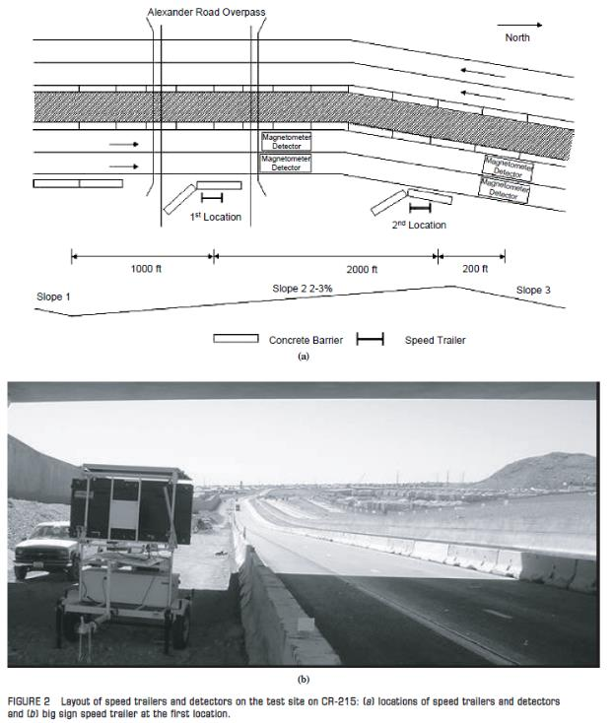

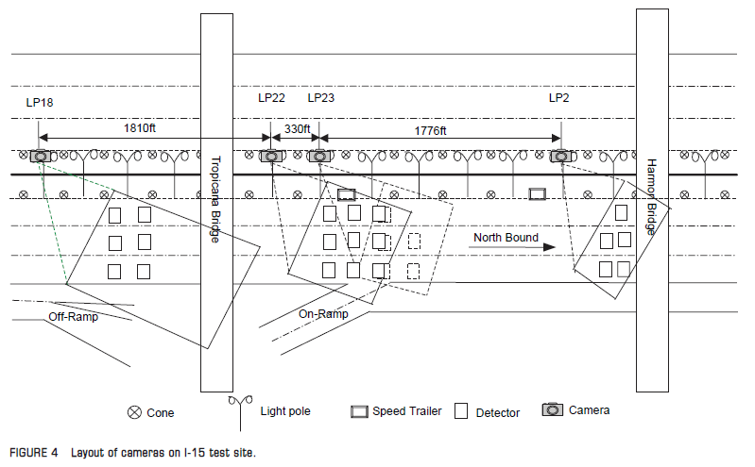

DSFS Graphic
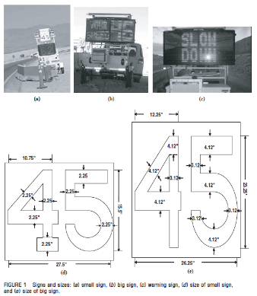

- Tribbett, McGowen, and Mounce, 2000

  - Study Characteristics
Item | Response
Authors | Tribbett, McGowen, and Mounce
Title | An Evaluation of Dynamic Curve Warning Systems in the Sacramento River Canyon: Final Report
Publication year | 2000

  - Quality Screening
Quality Criteria | Response (Yes or No)
Were the study population and the context of the study well described? | Yes
Were the exposure variables valid implementations of the conditions that they were meant to represent? | Yes
Was the outcome variable both a reliable and valid measure of the outcome of interest? | Yes

  - Study Features
Feature | Study Information
Experimental Design | O-X-O-O
Safety Focus | Horizontal curve
Graphic of DSFS available | Yes
Graphic of Layout available | Yes
Study restricted to free flow level of service | Yes
Classes of vehicles included | Passenger cars and trucks
Hypothesis 1 (H1) level | NA
Hypothesis 2 (H2) level | B
Hypothesis 3 (H3) level | na
H1: Mean speed | Nothing reported
H1: 85th percentile speed | Nothing reported
H1: Percentage of drivers over speed limit | Nothing reported
H1: Distribution of speed | Nothing reported
H2: Mean speed | Significant reduction at 3 of 5 sites for trucks and 2 of 5 for cars
H2: 85th percentile speed | Nothing reported
H2: Percentage of drivers over speed limit | Nothing reported
H2: Distribution of speed | Nothing reported
H3: Mean speed | Nothing reported
H3: 85th percentile speed | Nothing reported
H3: Percentage of drivers over speed limit | Nothing reported
H3: Distribution of speed | Nothing reported
DSFS displays speed | Yes
DSFS speed lighting | Yes
DSFS flashes (speed or other) | NS
Mobile DSFS units | No
Roadway type | Freeway
Area type (location) | Rural
Sidewalks present | No
Posted speed | 55 to 65 mph
Sensor positions | Adjacent (-300 to 0 ft) and downstream (ranging from 100 to 800 ft)
Number of sensors | 3
Sensor types | Manual (stopwatch)
Types of treatments | DSFS and changeable message sign
Number of relevant sites | 5
Number of cases | 10
Duration of measurements before activation (“before” measurements) | 3 days
Time interval between “before” measurements and activation | 9 months
Duration of activation | 10 months
Time of day when speed is measured (AM/PM) | Multiple
Time of day when speed is measured (peak/off peak) | Multiple
Time intervals at which measurements were taken during activation (“during” measurements) | 2, 5, and 10 months
Amount of time that elapsed after deactivation and prior to subsequent measurements (“after” measurements) | NA
Duration of “after” measurements | NA
Meta-analysis data available | Yes
Caveats | None
Best practices information available | No

  - Summary of Study
Five dynamic curve warning systems were installed by the California Department of Transportation (Caltrans) to notify motorists of alignment changes and speed advisories in the Sacramento River Canyon, a mountainous area on Interstate 5 between Redding and Dunsmuir. The individual sign systems included a changeable message sign (CMS) to display both text and diagrammatic curve warnings. The CMS sign systems were also coupled with a radar measurement and display so that both the advisory speed and operating speed of the approaching vehicles would be identified.
Mean speed was the only speed-related measure of effectiveness evaluated in the study. However, the study also investigated non-speed-related measures of effectiveness relevant to safety, including: frequency of crashes, frequency of erratic maneuvers, and reported change in behavior. Finally, the study also evaluated some measures of effectiveness not directly relevant to safety, including: reported public acceptance and reported maintenance requirements.
The speed limit for trucks and autos with trailers was 55 mph for all study sites throughout the analysis period. For passenger cars, the speed limit was 65 mph for the La Moine and Sims Road sites throughout the study period. At the other sites, the speed limit for passenger cars was 55 mph in the “before” condition (the first data collection trip), but was subsequently increased to 65 mph prior to the “during” measurement (the second and all subsequent data collection trips).
To collect this data, a total of four site visits were completed over the course of the evaluation including:
- Before sign deployment (9 months)
- During (at 2 months, 5 months, and 10 months)
Data were collected during daylight hours. The weather for all of the sites for each of the trips was sunny and clear, with the exception of the Sidehill Viaduct and O’Brien sites in January 2000 when it was raining and/or the roadway was wet. During each of the four site visits, vehicle speeds were measured at two locations at each site: at the DSFS location (or planned location) and then at the approximate beginning of the curve. Vehicle speeds were measured manually by researchers timing drivers with a stopwatch as they crossed over a 300 foot span. Data collection personnel measured speeds from a vantage point well away from traffic. Due to the low traffic volumes at the designated study sites, researchers considered all vehicles to be operating at a free- flow speed.
The first speed measurement section was measured from 300 feet upstream of the sign to the sign location, and the second section was measured from 300 feet upstream of the curve to the approximate beginning of the curve. The sign at each location was a 10-foot by 7-foot full matrix light-emitting diode (LED) sign supplied by American Signal Company that allows for 50 columns and 28 rows of lights.
The authors noted: “In retrospect, it might have been more appropriate to have positioned the first speed measurement section farther upstream so as to measure the speed at the driver’s first sight of the dynamic curve warning system. It is possible that drivers had already seen the dynamic curve warning system and began their deceleration process before reaching the first speed measurement section, in which case both the initial speed measurement and the overall change in speed would have been underestimated.”
Additionally, researchers collected, but did not analyze, radar measurements on subsequent unspecified data collection dates. They did report this data in the appendix. Data were collected at three locations:
- Location 1: 1000 feet upstream of the sign
- Location 2: middle of the first stopwatch speed measurement section (150 feet upstream of the sign)
- Location 3: middle of second stopwatch speed measurement section (150 feet upstream of the beginning of the curve)
Data were reported separately for trucks and passenger cars, and included mean speeds in addition to other non-speed-related measures of effectiveness.
Results. The authors reported that: “preliminary results indicate reductions in both accidents and operating speeds at selected sites based upon assessment of limited data available and evaluation time period.” For trucks, the study observed significant decreases in mean speed for three of five sites, although one of those showed that speeds rebounded in the third and fourth measurement periods. Two of five sites did not show any significant decrease. For passenger cars, the study observed significant decreases in mean speed for two of five sites, while three of five showed no significant change.
Statistical Analysis. “In order to determine if observed changes in vehicle speeds or erratic maneuvers were statistically significant, standard statistical analysis methods were used, as described by Kleinbaum, Kupper, and Muller, in Applied Regression Analysis and Other Multivariable Methods: 2nd edition, Belmont, California, 1988. For each statistical test, a 95% confidence level (a = 0.05) was used to determine statistical significance. Speed and erratic maneuver data were compared using two sample t-tests and two sample binomial tests.”
  - Study Schematic
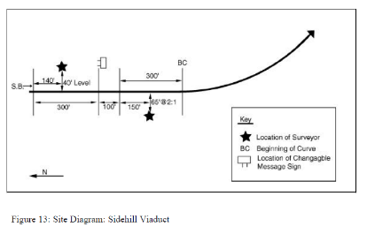
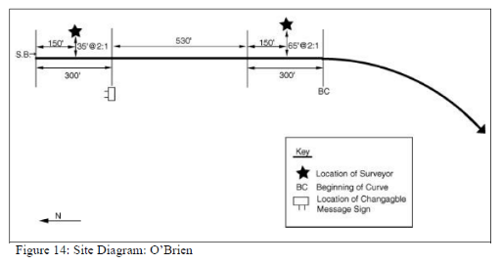
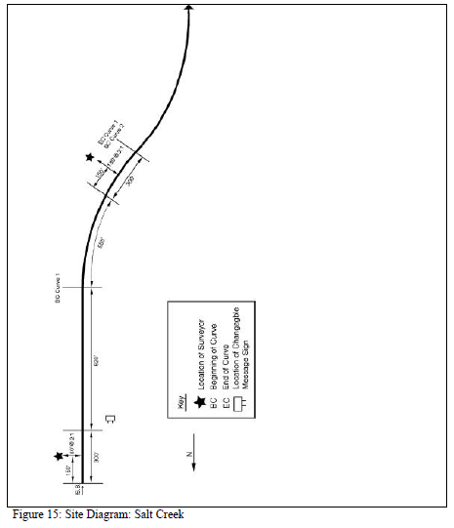
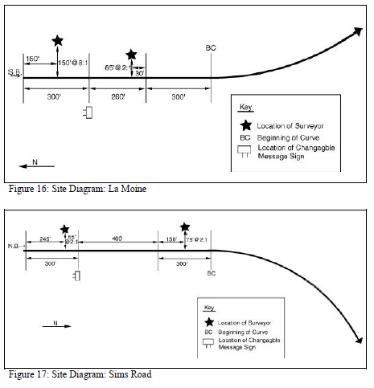

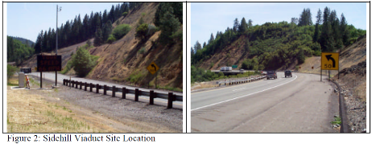
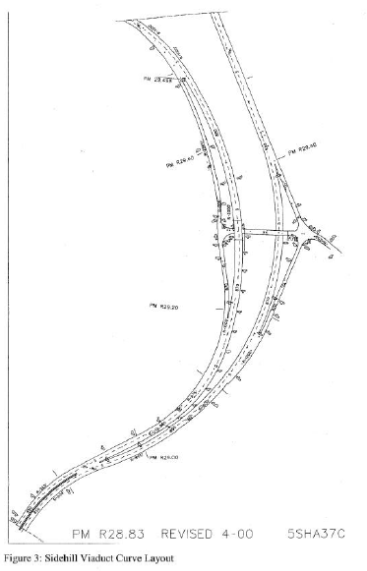
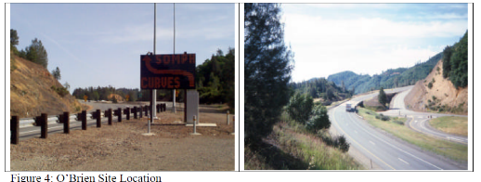
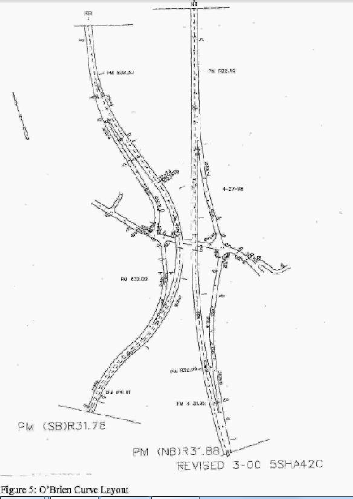
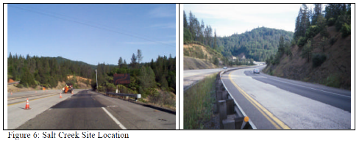
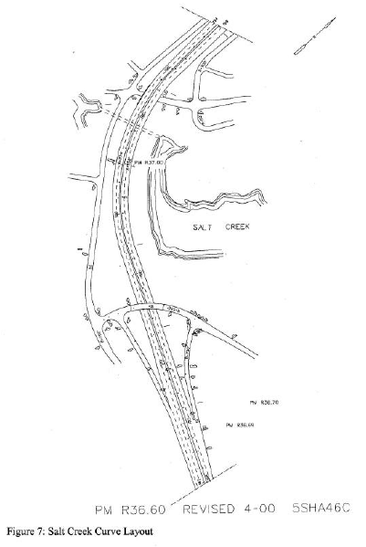
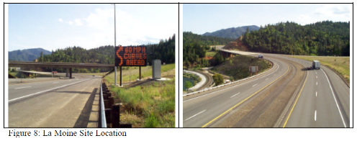
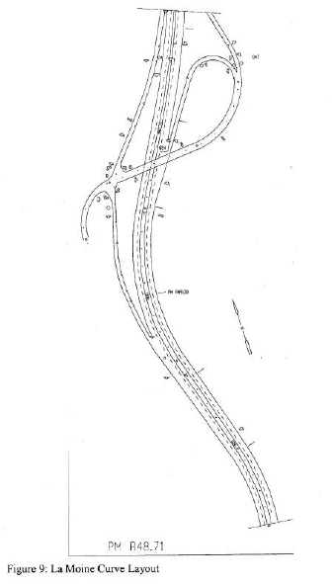
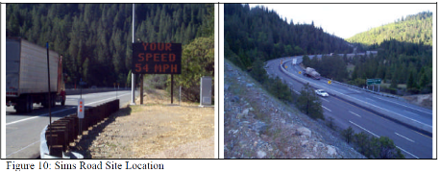
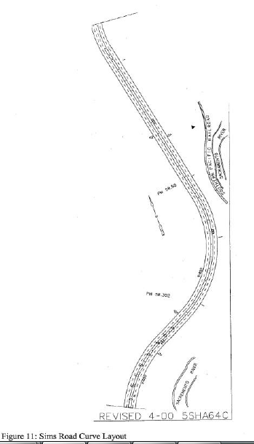
  - DSFS Graphic
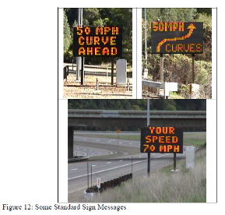
- Ullman and Rose, 2005

  - Study Characteristics
Item | Response
- Authors | Ullman and Rose
- Title | Evaluation of Dynamic Speed Display Signs
- Publication year | 2005

  - Quality Screening
Quality Criteria | Response (Yes or No)
Were the study population and the context of the study well described? | Yes
Were the exposure variables valid implementations of the conditions that they were meant to represent? | Yes
Was the outcome variable both a reliable and valid measure of the outcome of interest? | Yes

  - Study Features
Feature | Study Information
Experimental Design | O-X-O-O
Safety Focus | Multiple
Graphic of DSFS available | Yes
Graphic of Layout available | No
Study restricted to free flow level of service | Yes
Classes of vehicles included | Passenger cars and trucks
Hypothesis 1 (H1) level | B
Hypothesis 2 (H2) level | NA
Hypothesis 3 (H3) level | NA
H1: Mean speed | Significant reduction recorded
H1: 85th percentile speed | Reduction recorded
H1: Percentage of drivers over speed limit | Significant reduction recorded
H1: Distribution of speed | Nothing reported
H2: Mean speed | NA
H2: 85th percentile speed | NA
H2: Percentage of drivers over speed limit | NA
H2: Distribution of speed | Nothing reported
H3: Mean speed | NA
H3: 85th percentile speed | NA
H3: Percentage of drivers over speed limit | NA
H3: Distribution of speed | Nothing reported
DSFS displays speed | Yes
DSFS speed lighting | LED
DSFS flashes (speed or other) | NS
Mobile DSFS units | No
Roadway type | Multiple
Area type (location) | NS
Sidewalks present | NS
Posted speed | Multiple
Sensor positions | Upstream (-3000 to -2000 ft); adjacent (0 ft)
Number of sensors | 1,1,0
Sensor types | Lidar
Types of treatments | DSFS
Number of relevant sites | 7
Number of cases | 9
Duration of measurements before activation (“before” measurements) | 2 days
Time interval between “before” measurements and activation | NS
Duration of activation | 6-17 weeks
Time of day when speed is measured (AM/PM) | NS
Time of day when speed is measured (peak/off peak) | NS
Time intervals at which measurements were taken during activation (“during” measurements) | Sometime between 1-3 weeks and then again sometime between 6-17 weeks
Amount of time that elapsed after deactivation and prior to subsequent measurements (“after” measurements) | NA
Duration of “after” measurements | NA
Meta-analysis data available | Yes
Caveats | None
Best practices information available | No

  - Summary of Study
Dynamic speed feedback signs (DSFS) were installed at seven sites in Texas. The roadway types were as follows:
- Site 1: School zone, one lane in either direction
- Site 2: Advance of school zone, two lanes in either direction
- Site 3: Advance of school zone, two lanes in either direction
- Site 4: Advance of signalized intersection, three lanes in either direction
- Site 5: Advance of signalized intersection, three lanes in either direction
- Site 6: Advance of horizontal curve, two lanes in either direction
- Site 7: Advance of horizontal curve, two lanes in either direction
The posted speeds were as follows:
- Site 1: 55 mph speed limit upstream, 55 mph speed zone at DSFS (35 mph when school zone is active)
- Site 2: 55 mph speed limit upstream, 45 mph speed zone at DSFS
- Site 3: 55 mph speed limit upstream, 45 mph speed zone at DSFS
- Site 4: 70 mph speed limit upstream, 55 mph speed zone at DSFS
- Site 5: 50 mph speed limit upstream, 45 mph speed zone at DSFS
- Site 6: 55 mph speed limit upstream, 30 mph regulatory/20 mph advised at DSFS
- Site 7: 55 mph speed limit upstream, 30 mph regulatory/20 mph advised at DSFS
Measures were taken of the mean speed, the 85th percentile speed, and the percentage of vehicles exceeding the speed limit. These measures were taken 2000 to 3000 ft upstream and at the DSFS. The measures were gathered before (two days), short-term during (two days of measurement after DSFS had been operating for 1-3 weeks), and long-term during (two days of measurement after DSFS had been operating for 6-17 weeks). Data were not averaged across the sites. Independent variables were as follows: treatment, duration of treatment, safety focus/site type, upstream vehicle speed, vehicle type (truck or passenger vehicle). Dependent variables were as follows: average speeds, 85th percentile speeds, and the percentage of the sample exceeding the speed limit. The major hypothesis was H1B. The measures of effectiveness were mean speed, 85th percentile speed, and percentage of vehicles exceeding the speed limit. These measures were reported for each of the seven sites, and for both hypotheses. In each case the study also reported whether there was a statistically significant difference, at the 0.05 significance level. However, the study did not provide information on sample sizes or variability. The study reported separate results for passenger vehicles and trucks at sites 6 and 7 (the horizontal curve sites), but not for the other sites. At site 1, the article reported separate results for when the school zone was "active" versus "inactive."
Results. Overall, average speeds were reduced by 9 mph at the school speed zone. Elsewhere, the effect of the DSFS was less dramatic, with average speeds reduced by 5 mph or less depending on the location tested. At the two horizontal curve sites (Sites 6 and 7), small decreases in speeds were evident in automobiles approaching those curves (3.5 and 2.1 mph, respectively). Unfortunately, the speeds of large trucks—the target group for the DSFS installation—were essentially unchanged (or even higher in one instance) as compared to speeds in the before conditions. The regression models generated to compare upstream vehicle speed to the speed of the same vehicle at the DSFS location (hypothesizing a positive linear relationship) all had relatively low R² values. The authors noted that the slope coefficients dropped slightly between the before and second after studies at several of the test sites. In other words, vehicles approaching at higher speeds appeared to slow down more upon reaching the DSFS location than vehicles approaching at slower speeds.
Statistical Analysis. The statistical significance of effects was determined at the 0.05 significance level. "Statistical comparisons between studies were then performed as appropriate...In addition to the effects of the DSFS on speed reductions, its effect on the dispersion of speeds was also investigated, because several other studies have shown a correlation between higher speed variance and higher crash rates. Overall, the authors found no statistically significant differences in the standard deviation in speeds between any of the three studies at any of the seven test locations...In addition to the spot-speed statistical comparisons, the authors also used regression analysis to compare speeds of individual vehicles tracked through each test site. Specifically, vehicle speed at the upstream control point was compared against the speed of the same vehicle at the DSFS location. A positive linear relationship was hypothesized between the vehicle’s speed at the control point and the vehicle’s speed at the DSFS installation location. Least-squares regression lines were computed for each study (before, short-term after, and long-term after) and tested for significant differences of regression line coefficients between studies. This procedure allowed researchers to determine whether the effect of the DSFS differed as a function of the approach speed of the vehicle. Researchers hypothesized that the sign could cause those vehicles approaching at higher speeds to slow more substantially than those approaching at slower speeds. The authors tested this hypothesis directly by comparing the slopes of the regression lines for each of the three measurement periods (“before” versus “during (short term)” versus “during (long term)” using an appropriate t-statistic. A smaller slope coefficient in the during study relative to the before condition would indicate a more substantial influence of the DSFS on those vehicles approaching at higher speeds.
  - Study Schematic
Not available.
  - DSFS Graphic
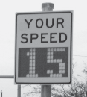

- Walter and Broughton, 2011

  - Study Characteristics
Item | Response
Authors | Walter and Broughton
Title | Effectiveness of Speed Indicator Devices: An Observational Study in South London
Publication year | 2011

  - Quality Screening
Quality Criteria | Response (Yes or No)
Were the study population and the context of the study well described? | Yes
Were the exposure variables valid implementations of the conditions that they were meant to represent? | Yes
Was the outcome variable both a reliable and valid measure of the outcome of interest? | Yes

  - Study Features
Feature | Study Information
Experimental Design | O-X-O-O
Safety Focus | Straight section
Graphic of DSFS available | No
Graphic of Layout available | No
Study restricted to free flow level of service | Yes
Classes of vehicles included | NS
Hypothesis 1 (H1) level | A
Hypothesis 2 (H2) level | A
Hypothesis 3 (H3) level | A
H1: Mean speed | Significant reduction recorded
H1: 85th percentile speed | NA
H1: Percentage of drivers over speed limit | NA
H1: Distribution of speed | Nothing reported
H2: Mean speed | Significant reduction recorded at 700 ft downstream, but not at 1300 ft
H2: 85th percentile speed | NA
H2: Percentage of drivers over speed limit | NA
H2: Distribution of speed | Nothing reported
H3: Mean speed | No change
H3: 85th percentile speed | NA
H3: Percentage of drivers over speed limit | NA
H3: Distribution of speed | Nothing reported
DSFS displays speed | Yes
DSFS speed lighting | NS
DSFS flashes (speed or other) | NS
Mobile DSFS units | NS
Roadway type | Collector
Area type (location) | Urban
Sidewalks present | NS
Posted speed | 30 mph
Sensor positions | Upstream (-700 ft); adjacent (0 ft); downstream (700 ft, 1300 ft)
Number of sensors | 1,1,2
Sensor types | Inductive loops
Types of treatments | DSFS
Number of relevant sites | 10
Number of cases | 10
Duration of measurements before activation (“before” measurements) | 1 week
Time interval between “before” measurements and activation | 0 days
Duration of activation | 1-3 weeks
Time of day when speed is measured (AM/PM) | NS
Time of day when speed is measured (peak/off peak) | NS
Time intervals at which measurements were taken during activation (“during” measurements) | 1,2, and 3 weeks
Amount of time that elapsed after deactivation and prior to subsequent measurements (“after” measurements) | 0 days
Duration of “after” measurements | 1 and 2 weeks
Meta-analysis data available | Yes
Caveats | International, thus not included
Best practices information available | No

  - Summary of Study
Dynamic feedback speed signs were installed at 10 sites in South London. The sites were straight sections of roadway of about 1 km in length where traffic was freely flowing (Level A). All sites had a posted speed of 30 mph. Measures were taken of the mean speed, the maximum speed, and the minimum speed 200 m upstream of the DSFS, at the DSFS, and 200 m (10 sites) and 400 m (6 sites) downstream of the DSFS. Treatment condition was the independent variable (before – 1 week, during – 1, 2, 3 weeks, after – 1, 2 weeks). Three major hypotheses were evaluated: H1A, H2A, and H3A.
Data Reported. The data reported include the following: (a) Activation effect adjacent to the DSFS on mean, max and min speed; (b) Activation effect downstream (200 m, 400 m) for mean, max and min speed; and (c) Deactivation effect adjacent to the DSFS 1 week and 2 weeks after removal on mean speed, max speed, and min speed.
Results. The results are as follows for changes in mean speeds. H1A: There was a statistically significant decrease in the mean speed of -1.4 mph at the DSFS when it was activated compared to baseline. H2A: There was a statistically significant decrease of -0.2 mph 200 m downstream of the DSFS when it was activated compared to baseline; there was no significant change in the mean speeds 400 m downstream of the DSFS. H3A: When compared with baseline, there was no significant change in the mean speeds at the DSFS 1 week after the DSFS was turned off but there was a statistically significant increase of 0.1 mph at the DSFS 2 weeks after the DSFS was turned off. Other Results. Similar results held for measures of the maximum and minimum speeds. For example, there was an overall reduction of 2.6 mph in the maximum speed and an overall reduction of 0.6 mph in the minimum speed when the DSFS was activated.
Statistical Analysis. ANOVA contrasts (or planned comparisons) were done on the dependent variables:
Where x is defined from 1 (-200 m before SID), 2 (at SID), 3 (200 m post SID), 4 (400 m post SID)
  - Study Schematic
Not provided.
  - DSFS Graphic
Not provided.

- Western Transportation Institute, 2003

  - Study Characteristics
Item | Response
- Authors | Western Transportation Institute
- Title | Greater Yellowstone Rural ITS Project: Work Order II-2C Dynamic Warning VMS Evaluation of Wyoming Site
- Publication year | 2003

  - Quality Screening
Quality Criteria | Response (Yes or No)
Were the study population and the context of the study well described? | Yes
Were the exposure variables valid implementations of the conditions that they were meant to represent? | Yes
Was the outcome variable both a reliable and valid measure of the outcome of interest? | Yes

  - Study Features
Feature | Study Information
Experimental Design | O-X-O
Safety Focus | Horizontal curve
Graphic of DSFS available | Yes
Graphic of Layout available | Yes
Study restricted to free flow level of service | NS
Classes of vehicles included | Passenger cars and trucks
Hypothesis 1 (H1) level | A,B
Hypothesis 2 (H2) level | A,B
Hypothesis 3 (H3) level | NA
H1: Mean speed | Significant decrease only at location 5
H1: 85th percentile speed | Nothing reported
H1: Percentage of drivers over speed limit | Nothing reported
H1: Distribution of speed | Nothing reported
H2: Mean speed | Significant reduction only at location 5
H2: 85th percentile speed | Nothing reported
H2: Percentage of drivers over speed limit | Nothing reported
H2: Distribution of speed | Nothing reported
H3: Mean speed | Nothing reported
H3: 85th percentile speed | Nothing reported
H3: Percentage of drivers over speed limit | Nothing reported
H3: Distribution of speed | Nothing reported
DSFS displays speed | No
DSFS speed lighting | Yes
DSFS flashes (speed or other) | No
Mobile DSFS units | No
Roadway type | Local
Area type (location) | Rural
Sidewalks present | No
Posted speed | NS
Sensor positions | Upstream (-2112 ft, -1478 ft), adjacent (just downstream) and downstream (2112 ft, 2904 ft, and 8184 ft)
Number of sensors | 2,1,3
Sensor types | Multiple (magnetic and pneumatic)
Types of treatments | DSFS
Number of relevant sites | 1
Number of cases | 2
Duration of measurements before activation (“before” measurements) | 2 weeks
Time interval between “before” measurements and activation | 2 weeks
Duration of activation | 2 weeks
Time of day when speed is measured (AM/PM) | Multiple
Time of day when speed is measured (peak/off peak) | Multiple
Time intervals at which measurements were taken during activation (“during” measurements) | 2 weeks
Amount of time that elapsed after deactivation and prior to subsequent measurements (“after” measurements) | NA
Duration of “after” measurements | NA
Meta-analysis data available | Yes
Caveats | None
Best practices information available | No

  - Summary of Study
This study evaluated the effectiveness of a DSFS installed on winding, rural Wyoming highway 14A, with significant grades. This was just one component of the Greater Yellowstone Rural Intelligent Transportation System (ITS) Project, which also encompassed two other evaluations in Idaho and Montana. In addition to analyzing speeds as a measure of effectiveness, the study also included a motorist survey and an analysis of crash data.
Inductive loops 0.3 miles upstream were used to detect the size and speed of vehicles approaching the DSFS. The regulatory speed limit was not specified, but the DSFS displayed advisory messages to vehicles that exceeded a speed threshold for their size category. The speed thresholds were as follows:
- Vehicles less than 22 feet: 40 mph
- Vehicles greater than 22 feet: 35 mph
The advisory warning included two panels: “Curves Ahead” and “Slow Down.” The DSFS was approximately 10 feet wide, 4 feet tall, and 2 feet deep, and showed LED characters with a text height of 12 inches.
Vehicle spot speeds and classifications were collected for a two-week period prior to the DSFS installation (using magnetic sensors) and a two-week period after (using pneumatic sensors). Researchers programmed the data collection equipment to record the average speed for each two hour interval, rather than recording individual vehicle speeds. Data were collected at two upstream, one adjacent, and three downstream locations. The study evaluated hypotheses H1A, H1B, H2A, and H2B.
Unfortunately some of the magnetic sensors were dislodged by passing vehicles, ruining some of the “before” data collection. This was the reason why the researchers switched to pneumatic tubes for the “during” data collection. Unfortunately, these two technologies classify vehicles in slightly different ways; e.g., a passenger car towing a trailer would have been classified as a truck in the “before” data collection, but would have been classified as a passenger car in the “during” data collection. This likely introduced some error in the “before” and “during” comparisons for specific vehicle types. Also, researchers noted that the two sensor types may have different errors. They conducted tests and determined that the magnetic sensors tend to overestimate speed by an average of 1.5 mph when compared to the pneumatic tubes. To compensate, they subtracted 1.5 mph from the “before” speeds. Researchers also noted that the “during” sensors may have collected data at slightly different locations than the “before” sensors, but difference between the pre- and post- locations was estimated to be 0.1 miles or less.
The publication reported mean speeds and adjusted mean speeds (to compensate for different sensor types), as well as sample sizes and standard deviations for passenger vehicles and trucks.
Results. When compared to speed after the installation was complete, there was a statistically significant reduction in vehicle speeds at the sharp curves for both passenger cars and trucks.
Statistical Analysis. The researchers determined whether observed differences were statistically significant at the 0.05 level of significance, in most cases using a one-tailed t-test.
  - Study Schematic
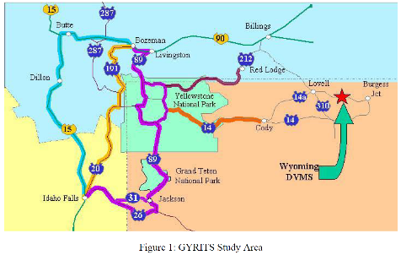
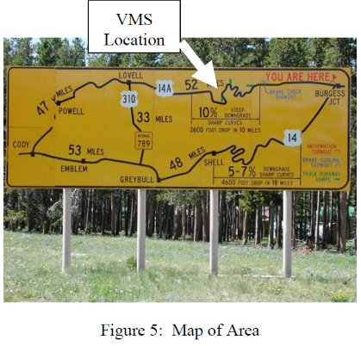
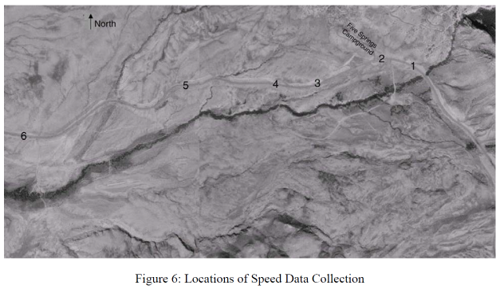
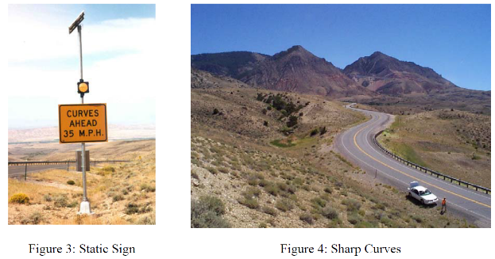
  - DSFS Graphic
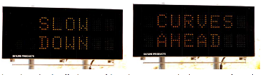
- Williamson and Fries, 2015

  - Study Characteristics
Item | Response
Authors | Williamson and Fries
Title | Effectiveness of Radar Speed Signs in a University Environment
Publication year | 2015

  - Quality Screening
Quality Criteria | Response (Yes or No)
Were the study population and the context of the study well described? | Yes
Were the exposure variables valid implementations of the conditions that they were meant to represent? | Yes
Was the outcome variable both a reliable and valid measure of the outcome of interest? | Yes

  - Study Features
Feature | Study Information
Experimental Design | X-O
Safety Focus | Transition zone
Graphic of DSFS available | Yes
Graphic of Layout available | No
Study restricted to free flow level of service | Yes
Classes of vehicles included | NS
Hypothesis 1 (H1) level | NA
Hypothesis 2 (H2) level | C
Hypothesis 3 (H3) level | NA
H1: Mean speed | Nothing reported
H1: 85th percentile speed | Nothing reported
H1: Percentage of drivers over speed limit | Nothing reported
H1: Distribution of speed | Nothing reported
H2: Mean speed | Significant reduction recorded
H2: 85th percentile speed | Nothing reported
H2: Percentage of drivers over speed limit | Significant reduction recorded
H2: Distribution of speed | Nothing reported
H3: Mean speed | Nothing reported
H3: 85th percentile speed | Nothing reported
H3: Percentage of drivers over speed limit | Nothing reported
H3: Distribution of speed | Nothing reported
DSFS displays speed | Yes
DSFS speed lighting | NS
DSFS flashes (speed or other) | NS
Mobile DSFS units | Yes
Roadway type | Local
Area type (location) | Suburban
Sidewalks present | NS
Posted speed | 25 mph
Sensor positions | Adjacent (NS) and downstream (620 ft)
Number of sensors | 0,1,1
Sensor types | Lidar
Types of treatments | DSFS
Number of relevant sites | 1
Number of cases | 1
Duration of measurements before activation (“before” measurements) | NA
Time interval between “before” measurements and activation | NA
Duration of activation | 9 months
Time of day when speed is measured (AM/PM) | Multiple
Time of day when speed is measured (peak/off peak) | Multiple
Time intervals at which measurements were taken during activation (“during” measurements) | 9 months
Amount of time that elapsed after deactivation and prior to subsequent measurements (“after” measurements) | NA
Duration of “after” measurements | NA
Meta-analysis data available | No
Caveats | NA
Best practices information available | No

  - Summary of Study
This study investigated the effect of a DSFS placed for an extended period of time on a road segment entering a university campus. The site was frequented by pedestrians and law enforcement and was known to have an existing speeding problem.
The sign was movable but had been installed for 9 months before the “during” data were collected. Researchers collected speed data in optimal weather conditions during weekday peak periods and on Saturday during an off-peak time. The speed limit upstream was 45 mph, transitioning to a 25 mph speed limit in the study area. The DSFS was placed within the 25 mph zone, but upstream of the area frequented by pedestrians.
Researchers used a handheld radar gun to record vehicle speeds near the point where pedestrians cross the roadway (620 feet downstream of the DSFS). The location was on the south end of campus, more than two miles from the nearest signalized intersection. Many drivers would have just finished a commute at interstate speeds before entering campus. Lead vehicles were identified and tracked through the study area; no following vehicles were used to ensure that each driver was independently setting their speed under free-flow conditions. The measures of effectiveness were mean speed and the percent of vehicles exceeding the speed limit. The hypothesis investigated was H2C.
Data reported. Mean speed reductions and percent of speeders responding to the DSFS.
Results. The upstream and downstream speed “during” measurements of each vehicle were compared using a statistical approach to identify the overall effectiveness of the radar speed signs. The findings suggest with 99 percent significance that drivers traveling above the speed limit reduced their speed by a mean of 1.19 mph, while drivers traveling below the posted speed limit increased their speed by a mean of 2.33 mph. Also, 85.6 percent of drivers reduced their speed when warned that they were speeding.
Statistical Analysis. “The two speed measurements of each vehicle were compared using a statistical approach to identify the overall effectiveness of the radar speed signs. Two additional groups were tested: those vehicles traveling above and below the posted speed limit at point 1.”
  - Study Schematic
Not provided
  - DSFS Graphic
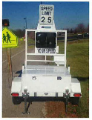

References
Addison County Regional Planning Commission. (2013). Effectiveness of Radar Speed Feedback Signs and Other Traffic Calming Techniques. Shelburne, VT: Addison County Regional Planning Commission.
Bertini, R., Monsere, C., Nolan, C., Bosa, P., & Abou El-Seoud, T. (2006). Field evaluation of Myrtle Creek advanced curve warning system. Washington, DC: Federal Highway Administration.
Bertucci, A. (2006). Sign Legibility Rules of Thumb. Bristol, PA: United States Sign Council.
Bloch, S., & Automobile Club of Southern California. (2007). Comparative study of speed reduction effects of photo-radar and speed display boards. Transportation Research Record , 1640.
Bowie, J. (2003). Efficacy of speed monitoring displays in increasing speed limit compliance in highway work zones (Masters's Thesis). Salt Lake City: Brigham Young University.
Brewer, M., Pestie, G., & Schneider, W. (2006). Improving compliance in work zone speed limits. Transportation Research Record , 67-76.
Bullough, J., Skinner, N., Brons, J., & Rea, M. (2012). Using Lighting And Visual Information to Alter Driver Behavior. Albany, NY: New York State Department of Transportation.
Chang, K., Nolan, M., & Nihan, N. (2004). Radar speed signs on neighborhood streets: An effective traffic calming device? 2004 ITE Annual Meetingn. Lake Buena Vista, FL.
Christ, S., & Abrams, R. (2006). Abrupt onsets cannot be ignored. Psychonomic Bulletin & Review , 13, 875-880.
City of Bellevue Transportation Department. (2009). Stationary radar sign program 2009 report. Bellevue, WA: Author.
City of Englewood, CO. (2014). Recent accomplishments: Traffic safety improvements at Logan and Eastman. Englewood, CO: Author.
Cooper, H., Hedges, L., & Valentine, J. (2009). The Handbook of Research, Synthesis and Meta-analysis (2nd ed.). New York: Russell Safe.
Cruzado, I., & Donnell, E. (2009). Evaluating effectiveness of dynamic speed display signs in transition ones of two-lane, rural highways in Pennsylvania. Transportation Research Record , 1-8.
Donnell, E., & Cruzado, I. (2007). Effectiveness of speed minder in reducing driving speeds on rural highway in Pennsylvania: Literature synthesis. State College, PA: Pennsylvania Transportation Institute.
Drakopoulos, A., & Uprety, S. (2003). I-43 speed warning sign evaluation. Milwaukee, Wisconsin: Marquette University.
Federal Highway Administration. (2012, October 19). Flexibility in Highway Design. Chapter 3. Functional Classification. Retrieved June 8, 2016, from http://www.fhwa.dot.gov/environment/publications/flexibility/ch03.cfm
Federal Highway Administration. (2013). Highway functional classification concepts, criteria and procedures. Washington, DC: Federal Highway Administration.
Federal Highway Administration. (2012). Manual on Uniform Traffic Control Devices: Standard Hihway Signs (2012 Supplement). Washington, DC: Federal Highway Administration.
Federal Motor Carrier Administration. (2014, March 27). Commercial drivers licences: Drivers. (Federal Motor Carrier Safety Administration) Retrieved June 8, 2016, from https://www.fmcsa.dot.gov/registration/commercial-drivers-license/drivers
Fontaine, M. (2008). Innovative traffic control devices for improving safety at rural short-term maintenance work zones. College Station, TX: Texas Transportation Institute.
Fontaine, M., & Carlson, P. (2001). Evaluation of speed displays and rumble strips in rural-maintenance work zones. Transportation Research Record , 1745, 27-38.
Gambatese, J., & Jafarnejad, A. (2015). Evaluation of Radar Speed Display for Mobile Maintenance. Salem, Oregon: Oregon Department of Transportation Research Unit.
Gambatese, J., & Zhang, F. (2014). Safe and effective speed reductions for freeway work zones Phase 2. Salem, OR: Oregon Department of Transportation.
Hajbabie, A., Medina, J., Wang, M., Benekohal, R. F., & Chitturi, M. (2011). Sustained and halo effects of various speed reduction treatments in highway work zones. Transportation Research Record , 118-128.
Hallmark, S., & Hawkins, H. K. (2015). Use of DSFS as a Speed Transition Zone Countermeasures in Small, Rural Communities. 2015 IEEE 18th International Conference on Intelligent Transportation Systems (pp. 1448-1454). Canary Islands, Spain: IEEE Computer Society.
Hallmark, S., Hawkins, H., & Knickerbocker, S. (2015). Use of DSFS as a Speed Transition Zone Countermeasures in Small, Rural Communities. 2015 IEEE 18th International Conference on Intelligent Transportation Systems (pp. 1448-1454). Canary Islands, Spain: IEEE Computer Society.
Hallmark, S., Hawkins, N., & Smadi, O. (2015). Evaluation of dynamic speed feedback signs on curves: A national demonstration project. McClean, VA: Office of Infrastructure Research and Development, Federal Highway Administration.
Hallmark, S., Knickerbocker, S., & Hawkins, N. (2013). Evaluation of Low Cost Traffic Calming for Rural Communities -- Phase II [Updated]. Ames: Institute for Transportation, Iowa State University.
Hallmark, S., Knickerbocker, S., & Hawkins, N. (2013). Evaluation of Low Cost Traffic Calming for Rural Communities -- Phase II [Updated]. Ames: Institute for Transportation, Iowa State University.
Hallmark, S., Peterson, E., Fitzsimmons, E., Hawkins, N., Resler, J., & Welch, T. (2007). Evaluationn of gateway and low-cost traffic-calming treatments for major routes in small, rural communities. Ames: Center for Transportation Research and Education, Iowa State University.
Hallmark, S., Peterson, E., Fitzsimmons, E., Hawkins, N., Resler, J., & Welch, T. (2007). Evaluationn of gateway and low-cost traffic-calming treatments for major routes in small, rural communities. Ames: Center for Transportation Research and Education, Iowa State University.
Jeihani, M., Ardeshiri, A., & Naeeni, A. (2012). Evaluating the effectiveness of dynamic speed display signs. Baltimore, MD: Morgan State University National Transportation Center.
Kamyab, A., Andrle, S., & Kroeger, D. (2002). Methods to reduce traffic speed in high pedestrian areas. St. Paul: Minnesota Department of Transportation.
Kloeden, C., McLean, A., Moore, V., & Ponte, G. (1997). Traveling speed and the risk of crash involvement. Adelaide, Australia: NHMRC Road Accident Research Unit, The University of Adelaide.
Knapp, K., & Robinson, F. (2012). The vehicle speed impacts of a dynamic horizontal curve warning sign on low-volume local roadways. St. Paul: Minnesota Department of Transportation.
Koricheva, J., & Gurevitch, J. (2016). Place of Meta-analysis among Other Methods of Research Synthesis. In J. Koricheva, J. Gurevitch, & K. Mengersen (Eds.), Handbook of Meta-analysis in Ecology and Evolution (pp. 3-13). Princeton, NJ: Princeton University Press.
Lee, C., Lee, S., Choi, B., & Oh, Y. (2005). Effectiveness of speed-monitoring displays in speed reduction in school zones. Transportation Research Record , 27-35.
Mattox, J., Sarasua, W., Ogle, J., Eckenrode, R., & Dunning, A. (2007). Development and evaluation of speed-activated sign to reduce speeds in work zones. Transportation Research Record , 3-11.
McCoy, P., & Pesti, G. (2001). Smart work zone technology evaluations: speed monitoring displays and condition-responsive, real-time travel information systems. Lincoln: Mid-America Transportation Center, University of Nebraska-Lincoln.
McCoy, P., Bonneson, J., & Kollbaum, J. (1995). Speed reduction effects of speed monitoring displays with radar in work zones on interstate highways. Transportation Research Record , 65-72.
Medina, J., Benekohal, R., Hajbabaie, A., Wang, M., & Chitturi, M. (2009). Downstream effects of speed photo-radar enforcement and other speed reduction treatments on work zones. Transportation Research Record , 24-33.
Meyer, E. (2000). Evaluation of two strategies for improving safety in highway work zones. Mid-Continent Transportation Symposium 2000 Proceedings (pp. 62-66). Ames: Iowa State University.
National Highway Traffic Safety Administration. (2014). Traffic safety facts 2012 data: Speeding. Washington, D.C.: Author.
National Highway Traffic Safety Administration. (2014, May). Traffic Safety Facts. 2012 Data. Speeding. Retrieved June 13, 2016, from http://www-nrd.nhtsa.dot.gov/Pubs/812021.pdf
O'Brien, S., & Simpson, C. (2012). Use of "Your Speed" changeable message signs in school zones: Experience from North Carolina Safe Routes to School Program. Transportation Research Record .
Pesti, G., & McCoy, P. (2011). Long-term effectiveness of speed monitoring displays in work zones on rural interstate highways. Transportation Research Record , 21-30.
Reddy, V., Datta, T., Savolainen, P., & Pinapaka, S. (2008). Evaluation of innovative safety treatments: A study of the effectiveness of motorist awareness systme in construction work zones. Tallahassee: Florida Department of Transportation.
Richard, C., Campbell, J., Lichty, M., Brown, J., Chrysler, S., Lee, J., et al. (2013). Motivations for speeding, Volume II: Findings report. Washington, DC: National Highway Traffic Safety Administration.
Roberts, C., & Smaglik, E. (2012). Driver feedback on monetary penalty and its impact on work zone speed. Transportation Research Record , 27-34.
Robinson, F. (2012). The vehicle speed impacts of dynamic horizontal curve warning sign on low-volume local roadways. St. Paul: Minnesota Department of Transportation.
Saito, M., & Ash, K. (2005). Evaluation of four recent traffic safety initiatives, Volume IV: Increasing speed limit compliance in reduced speed school ones. Salt Lake City, Utah: Utah Department of Transportation Research Division.
Santiago-Chaparro, K., Chitturi, M., Bill, A., & Noyce, D. (2012). Spatial effectiveness of speed feedback signs. Transportation Research Record , 8-15.
Sarasua, W., Ogle, J., & Chowdhury, M. (2006). Better management of speed control in work zones. Columbia, SC: South Carolina Department of Transportation.
Schoenecker, T., Sandberg, W., Sebastian, K., & Soler, P. Long-term effectiveness of dynamic speed monitoring display (DSMD) signs for speed management at speed limit transitions.
Schroeder, P., Kostynuik, L., & Mack, M. (2013). 2011 National survey of speeding attitudes and behaviors. Washington, DC: National Highway Traffic Safety Administration.
South Carolina Department of Transportation. (2006). Traffic Calming Guidelines. Columbia, SC: Soutch Carolina Department of Transportation.
Tefft, B. (2011). Impact speed and a pedestrain's risk of severe injury or death. Washington DC: AAA FTS.
Teng, H., Xu, X., Li, X., Kwigizile, V., & Gibby, A. (2009). Evaluation of speed monitoring displays for work zones in Las Vegas, Nevada. Transportation Research Record , 45-56.
Transportation Research Board. (2010). Highway Capacity Manual (2010). Washington,DC: National Academies of Science.
Tribbett, L., McGowen, P., & Mounce, J. (2000). An evaluation of dynamic curve warning systems in the Sacramento River Canyon. Bozeman, MT: Western Transportation Institute.
Tribbett, L., McGowen, P., & Mounce, J. (2000). An evaluation of dynamic curve warning systems in the Sacremento River Canyon. Bozeman, MT: Western Transportation Institute.
Turner, J. (2015, June 10). What's a Work Zone? Retrieved June 8, 2016, from Federal Highway Administration Research and Technology: Public Roads: http://www.fhwa.dot.gov/publications/publicroads/99mayjun/workzone.cfm
Ullman, G., & Rose, E. (2005). Evaluation of dynamic speed display signs. Transportation Research Record , 92-97.
Walter, L., & Broughton, J. (2011). Effectiveness of speed indicator devices: An observational study in South London. Accident Analysis and Prevention , 1355–1358.
Western Transportation Institute. (2003). Greater Yellowstone Rural ITS Project: Work Order II-2C Dynamic Warning VMS Evaluation of Wyoming Site. Bozeman, MT: Western Transportation Institute.
Williamson, M., & Fries, R. (2015). Effectiveness of radar speed signs in a university environment. ite Journal , 44-48.

The duration of “during” measurement periods was not collected, because this information was often not explicitly stated.
The duration of “during” measurement periods was not collected, because this information was often not explicitly stated.
The duration of “during” measurement periods was not collected, because this information was often not explicitly stated.
The duration of “during” measurement periods was not collected, because this information was often not explicitly stated.
The duration of “during” measurement periods was not collected, because this information was often not explicitly stated.
The duration of “during” measurement periods was not collected, because this information was often not explicitly stated.
The duration of “during” measurement periods was not collected, because this information was often not explicitly stated.
The duration of “during” measurement periods was not collected, because this information was often not explicitly stated.
The duration of “during” measurement periods was not collected, because this information was often not explicitly stated.
The duration of “during” measurement periods was not collected, because this information was often not explicitly stated.
The duration of “during” measurement periods was not collected, because this information was often not explicitly stated.
The duration of “during” measurement periods was not collected, because this information was often not explicitly stated.
The duration of “during” measurement periods was not collected, because this information was often not explicitly stated.
The duration of “during” measurement periods was not collected, because this information was often not explicitly stated.
The duration of “during” measurement periods was not collected, because this information was often not explicitly stated.
The duration of “during” measurement periods was not collected, because this information was often not explicitly stated.
The duration of “during” measurement periods was not collected, because this information was often not explicitly stated.
The duration of “during” measurement periods was not collected, because this information was often not explicitly stated.
The duration of “during” measurement periods was not collected, because this information was often not explicitly stated.
The duration of “during” measurement periods was not collected, because this information was often not explicitly stated.
The duration of “during” measurement periods was not collected, because this information was often not explicitly stated.
The duration of “during” measurement periods was not collected, because this information was often not explicitly stated.
The duration of “during” measurement periods was not collected, because this information was often not explicitly stated.
The duration of “during” measurement periods was not collected, because this information was often not explicitly stated.
The duration of “during” measurement periods was not collected, because this information was often not explicitly stated.
The duration of “during” measurement periods was not collected, because this information was often not explicitly stated.
The duration of “during” measurement periods was not collected, because this information was often not explicitly stated.
The duration of “during” measurement periods was not collected, because this information was often not explicitly stated.
The duration of “during” measurement periods was not collected, because this information was often not explicitly stated.
The duration of “during” measurement periods was not collected, because this information was often not explicitly stated.
The duration of “during” measurement periods was not collected, because this information was often not explicitly stated.
The duration of “during” measurement periods was not collected, because this information was often not explicitly stated.
The duration of “during” measurement periods was not collected, because this information was often not explicitly stated.
The duration of “during” measurement periods was not collected, because this information was often not explicitly stated.
The duration of “during” measurement periods was not collected, because this information was often not explicitly stated.
The duration of “during” measurement periods was not collected, because this information was often not explicitly stated.
The duration of “during” measurement periods was not collected, because this information was often not explicitly stated.
The duration of “during” measurement periods was not collected, because this information was often not explicitly stated.
The duration of “during” measurement periods was not collected, because this information was often not explicitly stated.
The duration of “during” measurement periods was not collected, because this information was often not explicitly stated.
The duration of “during” measurement periods was not collected, because this information was often not explicitly stated.
The duration of “during” measurement periods was not collected, because this information was often not explicitly stated.
The duration of “during” measurement periods was not collected, because this information was often not explicitly stated.
The duration of “during” measurement periods was not collected, because this information was often not explicitly stated.

